NSTX Upgrade

Analysis of Existing and Upgrade PF4/5 Coils and Supports – With Alternating Columns.
NSTXU-CALC-12-05-00
Rev 0
March 2011

Prepared By:

___________________________________
Peter Titus, PPPL Mechanical Engineering

Reviewed By:

________________________________________
Irving Zatz, Engineering Analysis Division

Reviewed By:

_______________________________________
Mark Smith, Cognizant Engineer

PPPL Calculation Form

Calculation # NSTXU-CALC-12-05 Revision # 00 WP #, 1677
(ENG-032)

Purpose of Calculation: (Define why the calculation is being performed.)

To qualify the stresses in PF4 and 5 and the stresses in their support brackets and columns.

References (List any source of design information including computer program titles and revision levels.)

Included in the body of the report - See section 6.1

Assumptions (Identify all assumptions made as part of this calculation.)

Multiple models of PF4 and 5 are used in these calculations. Each has a different level of refinement, and is intended to address different aspects of the coils and supports. The assumptions regarding the individual models and their relationship with the other models and analyses are discussed with each model. There is a global model of the tokamak which uses smeared properties of the winding pack and there is a quarter symmetry model of just the upper half of half of the coils and associated brackets and vessel sections. The quarter symmetry model addresses local conductor and insulation stress, and the global model addresses the interactions with the full PF and TF systems.

Calculation (Calculation is either documented here or attached)

See the following report

Conclusion (Specify whether or not the purpose of the calculation was accomplished.)

Stress levels in both the coils and supports satisfy the NSTX CSU criteria

Cognizant Engineer’s printed name, signature, and date

Mark Smith

I have reviewed this calculation and, to my professional satisfaction, it is properly performed and correct.

Checker’s printed name, signature, and date

2.0 Table of Contents
NSTX PF 4 and 5 Coils and Supports
Section.Paragraph
Title Page 1.0
Table Of Contents 2.0
Executive Summary 3.0
Digital Coil Protection System 4.0
Introduction and Evolution of the Design 5.0

Design Input,
References 6.1
Criteria 6.2
Coil Geometry Loads and Currents and Temperatures from the Design Point 6.3
Input Currents 6.4
Materials Properties 6.5
Elastic Constants 6.6
Fatigue Data 6.7

Analysis Models 7.0
Model elements 7.1
Fields and Forces 7.2
Link Concept 7.3

PF 4 and 5 Coil Results 8.0
PF 4 and 5 Coil Displacement Results 8.1
PF 4 and 5 Coil Conductor Stress Results 8.2
PF4 and 5 Coil Insulation Stress 8.3
Provisions for Differential Thermal Growth of PF4 and 5
- Results for the Link Concept 8.5
TF Ripple Loads on PF 4 and 5 8.6
Digital Coil Protection Input 9.0
PF5 Stress Influence Coefficients 9.1
PF4 Stress Influence Coefficients 9.2
Existing PF4 and 5 Bracket Weld Force Influence Coefficients 9.3

Lead Support Analysis 10.0
Fatigue Analysis 11.0

Brackets, Hardware, and Bracket to Vessel Welds 12.0
PF4/5 Existing Support Weld Stress 12.1
Bracket Welds for Upgrade Loads 12.2
PF5 Bracket Support Plate and weld, With and Without Support Column 12.3
PF4 and 5 Column Support Stress 12.4
Coil Clamp Plate Bolting 12.5
T slot Stress 12.6
Vessel Shell Stress 12.7

Bake Out Local Thermal Stresses 13.0
Appendices
Appendix A Earlier Support Model Results A.0
Results using only the existing Six Support Brackets A.1
Results for Added Columns and Rubber Support Pads A.2
Concept which Supports TF OOP Loads off the PF4 and 5 supports A.3
Appendix B PF4/5 Bracket Support Weld Inspection
3.0 Executive Summary:
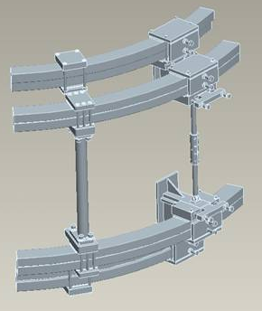
Figure 3.0-1 FDR PF4/5 Supports

The design of the outer PF 4/5 supports has gone through a number of iterations. Initially only 6 support points were proposed (twelve including uppers and lowers). The existing support brackets (Figure 3.0-2) were to be bypassed and an additional set of six stronger columns were to be added. This left six strong support points that could react the large attractive loads between PF4/5 upper and PF4/5 lower. If the coils could handle the spans created by the six support points, this option was thought to be attractive because the vessel shell would be off-loaded.
The PF5 insulation system is a mylar wrapped fusifab epoxy system. Because of the poor bonding of the mylar to epoxy and to the copper conductors, twelve supports were necessary to reduce the spans and resulting bending stress. Stresses in PF4 and 5 have been calculated in a detailed model of the vessel shell, support hardware, and winding pack. In order to assess the stress in the coils, stress analysis of the winding pack is used in concert with influence coefficients to add localized stress behavior with thermal stress and for all scenarios currently postulated for NSTX - with 10% headroom in currents, with and without plasma. PF5U conductor stress is calculated to be 122 MPa with all effects included. This is below the fatigue allowable developed for the OH coil [7]
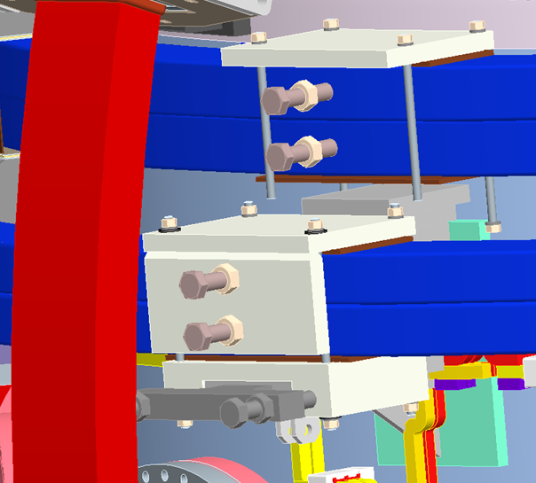
Figure 3.0-2 Existing PF4/5 Supports
The coil support concept is as presented in the PDR, with six existing supports augmented by six new support columns. Elimination of the existing strut or column between the upper and lower existing PF4/5 supports was considered but this overstressed the cantilevered portion of the PF5 support, added loads to the pad welded to the vessel, and added stress in the port ligamants, and so, the strut/column has been retained.
PF4 and 5 have to be aligned with respect to the centerline of the plasma. The current (meaning prior to the upgrade) approach is to connect" pushers and clamps around the coils to push the coils into roundness and concentricity. Currently coil heat up is trivial. For the upgrade the coils will be on for the 5 sec. pulse and will heat to 100C -expanding and fighting the alignment clamps. Table 6.3-2 shows the maximum temperatures expected during upgrade operation. John Menard and Masa Ono were consulted during a Wednesday project meeting. An n=2 error i.e. an elliptical coil is acceptable as long as it is aligned with the plasma centerline - i.e. it precludes a n=1 error, or a net lateral shift. So the coils are radially held with respect to the vessel and have them grow into an oval as they thermally expand. The degree of ovality was accepted by Jon Menard and Masa Ono.
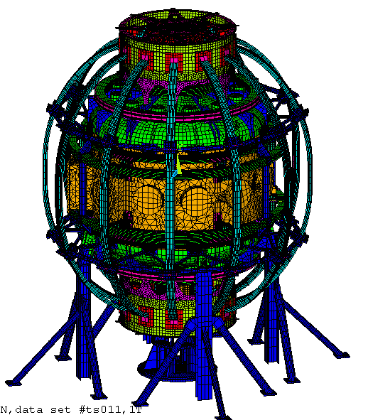
Figure 3.0-3 Linear Global Model [2] Used in Calculating DCPS Stress Multipliers
The intention is to fix the sliding blocks on two opposite, existing PF4 and 5 supports. This makes the coils and their supports symmetric about a vertical plane that cuts through both fixed supports. A 180 degree half symmetry modeling is sufficient to capture the full 360 degree behavior of the coils In addition to the alignment issues, there are leads that require support. They currently break out of the coils and are connected to a unistrut frame that fixes them in space, providing support for Lorentz loads but allowing no thermal growth of the coil. If the fixed radial supports are chosen near the leads then the lead supports will work - at least conceptually.

The staggered column design produces 12 support s for the attractive loads on the PF4/5 upper and lower coils. The support points alternate between support by the vessel, and support by the six columns. This analysis assumes that the small columns (that buckled during initial NSTX runs) are retained. They are much less stiff than the new columns, and some loading is transferred to the vessel. The new columns are modeled as 3 inch in diameter and .3 inch with wall thickness. The welds connecting the bracket to the vessel shell concentrate at the corner of the perimeter weld. The weld is nominally 5/16, but the QA report recommends an effective ¼ inch weld .Local corner stresses were high even for the existing NSTX loading, and an inspection of these corner welds was performed to determine if any fatigue failures were initiating.- No indications of cracking or fatigue were found. The six (twelve included uppers and lowers) existing PF4 and 5 brackets are the only support for the assembly of PF 4,5 upper and lower coils. Most loading on the coils is attractive loading between the series connected PF4U&L coils and PF5U&L coils. The net loading is smaller . The attractive loads are intended to be taken by 12 columns, six original and six new columns. Without consideration of elastic effectiveness of the old columns, and considering the columns to resist all the attractive loads, then the weldments to the vessel would only take the net load with acceptable stress levels. Hand calculations of these loads show that these welds satisfy static and fatigue limits. In order for the bracket to vessel welds to be loaded primarily by the net assembly loads rather than the attractive loads between PF4 and 5, the existing columns must be stiffened. . Clamp plate studs are currently listed as 316, but no grade or condition is specified. It is recommended that they be replaced with ASTM A193 B8M Class 2 bolting material. These provide assurance that if the launching loads are not equal and opposite on top vs. bottom, then 6 support points can support the net tensile loads on the studs.

4.0 Digital Coil Protection System Input

The digital coil protection system algorithms are discussed in more detail in section 9. Conceptual design of the upgrade to NSTX explored designs sized to accept the worst loads that power supplies could produce. Excessive structures resulted that would have been difficult to install and were much more costly than needed to meet the scenarios required for the upgrade mission, specified in the General Requirements Document (GRD). Instead the project decided to rely on a digital coil protection system (DCPS). Initial sizing was then based on the 96 scenarios in the GRD design point with some headroom to accommodate operational flexibility and uncertainty. The DCPS must control currents to limit component stresses and temperatures to acceptable levels.
Two approaches are used to provide the needed multipliers/algorithms.
The first is to use the loads on PF coils computed by the DCPS software and apply these to local models of components. The second approach to calculating the stress multipliers/algorithms is to utilize a global model that simulates the whole structure and includes an adequately refined modeling of the component in question. Unit terminal currents are applied to each coil separately, Lorentz loads are calculated, and the response of the whole tokamak and local component stress is computed. Local component stresses may then be computed in the DCPS or in a spreadsheet for the many scenarios required by the GRD. This approach has been applied to the PF4 and 5 coil stress.

PF4/5 DCPS Multipliers

The DCPS should calculate the upward load on the upper PF4 and 5 coils individually and assume this is split over 6 of the 12 support clamp plates which each have 4 studs. Similarly the downward load on each of the lower PF4 and PF5 coils should be split over 6 of their 12 supports. This is a conservative but needed assumption because for most loading all 12 supports will resist the tensile loads of the coils with respect to their support brackets. Up-down asymmetry in loading may effectively load less than 12. If the existing s316 generic studs are replaced by ASTM A-193 B8M Class 1 bolts, the stress allowable would be 2/3*95 = 63.3 ksi. which corresponds to 8000 lbs per stud. The studs should be tensioned above this or about 10000 lbs (the NSTX Criteria Document allows .75*yield). With proper pre-tensioning, the alternating stress effecting fatigue will be small.
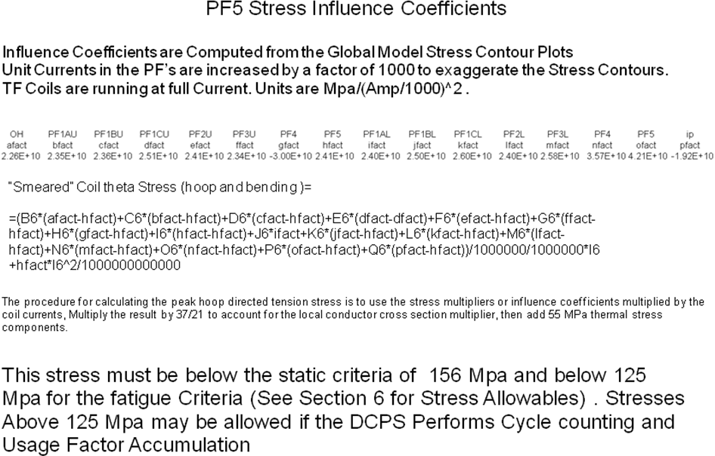

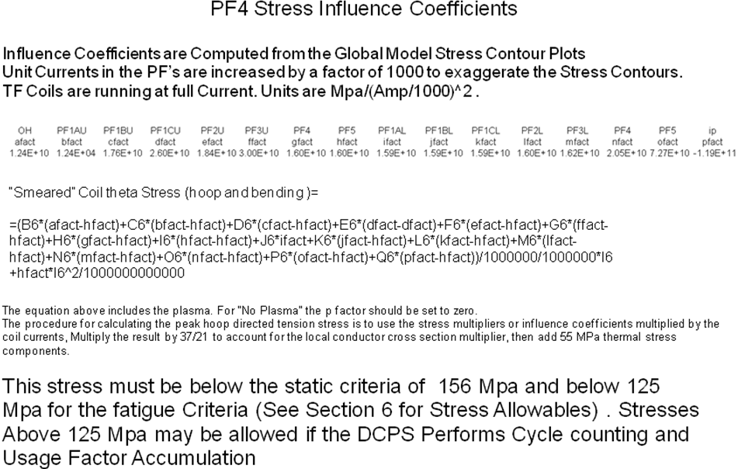

5.0 Introduction and Evolution of the Design

A number of structural concepts for the PF 4 and 5 supports have been considered and analyzed. Early in the upgrade effort "Worst Case Power Supply Loads" were used to size components. This led to a heavy support or frame intended to carry PF4 and 5 loads away from the vessel shell.
The expense of the outer PF frame – particularly the effort associated with removing diagnostics and instrumentation, power and coolant lines, to install the cage structure, led to the investigation of supporting the outer PF coils off the vessel. This is the original support concept used by NSTX. The re-categorization of the worst case current loads as “Extremely Unlikely” as described in the structural criteria document, has allowed consideration of less extensive modifications to the outer PF supports. In the this concept, stronger columns are being added to connect the upper PF4/5 grouping and PF4/5 lower groupings. The location for these six columns is chosen to be between the existing (small/weak) columns. These locations are judged less congested than the existing attachment points shows the PF 4/5 support column upgrade mounted on the vacuum vessel.

Upgrade operations will make more extensive use of PF4 and 5, for both current levels and pulse duration. For the upgrade scenarios, the coils will warm to temperature significantly above current operational values. The coil out-of round condition caused by the Joule heating of PF4 and 5 during normal operation is discussed in section 8.1. The structural concept chosen for the FDR and PDR uses radially restrained supports 180 degrees apart. This causes the coil to deform elliptically when energized and more significantly, when allowed to heat to 100 degrees C during a long pulse. Table 6.3-2 shows the maximum temperatures expected during upgrade operation.
At the PDR the columns were 5 inch in diameter and 1/2 inch thick.

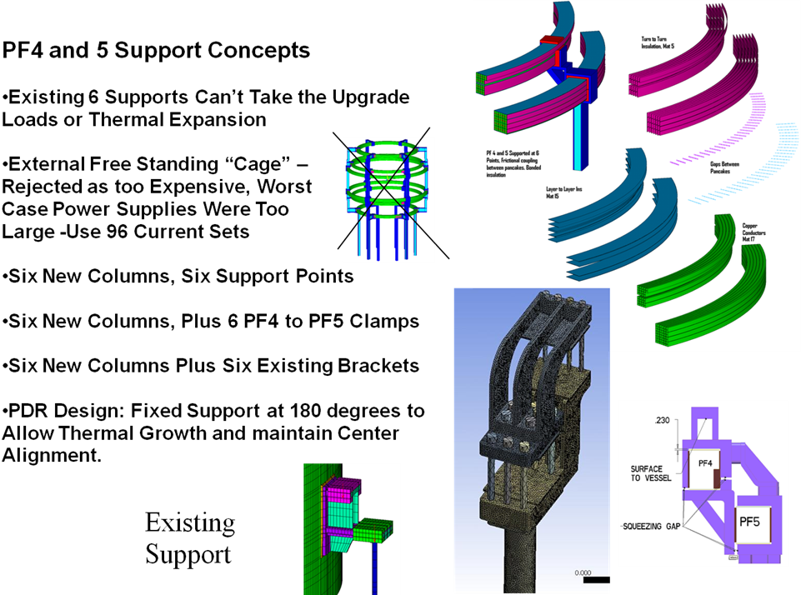
Figure 5.0-1 Earlier Concepts for Support of PF 4 and 5
6.0 Design Input,

6.1 References

[1] NSTX Upgrade Moment Influence Coefficients NSTXU-CALC-13-05-00Rev 0, Peter Titus, January 18 2011
[2] NSTX-CALC-13-001-00 Rev 1 Global Model – Model Description, Mesh Generation, Results, Peter H. Titus December 2010
[3] NSTX Structural Design Criteria Document, NSTX_DesCrit_IZ_080103.doc I. Zatz
[4] NSTX Design Point Sep 8 2009 http://www.pppl.gov/~neumeyer/NSTX_CSU/Design_Point.html
[5] OOP PF/TF Torques on TF , R. Woolley, NSTXU CALC 132-03-00
[6] "MHD and Fusion Magnets, Field and Force Design Concepts", R.J.Thome, John Tarrh, Wiley Interscience, 1982
[7] OH Conductor Fatigue Analysis NSTXU-CALC-133-09-00 Rev 0 Jan 7 2011 Peter Titus, PPPL
[8] Approximate Rubber Elastic Properties from Wikipedia:
Approximate Young's modulus for various materials^{[3]}
Material | GPa | lbf/in² (psi)
Rubber (small strain) | 0.01-0.1 | 1,500-15,000
[9] Analysis of Weld Stresses for Existing PF4/5 Supports, Memo to: Ron Hatcher, Larry Dudek, Danny Mangra, NSTX Distribution, From: Peter Titus Date: Feb 11 2010
[10] NSTX General Requirements Document (GRD)
[11] email from C. Neumeyer providing explanation of temperature specs in the Design Point Spreadsheet, Included in Appendix C
[12] April 5 2011 email from Jim Chrzanowski: PF 2,3,4,5 are all mylar wrapped then bstage fusifab

6.2 Criteria
Coil and structural criteria are outlined in "NSTX Structural Design Criteria Document", Zatz[3]

Criteria – Static Allowables for Coil Copper Stresses

The TF conductor properties are taken as representative of teh PF4 and 5 copper physicals. THe OH conductor is taken as representative of the fatigue performance of PF4 and 5. The TF copper ultimate is 39,000 psi or 270 MPa . The yield is 38ksi (262 MPa). Sm is 2/3 yield or 25.3ksi or 173 MPa – for adequate ductility, which is the case with this copper which has a minimum of 24% elongation. Note that the ½ ultimate is not invoked for the conductor (It is for other structural materials) . These stresses should be further reduced to consider the effects of operation at 100C. This effect is estimated to be 10% so the Sm value is 156 MPa. and the bending allowable is 233 MPa
- From: I-4.1.1 Design Tresca Stress Values (Sm), NSTX_DesCrit_IZ_080103.doc
- • (a) For conventional (i.e., non-superconducting) conductor materials, the design Tresca stress values (Sm) shall be 2/3 of the specified minimum yield strength at temperature, for materials where sufficient ductility is demonstrated (see Section I-4.1.2). *
- It is expected that the CS would be a similar hardness to the TF so that it could be wound readily. For the stress gradient in a solenoid, the bending allowable is used. The bending allowable is 1.5*156 or 233MPa,

• (d) For bolting materials, the design Tresca stress values shall be:
• 2/3 of the minimum specified yield strength at every point in time;
Ref. 3(Section III, Appendix III, Article III-2120) specifies 1/3
• Also, the component must meet ductility requirements which are to be established for each material not specified by Reference [3].
See Section I-4.1.4.3 for bolting stress limits.

I-4.1.4.3 Stress Limits for Bolting Material
For preload:
• Bolt preload stress shall not exceed the lesser of 0.75 Sy at room temperature or 0.75 Sy at operating temperature.

For operating loads:
• Average tensile stress due to primary loads shall not exceed 1.0 Sm.
• Maximum direct tension plus bending stress due to primary loads shall not exceed 1.5 Sm.

For preload combined with operation:
At any point in time, combined operating loads and preload shall be evaluated for compatibility with joint design but in any case the maximum direct tension plus preload stress shall not exceed 0.9 Sy.

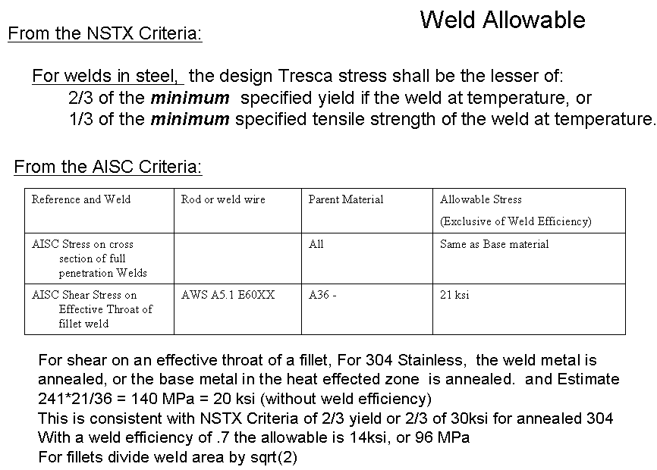

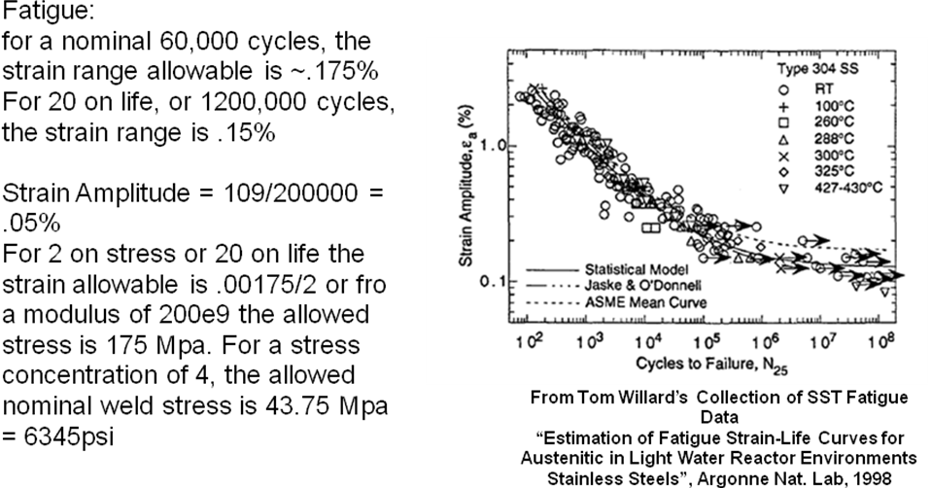

6.3 Coil Builds Forces and Temperatures from the Design Point

Table 6.3-1 Coil Builds from the Design Point
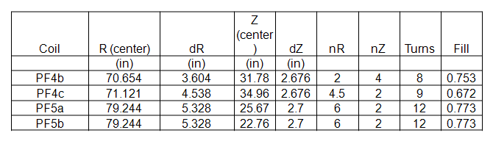
Table 6.3-2 Coil Temperatures from the Design Point
Coil | Tmax_LPPI | Tmax_SPFI
 | deg C | deg C
OH (half-plane) | 100 | 100
PF4b | 33 | 25
PF4c | 33 | 25
PF5a | 100 | 72
PF5b | 100 | 72

From an email from Charlie Neumeyer [11]:

"LPPI" is a term I came up to describe the nominal upgrade target, namely a 5 second (long pulse) plasma flat top where the OH current does not complete the second swing, only delivering part of its double-swing flux. The remaining flux is supplied non-inductively. Thus LPPI stands for "Long Pulse Partial Inductive".

"SPFI" is another operating mode I felt the need to describe because it forces the design to contend with the full second swing current. In this case the pulse has a flat top less than 5 seconds (short pulse) but the full OH double-swing flux is used and it is sufficient to drive the current without reliance on non-inductive means. In this case it turns out that the flat top duration is limited by the OH I2T, not the available OH flux, which is more than sufficient per my plasma model.

Table 6.3-2 Coil Forces from the Design Point

Fr(lbf) | PF4U | PF5U | PF5L | PF4L
Min w/o Plasma | -95013 | 82112 | 82136 | -95015
Min w/Plasma | -103764 | 142324 | 141288 | -103805
Min Post-Disrupt | -148517 | 37584 | 37596 | -148573
Min | -148517 | 37584 | 37596 | -148573
Worst Case Min | -147018 | -20953 | -20951 | -147020
Max w/o Plasma | 260098 | 507374 | 507445 | 260075
Max w/Plasma | 287106 | 625215 | 625286 | 287213
Max Post-Disrupt | 121449 | 363572 | 361490 | 121496
Max | 287106 | 625215 | 625286 | 287213
Worst Case Max | 468102 | 667642 | 667721 | 468078
Fz(lbf) | PF4U | PF5U | PF5L | PF4L
Min w/o Plasma | -203072 | -239929 | -49698 | -78007
Min w/Plasma | -171095 | -150201 | -145201 | -63411
Min Post-Disrupt | -89212 | -203095 | -20016 | -133935
Min | -203072 | -239929 | -145201 | -133935
Worst Case Min | -415803 | -506937 | -181134 | -74506
Max w/o Plasma | 78007 | 49698 | 239929 | 180275
Max w/Plasma | 63403 | 145201 | 150218 | 148314
Max Post-Disrupt | 133920 | 20017 | 203119 | 89222
Max | 133920 | 145201 | 239929 | 180275
Worst Case Max | 149049 | 181133 | 506937 | 415804

Table 6.3-2 Loads from Earlier (PDR) Design Point Spreadsheet
 | Fz(lbf) | PF4U | PF5U | PF5L | PF4L
 | Min | -204724 | -241452 | -50636 | -85361
 | Worst Case Min | -423491 | -523610 | -191878 | -151945
 | Max | 85361 | 50636 | 241452 | 186601
 | Worst Case Max | 151945 | 191878 | 523610 | 423491

6.5 Materials Properties

Material | Yield  4 deg K (MPA) | Ultimate 4 deg K,  (Mpa) | Yield, 80 deg. K (MPa) | Ultimate, 80 deg. K (MPa) | Yield, 292 deg K (MPa) | Ultimate, 292 deg K (MPa)
304 SST 50% CW |  |  | 1344 (195 ksi) | 1669 | 1089 | 1241
304 Stainless Steel (Bar,annealed) | 404 | 1721 | 282 | 1522 | 234 | 640
Coil Structure Room Temperature (292 K) Maximum Allowable Stresses, Sm = lesser of 1/3 ultimate or 2/3 yield, and bending allowable=1.5*Sm
Material | Sm | 1.5Sm
304 Stainless Steel (Bar,annealed) | 156MPa(22.6ksi) | 234 MPa (33.9ksi)

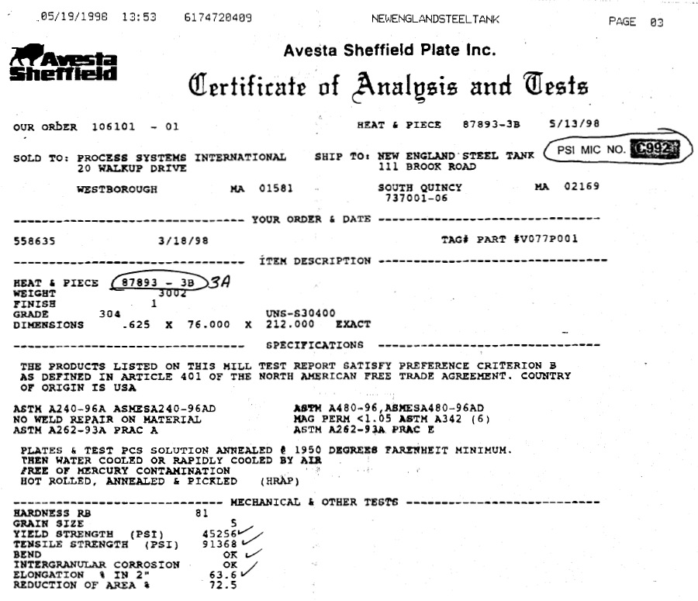
Vessel Material Mill Certifications for the 304 Vessel Show a 45 ksi Yield

ASTM A193 Bolt Specs from PortlandBolt.com
B8M | Class 1 Stainless steel, AISI 316, carbide solution treated.
B8 | Class 2 Stainless steel, AISI 304, carbide solution treated, strain hardened
B8M | Class 2 Stainless steel, AISI 316, carbide solution treated, strain hardened

Mechanical Properties
Grade | Size | Tensile ksi, min | Yield, ksi, min | Elong, %, min | RA % min
B8 Class 1 | All | 75 | 30 | 30 | 50
B8M Class 1 | All | 75 | 30 | 30 | 50
B8 Class 2 | Up to 3/4 | 125 | 100 | 12 | 35
B8 Class 2 | 7/8 - 1 | 115 | 80 | 15 | 35
B8 Class 2 | 1-1/8 - 1-1/4 | 105 | 65 | 20 | 35
B8 Class 2 | 1-3/8 - 1-1/2 | 100 | 50 | 28 | 45
B8M Class 2 | Up to 3/4 | 110 | 95 | 15 | 45
B8M Class 2 | 7/8 - 1 | 100 | 80 | 20 | 45
B8M Class 2 | 1-1/8 - 1-1/4 | 95 | 65 | 25 | 45
B8M Class 2 | 1-3/8 - 1-1/2 | 90 | 50 | 30 | 45

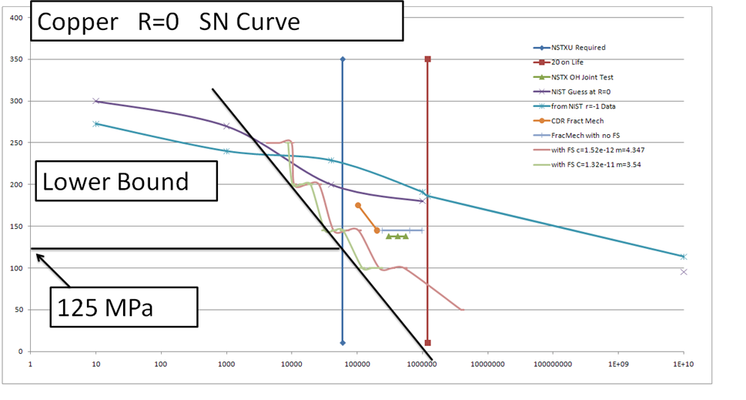
SN Curve developed for the OH coil in ref [7]

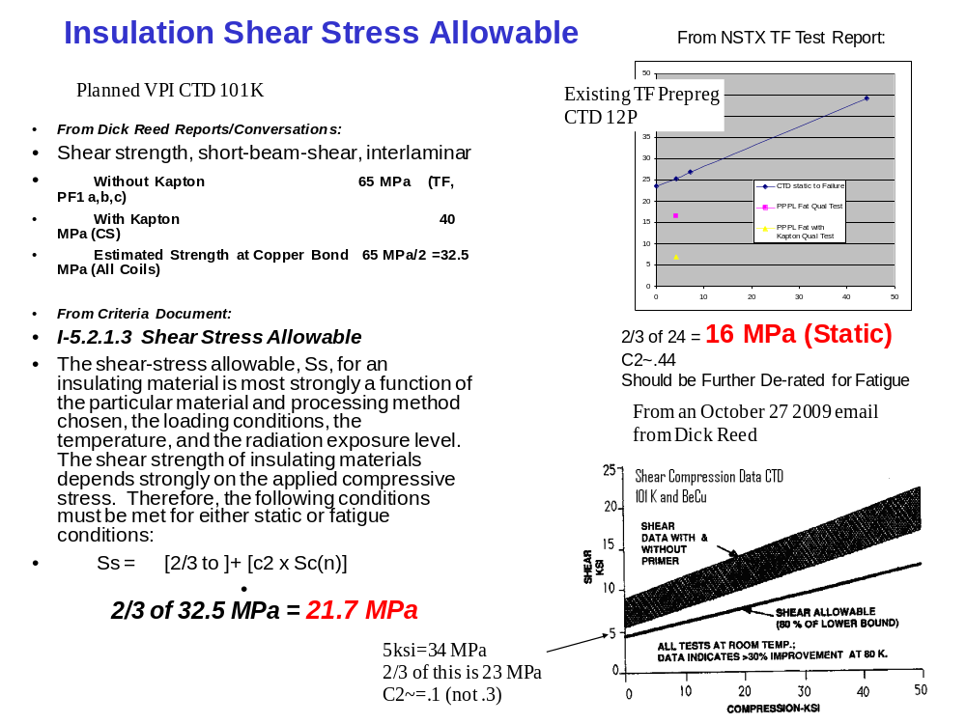

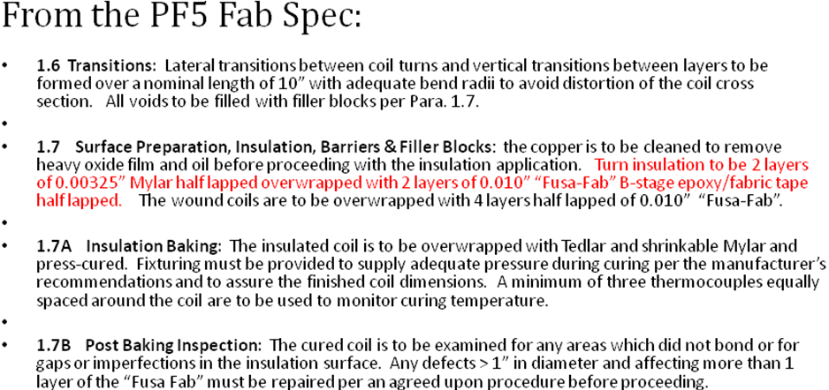

6.3 Coil Geometry and Currents

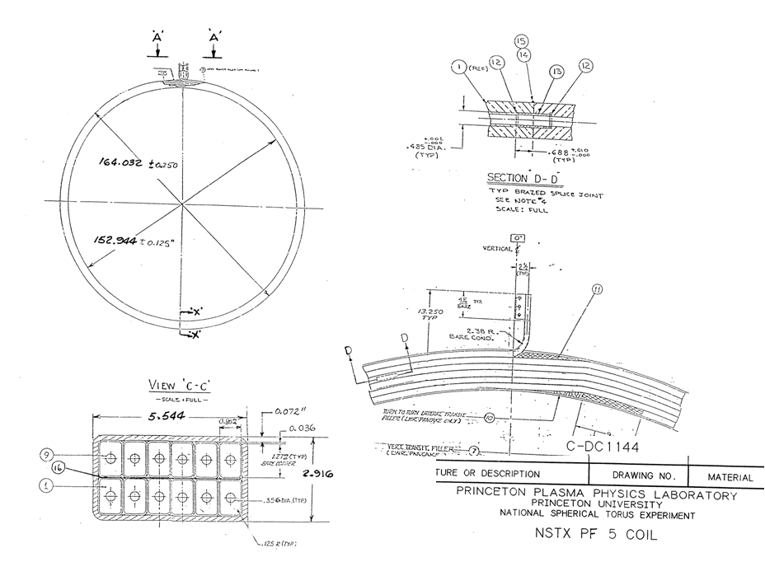

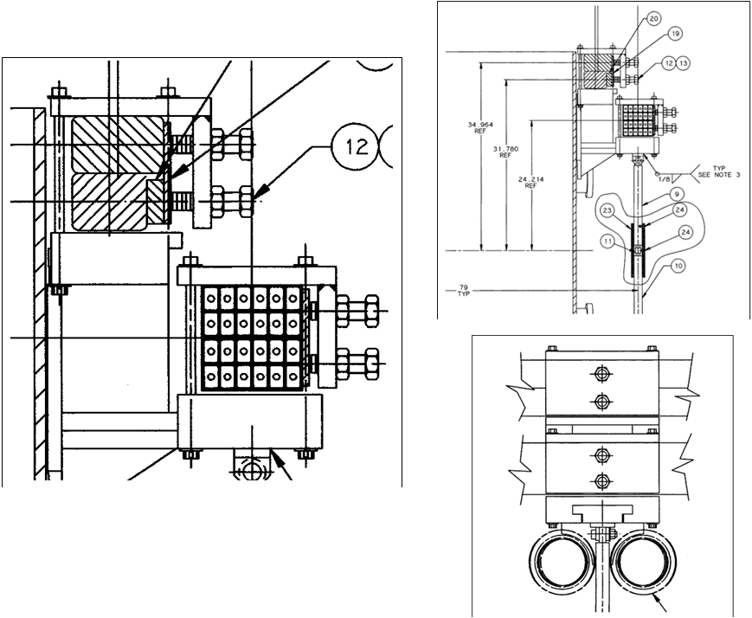

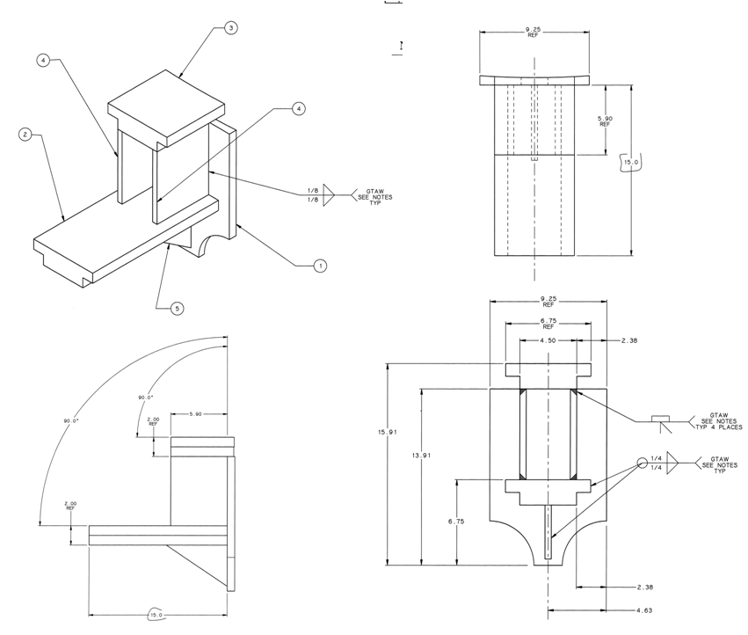
Type B Bracket Details
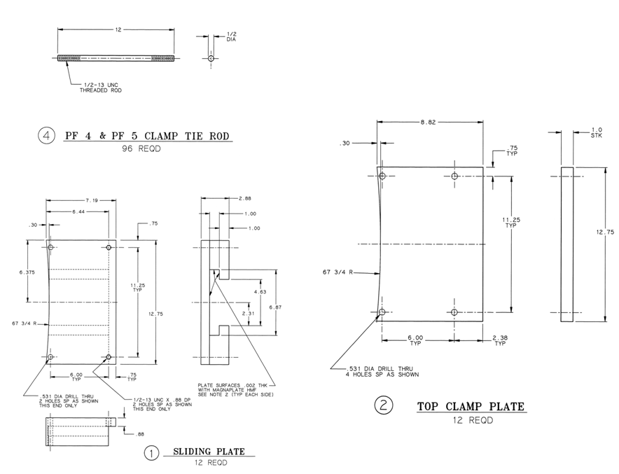
Existing Coil Clamp Details

6.6 Elastic Constants, Thermal Expansion Coefficients
There are no composite or orthotropic moduli used in these models. Isentropic moduli are listed below:

*do,imat,1,100
ex,imat,200e9
alpx,imat,17e-6
r,imat,10e8
*enddo
ex,90,1e9
ex,3,20e9
ex,5,20e9
ex,6,2e6
ex,7,2e6
ex,17,110e9
mu,6,.3
7.0 Coil and Support Model

The analysis model used for both the coils and support details is a quarter symmetry model. The vertical symmetry plane cuts through the two radially fixed supports which are two of the existing sliding block supports that have been locked. Equatorial plane symmetry is also imposed, so net vertical loading must be addressed in the global model [1]. Coil loads have been calculated from combinations of coil full current levels. Other coils are not included in the Lorentz calculations. for this model. Effects of the other coil currents is addressed in other models - the global model [2] and exercising the DCPS multipliers for the latest scenarios, with and without the plasma. The model discussed in this section includes the coil cross section pancake structures and individual conductors and insulation layers. It was expected that the self attractive loads between pancakes would affect their ability to support bending moments due to vertical loading. The coils are supported at discrete support brackets and columns around the perimeter of the coils. In order to include the flexibility of the vessel shell, and evaluate the weld stresses of the attachments to the vessel, a portion of the vessel shell is included.
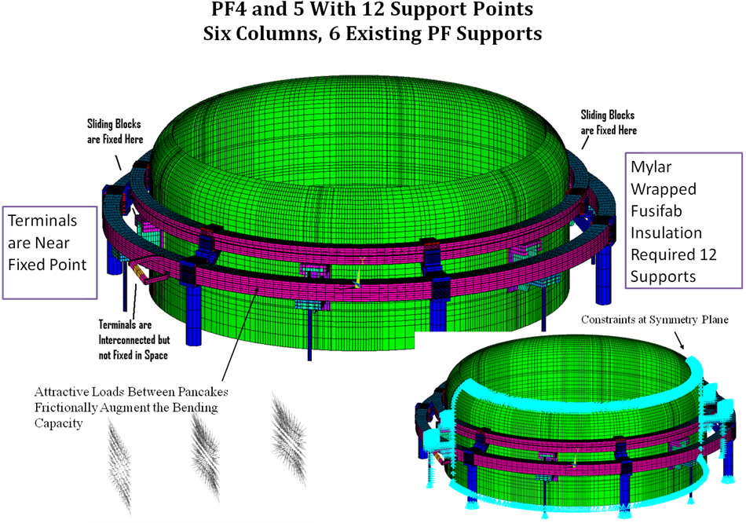

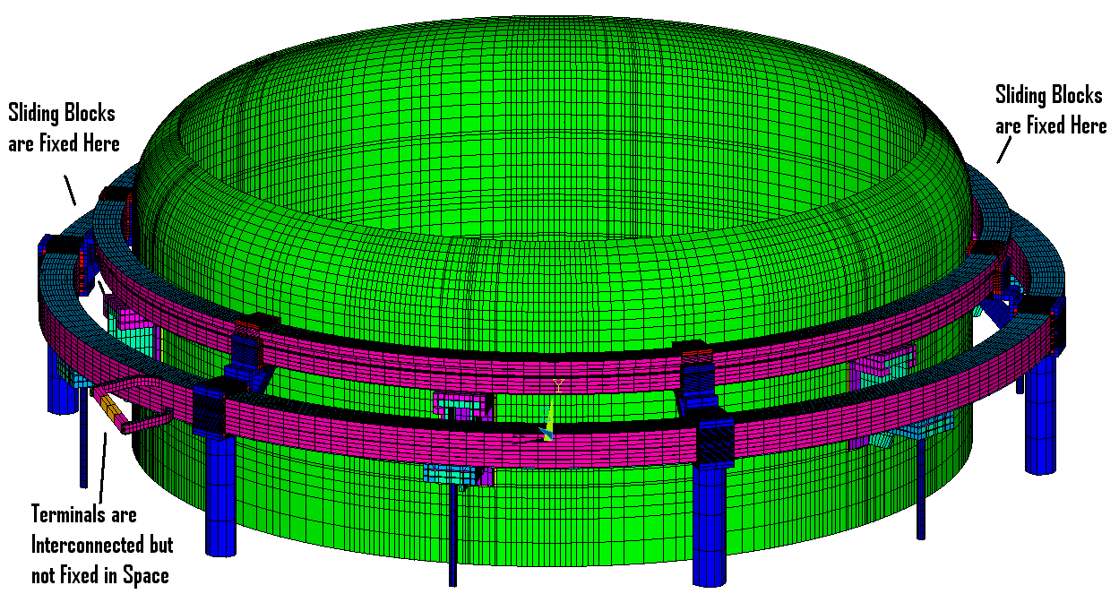Model of the PF4 and 5 supports Support Column Upgrade Mounted on the Vacuum Vessel

The mesh generation and calculation of the Lorentz forces is done outside of ANSYS using a code written by the author of this report. The mesh generation feature of the code is checked visually and within ANSYS during the PREP7 geometry check. . The authors code uses a Biot Savart solution for field calculations, based on single stick field calculations from Dick Thome's book [6] with some help from Pillsbury’s FIELD3D code to catch all the coincident current vectors, and other singularities. The analysts in the first ITER EDA went through an exercise to compare loads calculated by the US, RF and by Cees Jong in ANSYS, and that the US analyses were “OK”. Agreement was not good on net loads on coils that should net to zero – all the methods had some residuals, but summations on coil segments agreed very well. code Some information on the code, named FTM (Win98) and NTFTM2 (NT,XP), is available at: http://198.125.178.188/ftm/manual.pdf ).
7.5 Provisions for Differential Thermal Growth of PF4 and 5 - Results for the Link Concept

From the NSTX Design Point Spreadsheet, [4] the max temperature innPF4 is 33 degrees and PF5 is 100 degrees. The design Point Summary of these temperatures is included in Section 6.3.

While the link concept is not being used, as a mechanism, it provides the needed degrees of freedom to allow independent thermal expansion of PF4 and 5. In the present FDR design, a sliding T slot or dovetail joint is used similar to the sliding joint used in the existing support. j
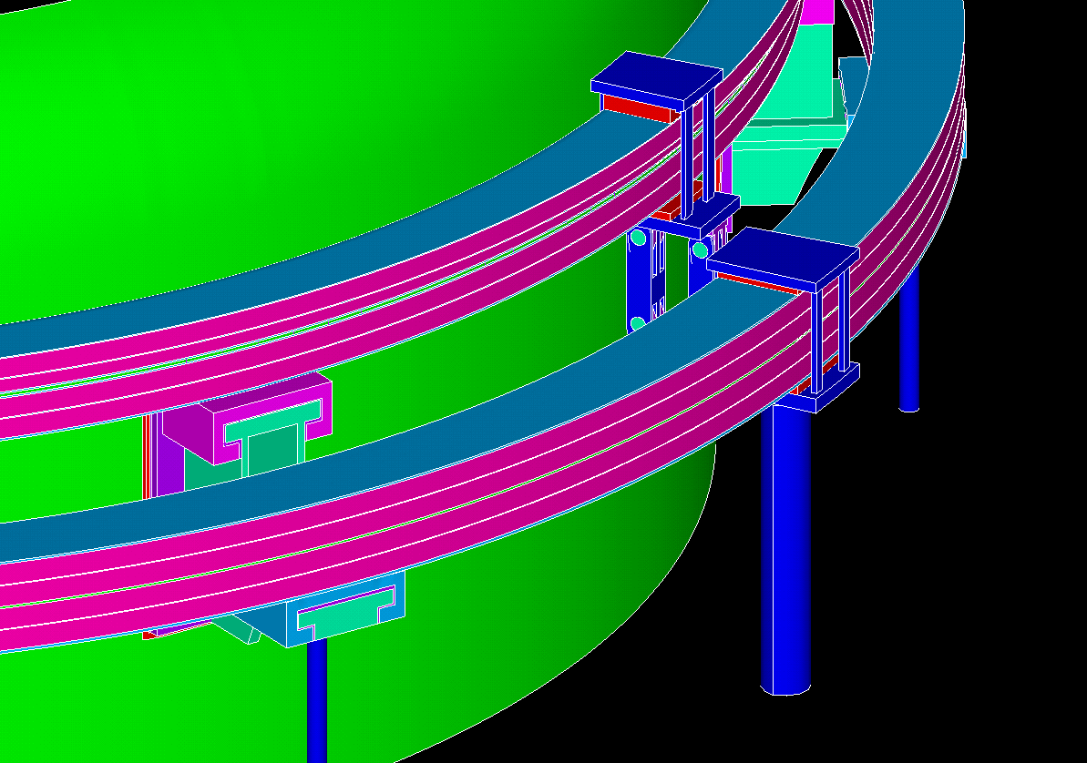

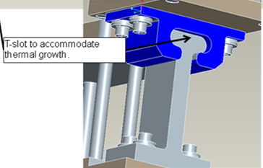

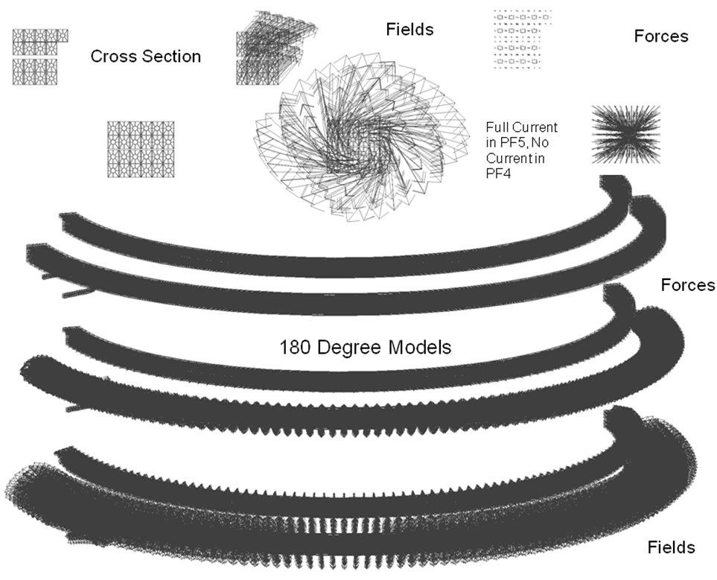

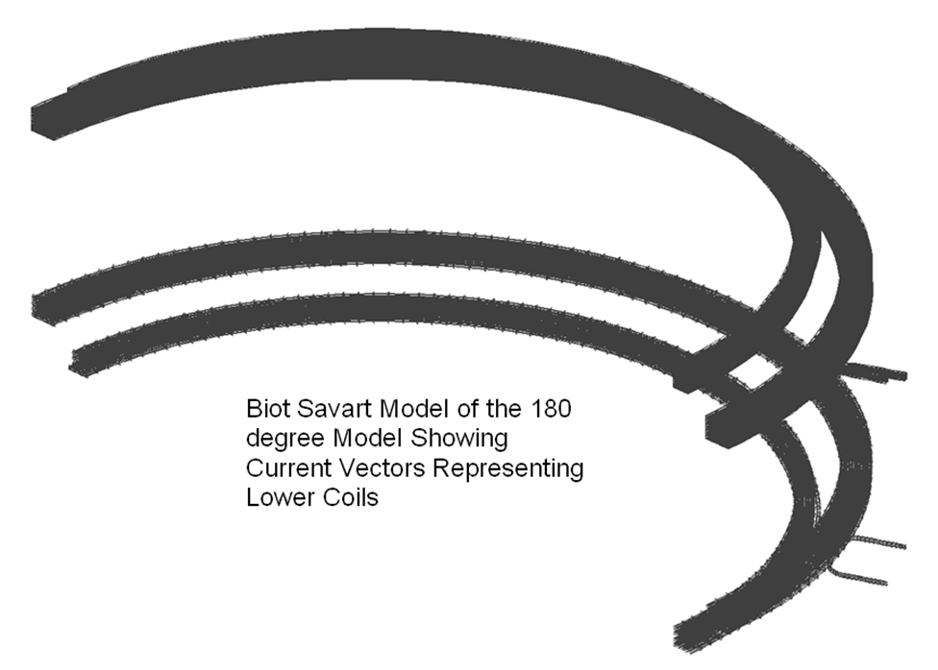

7.4 Run Log Files and File Locations

run files and some results will be put on the pdrive.

P drive:
P:\public\Snap-srv\Titus\NSTX\CSU\PF45Sup

ptitus-64pc
Clam03.txt, f:\nstx\csu\PF45Sup
\nstx\csu\pf45sup\Dove01.txt April 2011
\nstx\csu\PF45Sup\Coib03\ Coib05.txt, Link concept that allows differential thermal growth between PF4 and 5

Laptop
OuterPFs/ProE Existing support
OuterPFs/RonHatcher Existing support Weld Influence Coefficients
OuterPFs/Thermal Bake-out Thermal Gradient around existing support

Titus_64 (Andrei's Computer)
e:\run27 Latest Global Model Files
e:\nstx\csu\pf45Sup Larry's Model

8.0 PF 4 and 5 Results
8.1 Displacement Results

PF4 and 5 have to be aligned with respect to the centerline of the plasma. The current (meaning prior to the upgrade) approach is to connect" pushers and clamps around the coils to push the coils into roundness and concentricity. Currently coil heat up is trivial. For the upgrade the coils will be on for the 5 sec. pulse and will heat to 100C -expanding and fighting the alignment clamps. We consulted with John Menard and Masa Ono. An n=2 error i.e. an elliptical coil is acceptable as long as it is aligned with the plasma centerline - i. e it precludes a n=1 error. So the coils are radially held with respect to the vessel and have them grow into an oval. I presented the degree of ovality at our Wed. meeting and Jon and Masa accepted it.
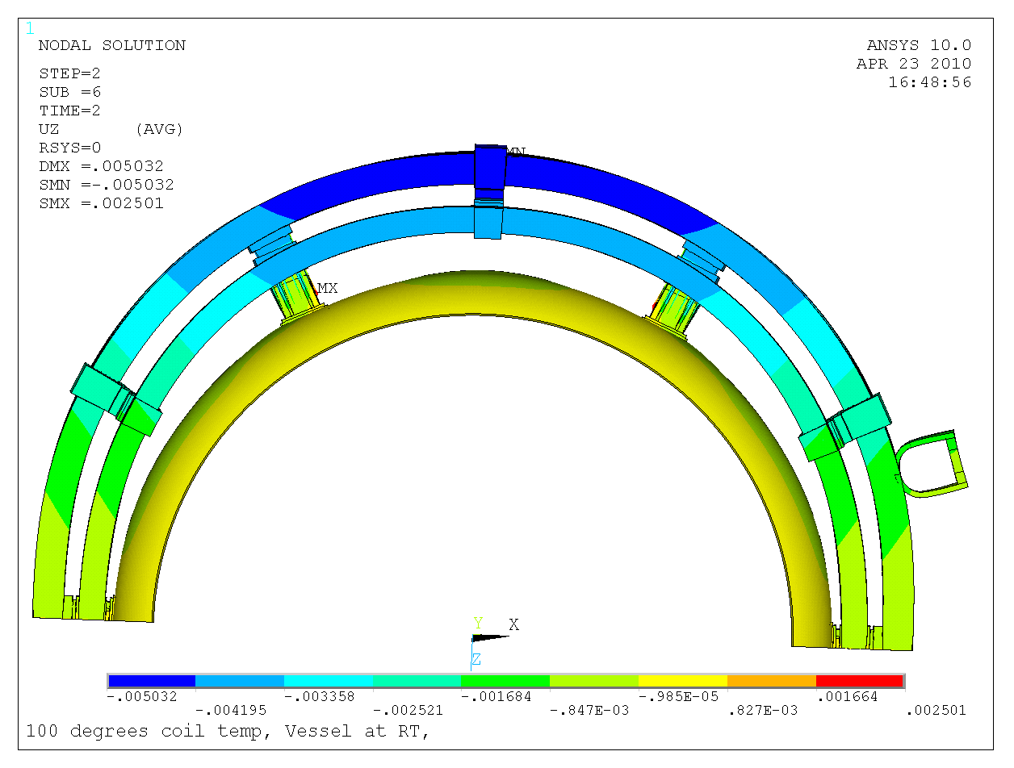
Figure 8.1-1 Coils held radially at left and right. Existing supports free to slide. Coils at 100C

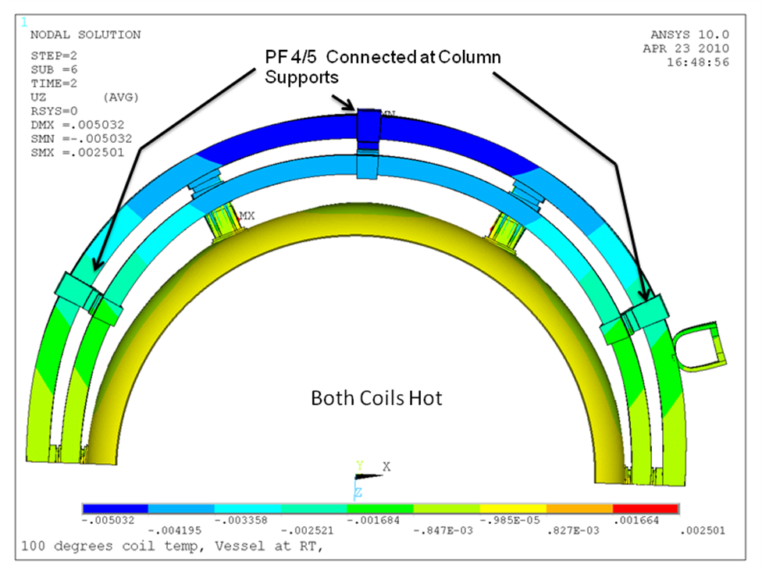
Figure 8.1-2 Coils held radially at left and right. Existing supports free to slide. Coils at 100C

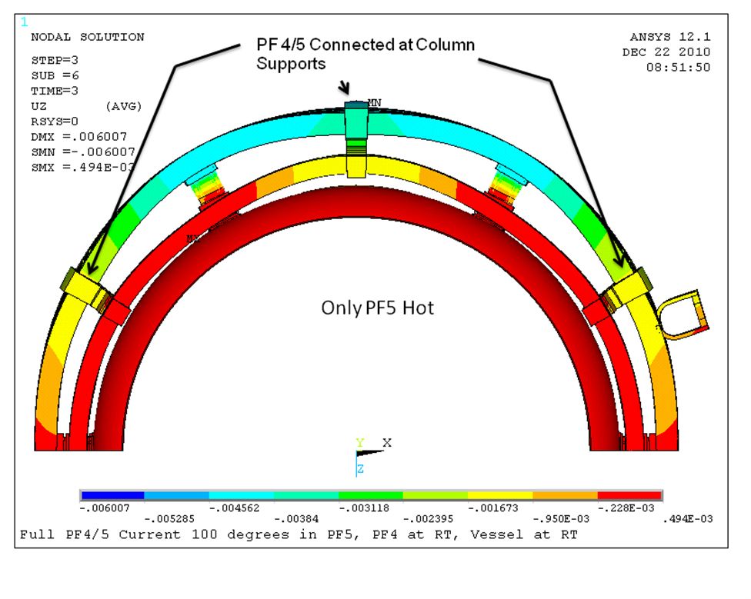
Figure 8.1-3 Coils held radially at left and right. Other supports free to slide. PF5 at 100C, PF4 and 5 clamped together at added support columns
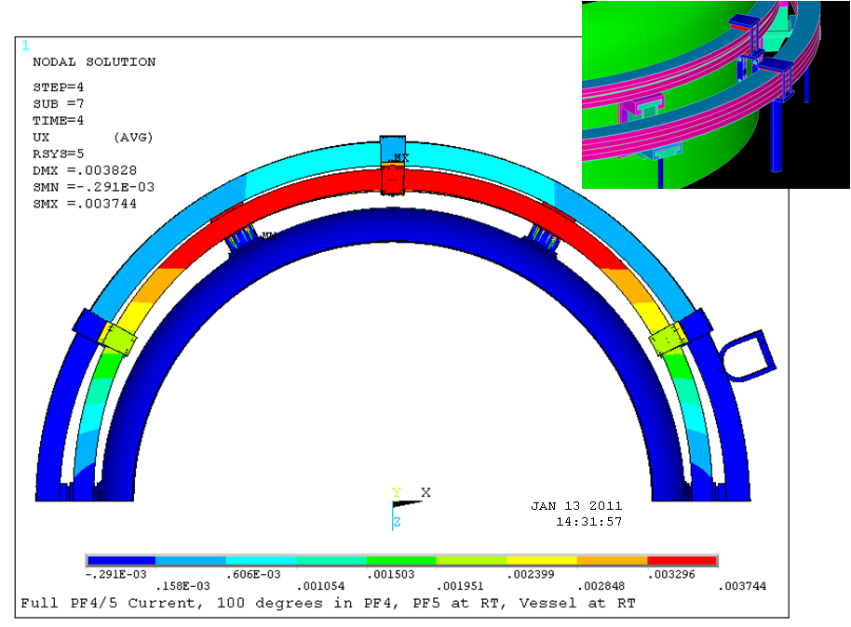
Figure 8.1-4 Coils held radially at left and right. All Other supports free to slide. PF4 and5 at 100C

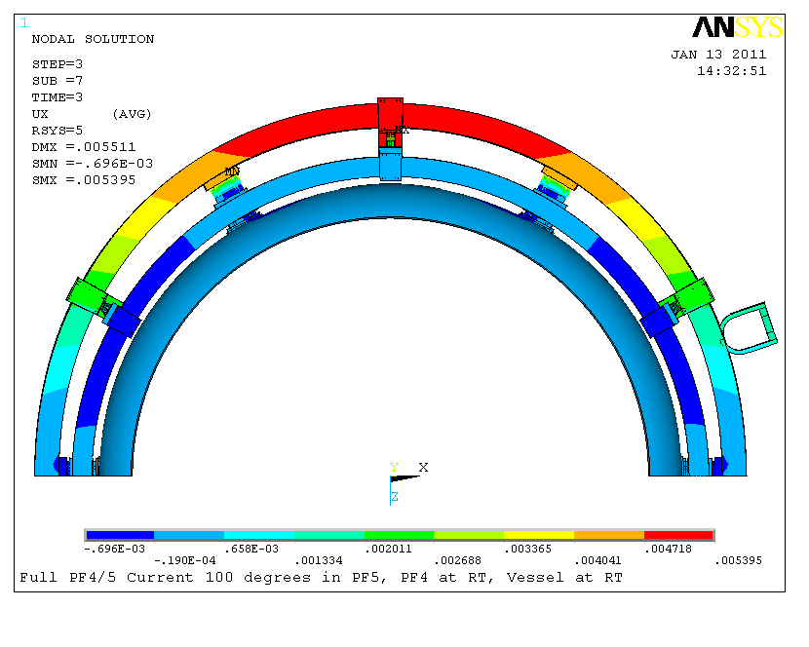
Figure 8.1-5 Coils held radially at left and right. All Other supports free to slide. PF5 at 100C, PF4 at RT

8.2 PF 4 and 5 Coil Conductor Stress Results

The global model, ref[2] produces stress results for the 96 scenarios and for cases with and without the plasma. The coils in this model are "smeared" and do not include the effects of the details of the conductor cross section - insulation layers and coolant holes. The smeared Von Mises Stress values in the figure below are modest - 57 MPa, 63 MPa, 62 and 60 MPa. for scenarios 3,13,33,and 43 steps These are scenarios run without plasma. The thermal effects of warm expanded coils are not included in the global model. These are simulated in the model which has winding pack details and the mechanics of the sliding connections at the new column locations.
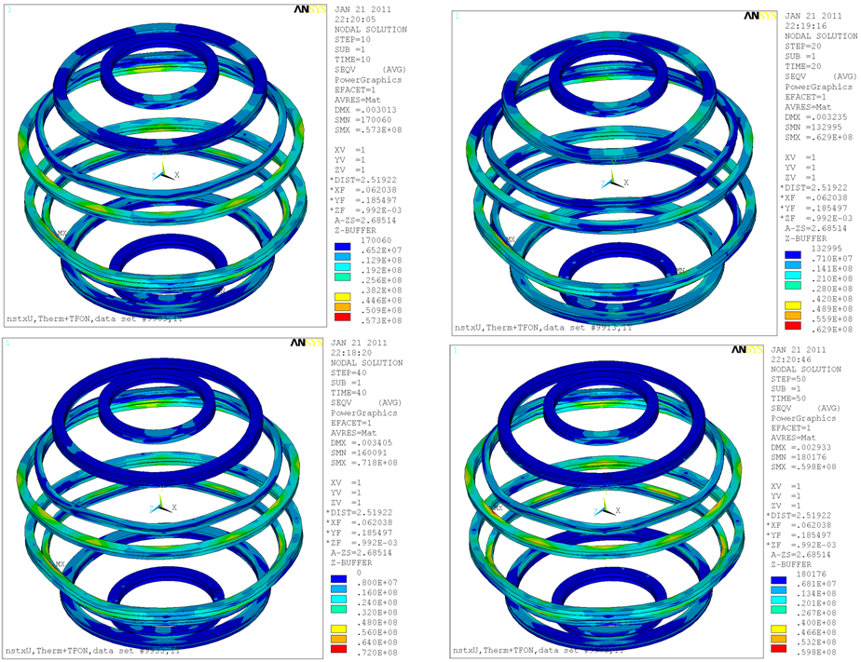

In order to assess the effects of the latest scenarios the DCPS stress multipliers offer an attractive method of keeping up with the evolution in the design point spreadsheet currents. These latest GRDS requirements include with and without plasma, and variations in plasma shape and disruption inductive coupling of the coils with the decaying plasma.

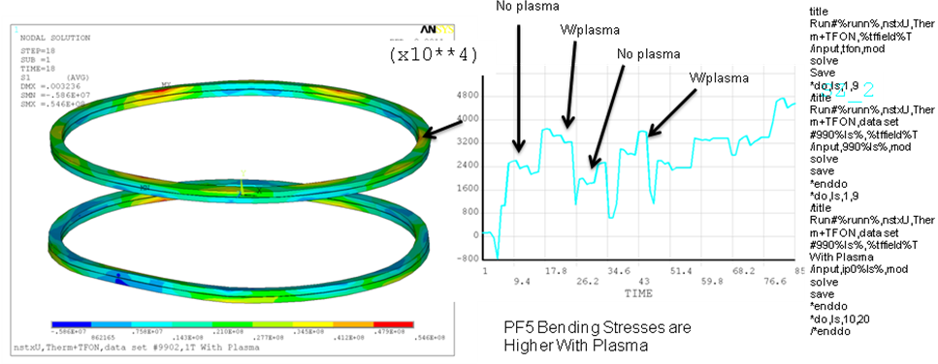
Coil Conductor Stress
The stress in the conductor for Lorentz Loads and thermal loads with PF4 and 5 at the same temperature, is shown below. Peak stresses are where the coils are restrained radially at the existing clamps near the lead and 180 degrees away from the lead.

The Sm value for the coil cold worked copper is expected to be similar to the TF specs or Sm is 156 MPa. and the bending allowable is 233 MPa (See the criteria in section 6). Fatigue is addressed in section 11. Peak Stresses below are all above the 233 MPa limit.
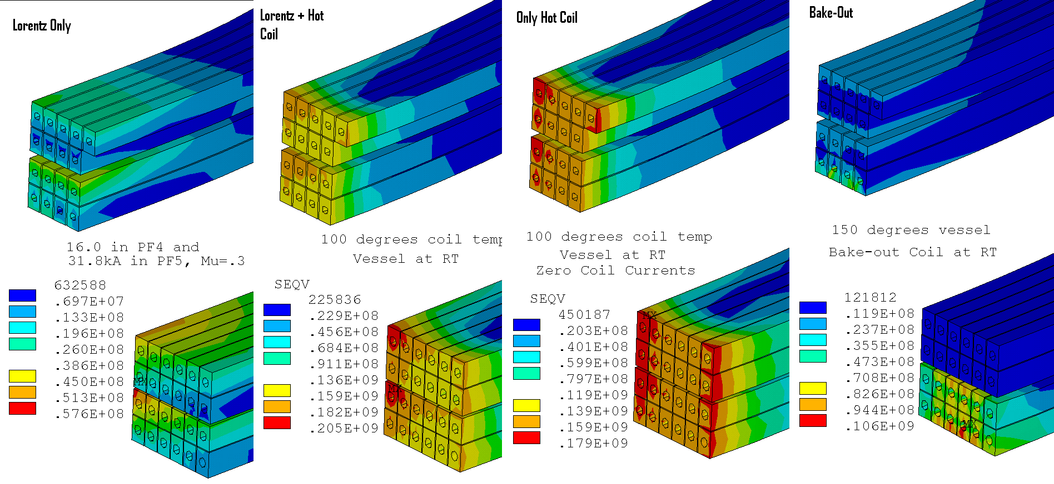

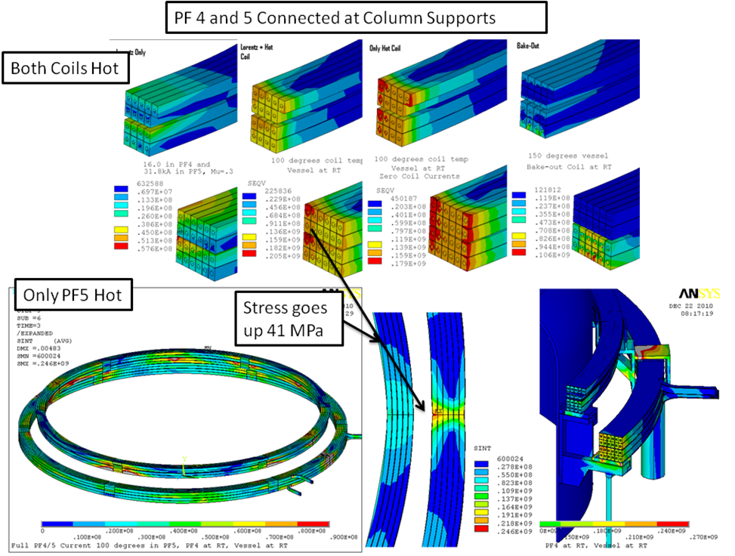
With PF4 and 5 rigidly connected at the added support column locations, and only PF5 hot, the stress goes up 41 MPa. and is above the 233 MPa static limit.
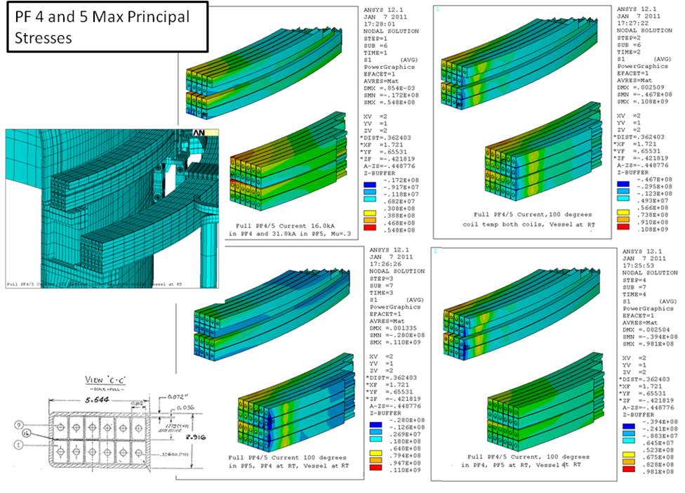
Conductor stress with a mechanism to allow differential radial motion of PF4 and 5

8.3 PF4 and 5 Coil Insulation Stress

Insulation Stress or more properly insulation shear displacements were an important concern that led to the adoption of 12 support points for the coils. The insulation system used for the PF5 coil is a mylar wrapped Fusifab Epoxy system that is expected to have minimal bond strength. Analysis of a support concept that utilized six new support columns, and did not rely on the existing support brackets is discussed in Appendix A. This produced large copper bending stresses
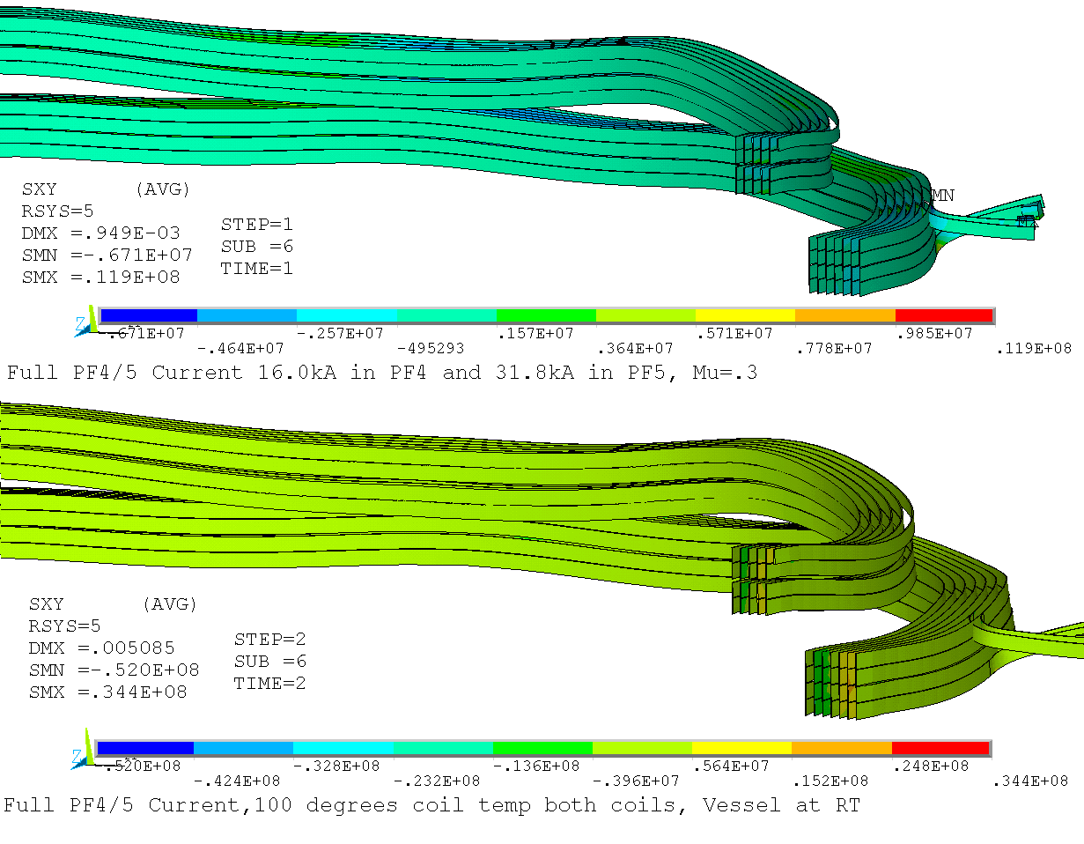

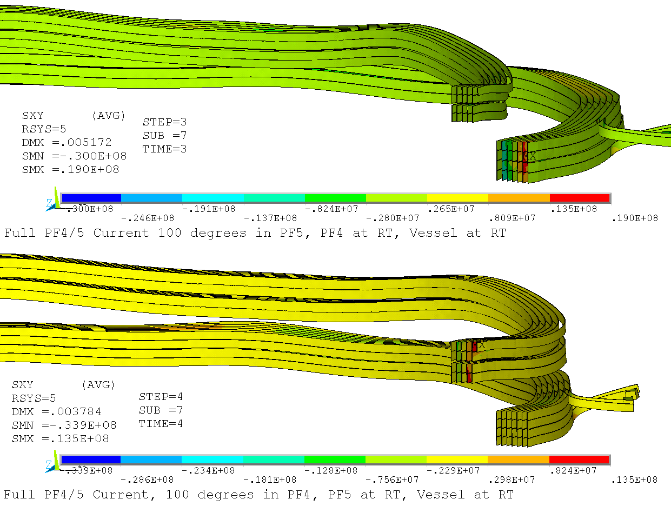

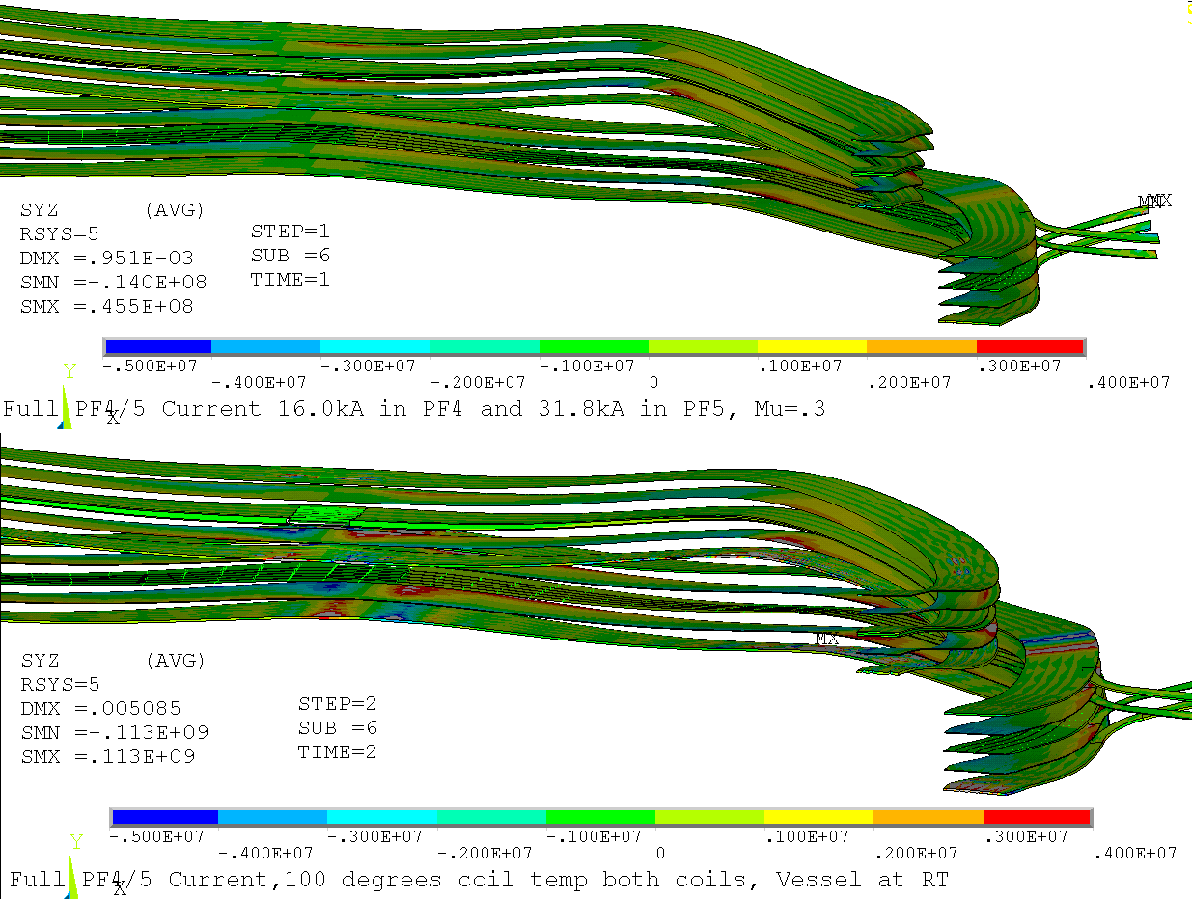

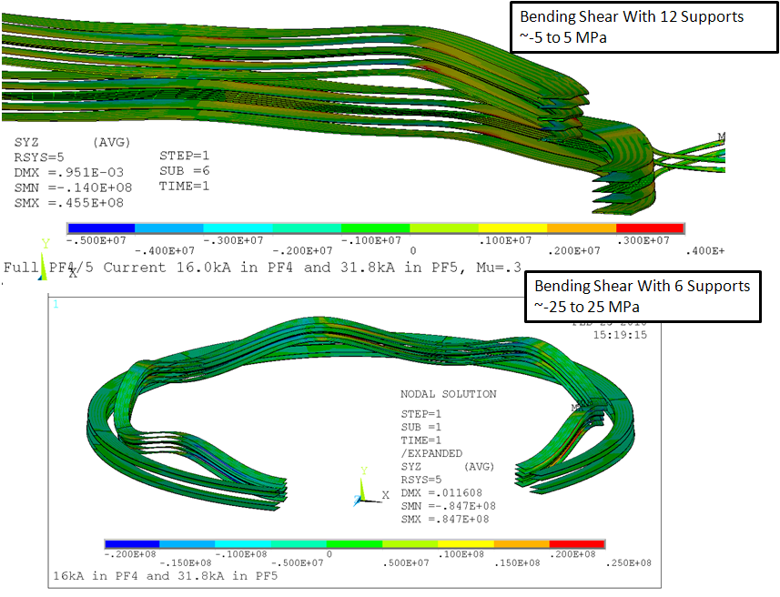

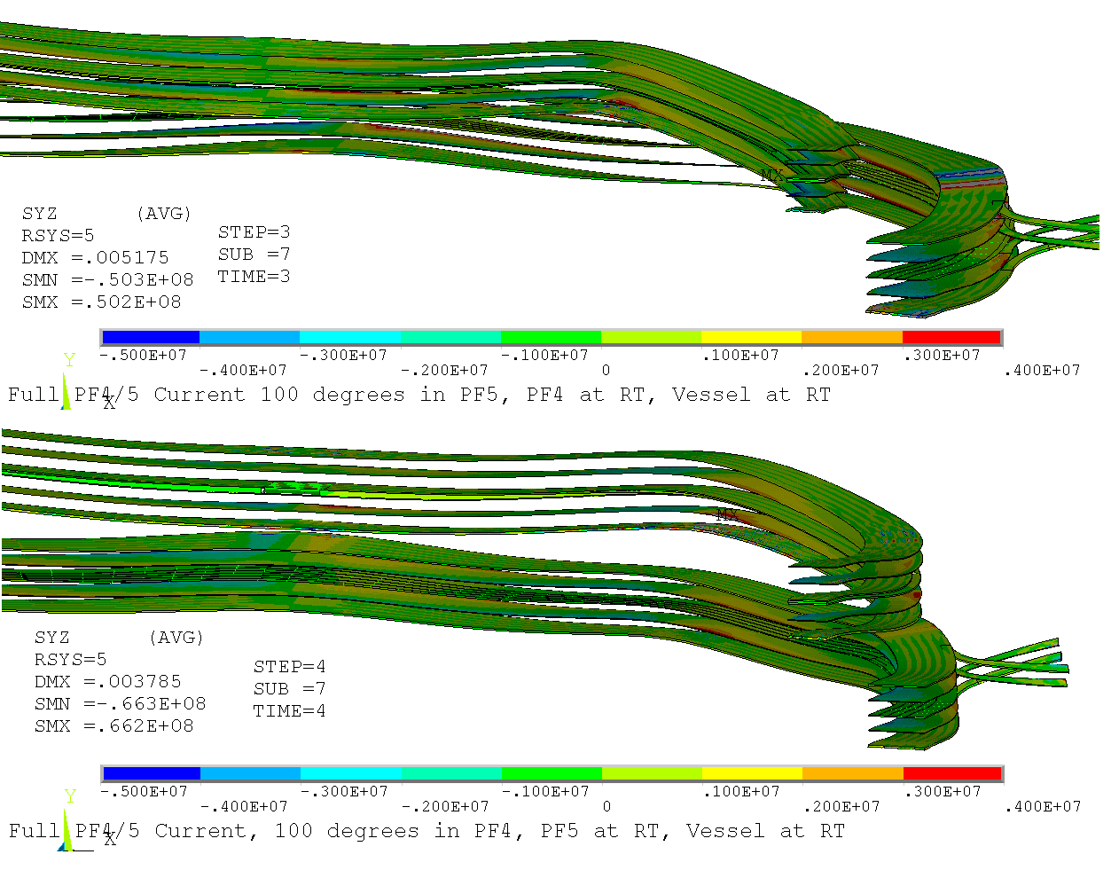

Lowering insulation stress was a significant driver in the decision to provide 12 support points. In the figure above the shear stress due to bending between supports is reduced from about 25 MPa to 5 MPa in PF4. PF4 is divided into two pancakes and interacts strongly with PF5. With PF4 and 5 Upper and lower coils energized, PF4U is loaded downward and PF5 is attracted both the PF4 U and the PF4/5 lower pair. For this loading the bending load in PF4 is most severe, and the bending in PF5 is moderate. PF4 pancakes partially separate and the local self load does not provide any frictional shear between pancakes to engage the full section of the coil. Both PF4 and 5 use the fusifab/mylar epoxy system that will have minimal epoxy bond shear strength. Even the 1 or 2 MPa in the bulk of the coils for the12 support FDR concept may be too much to eliminate sliding. Demonstration of acceptable copper stresses, small shears and displacements will have to be sufficient to qualify the coils.

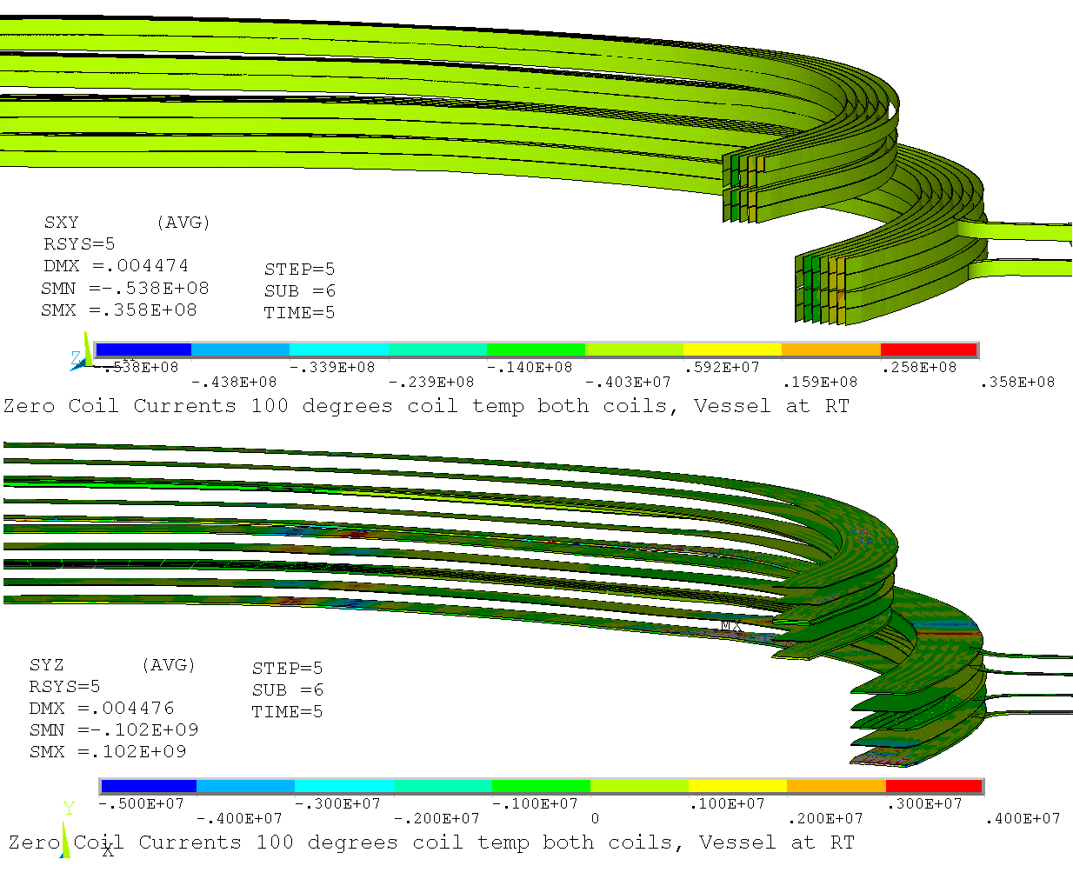

8.6 TF Ripple Loads on PF 4 and 5

PF 4 and 5 pass by the TF outer leg. The local toroidal field at the outer TF legs impose periodic torques on the neighboring PF coils. The torques add bending stress that adds to bending stresses which result from the discrete coil support points. The ripple effect is being quantified independent of other loading. To accomplish this, the Lorentz Loads are quantified with and without the TF current and the two files are differenced to obtain loading for only the effect of the TF currents.

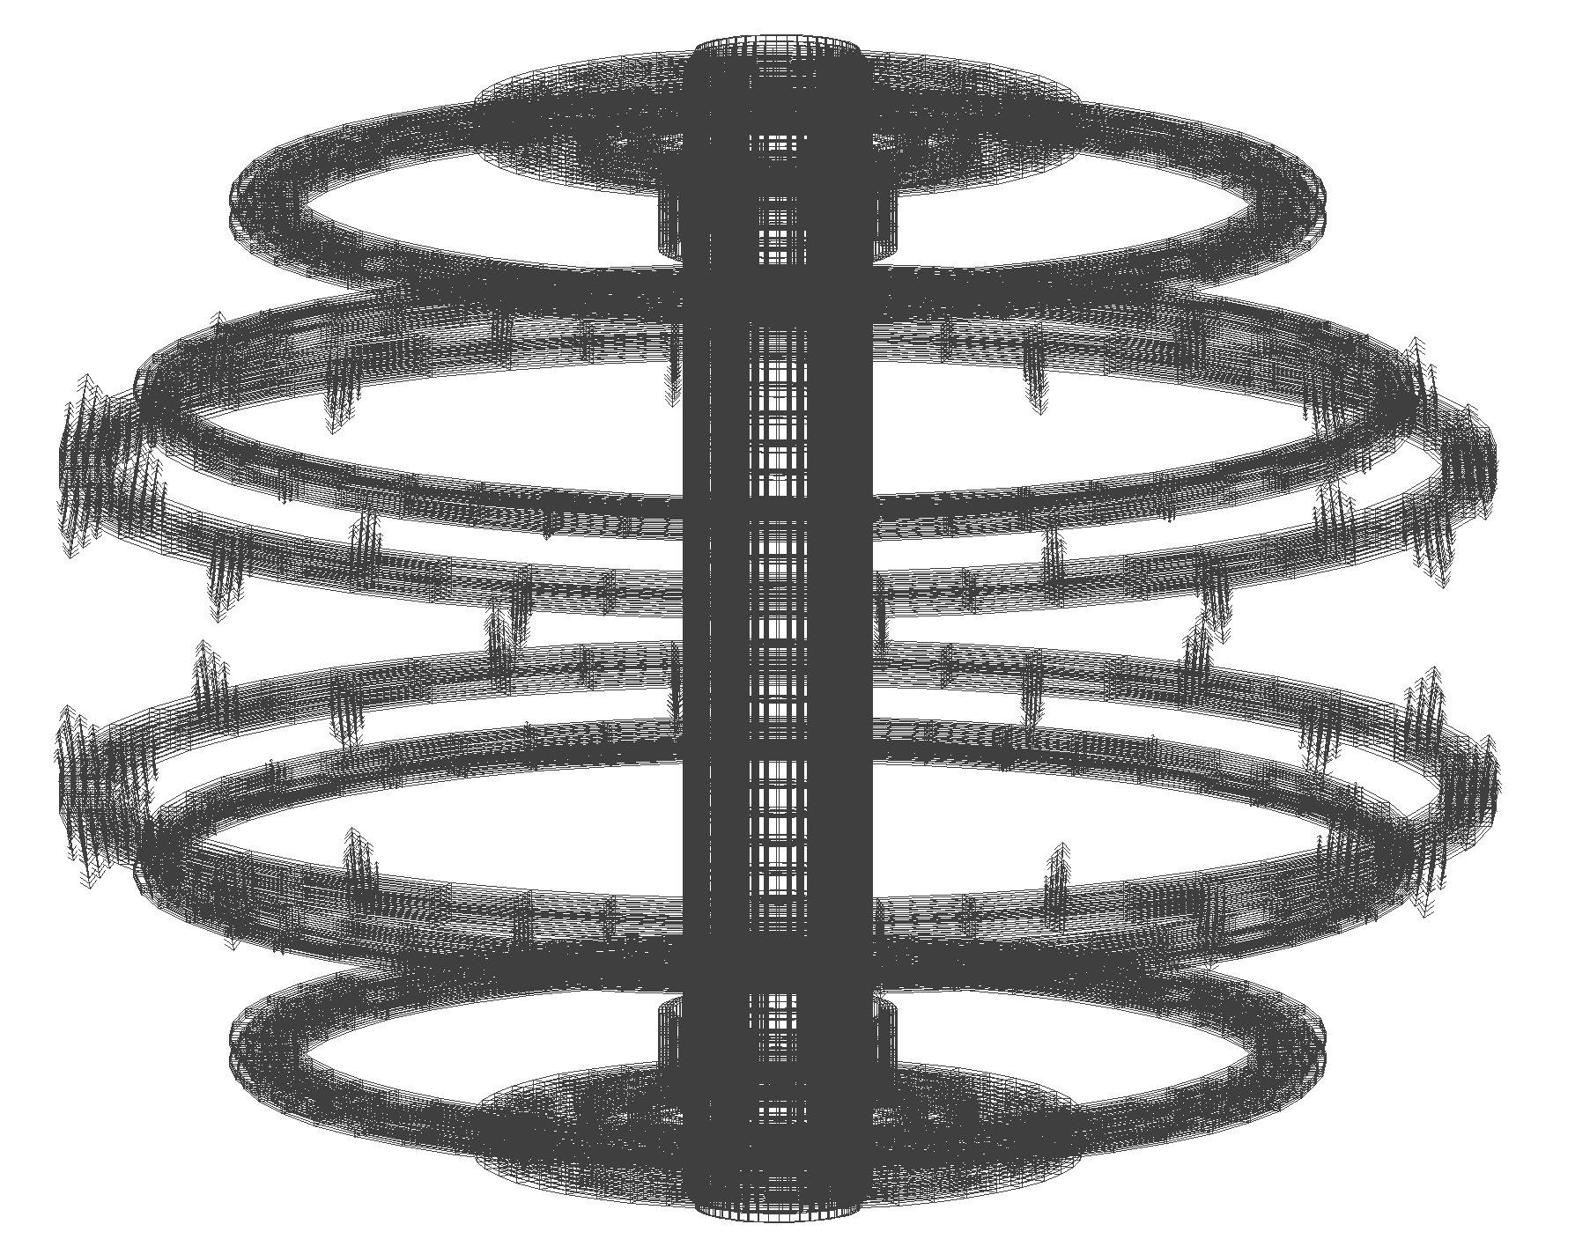
The Result of the Subtraction of (PF+TF) Load File and (PF Only) Load File, with only the PF coils plotted.. Only the effect of the TF on the PF remain.

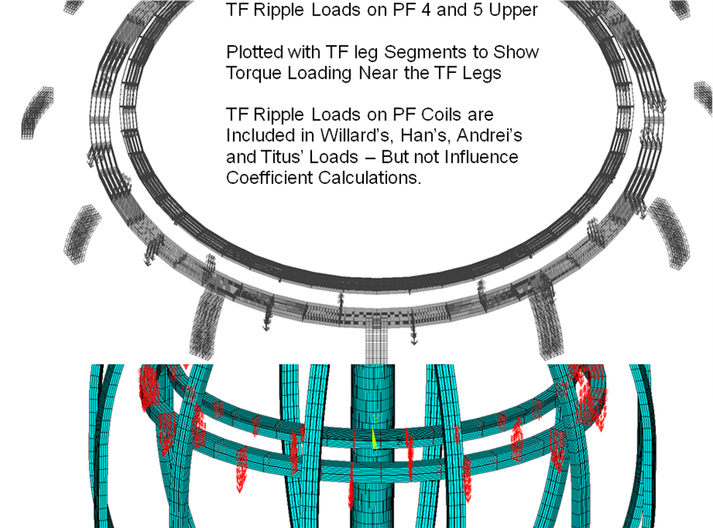

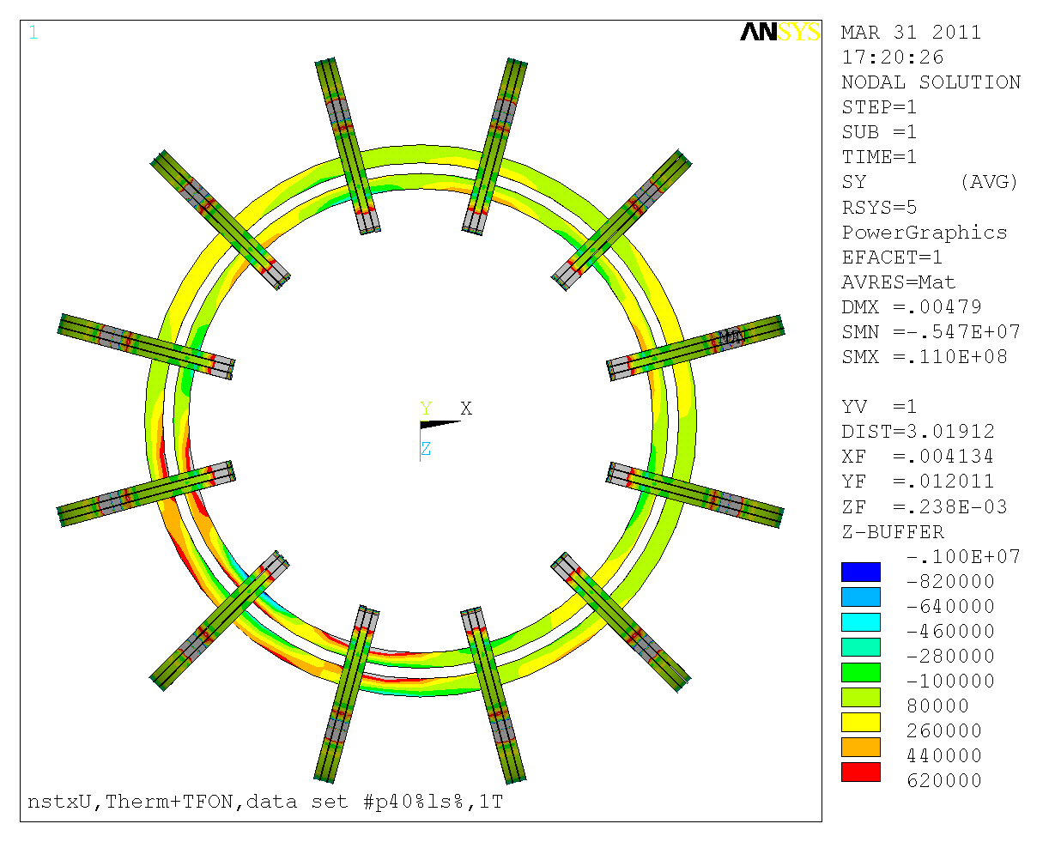
Hoop Directed Stress - Bending Stress Due to TF Ripple. -Less then 11 MPa most locations. The asymmetry is due to local support bracket and port modeling.

9.0 Digital Coil Protection System Input
Figure 9.1= Linear Global Model Used in Calculating DCPS Stress Multipliers, Ref [2]

The approach used for the PF4 and 5 coils for calculating the stress multipliers/algorithms is to utilize a global model [2] that simulates the whole structure and includes an adequately refined modeling of the component in question. Unit terminal currents are applied to each coil separately, Lorentz loads are calculated, and the response of the whole tokamak and local component stress is computed. This approach is correct for stresses that are a consequence of an individual coil load which is in turn a result of the superposition of contributions from all other coil currents. Local component stresses may then be computed in the DCPS or in a spreadsheet for the many scenarios required by the GRD. This approach has been applied to the PF4 and 5 coil stress. Where a component stress is a consequence of multiple coil loads, the approach must derive coefficients from unit loads which in turn are computed from the influence coefficients. This analysis approach has been exercised for the existing PF 4 and 5 support welds and is discussed in section 9.3
At this writing, thermal Stresses are assumed to be a consequence of uniform heat-up of the coils. Stresses due to temperature gradients in the coils are not considered.

Two approaches are used to provide the needed multipliers/algorithms.
The first is to use the loads on PF coils computed by the DCPS software and apply these to local models of components. It is usual practice to utilize influence coefficient calculations to determine hoop and axial (vertical for tokamak's) loads from coil currents. However the centroid of the Lorentz loads may not be at the geometric center of the coils, and a moment about a geometric center of the coil may be produced. The effect of this offset in force centroid, especially on local PF supports, is discussed.

The second approach to calculating the stress multipliers/algorithms is to utilize a global model that simulates the whole structure and includes an adequately refined modeling of the component in question. Unit terminal currents are applied to each coil separately, Lorentz loads are calculated, and the response of the whole tokamak and local component stress is computed. Local component stresses may then be computed in the DCPS or in a spreadsheet for the many scenarios required by the GRD.

9.1 PF5 Coil Stress DCPS Input

First a candidate "worst case" location is selected. The stress state that will be checked must be an individual stress component. For PF5 the peak stress in the conductor is driven by a combination of hoop stress and bending stress in the same direction caused by the 12 discrete points at which the large ring coil is supported.

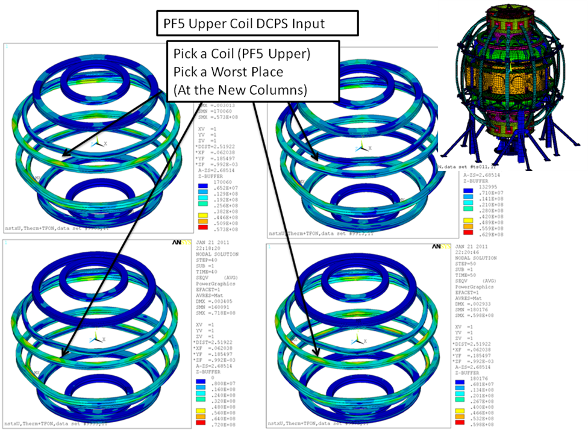

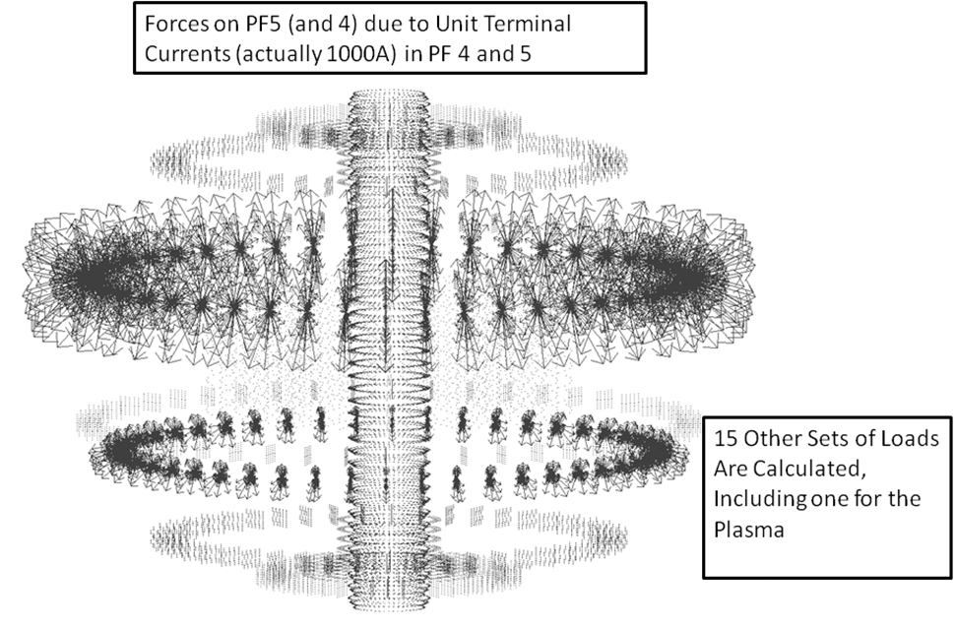

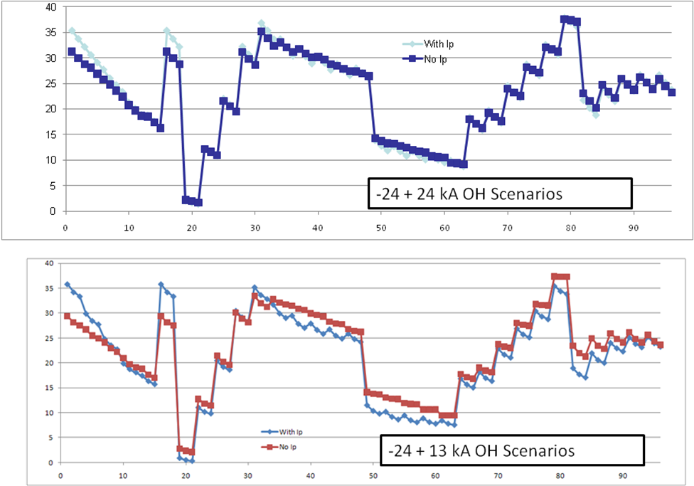

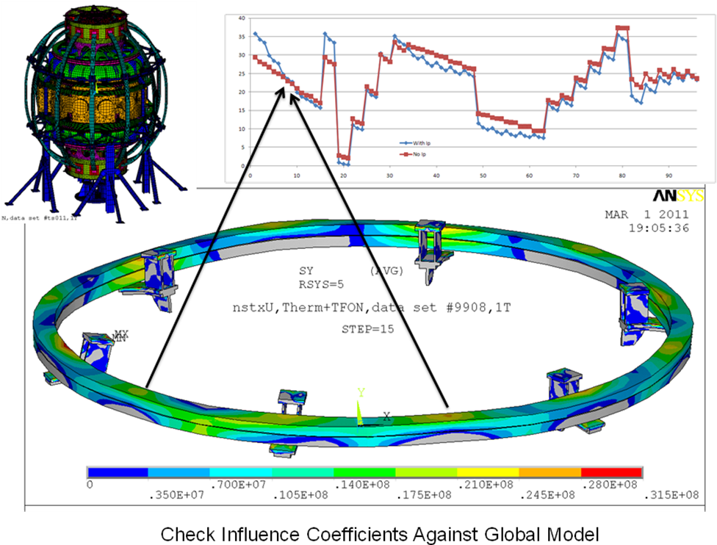

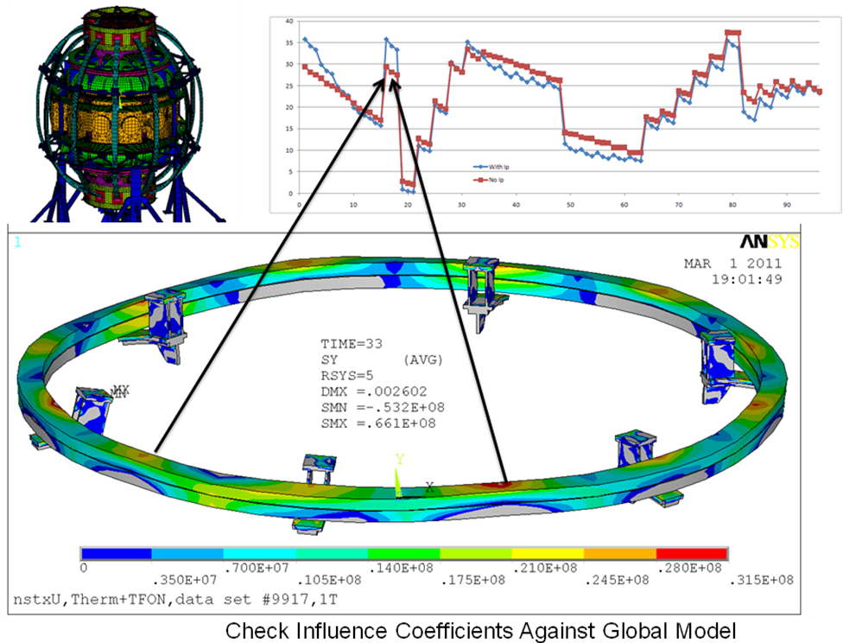

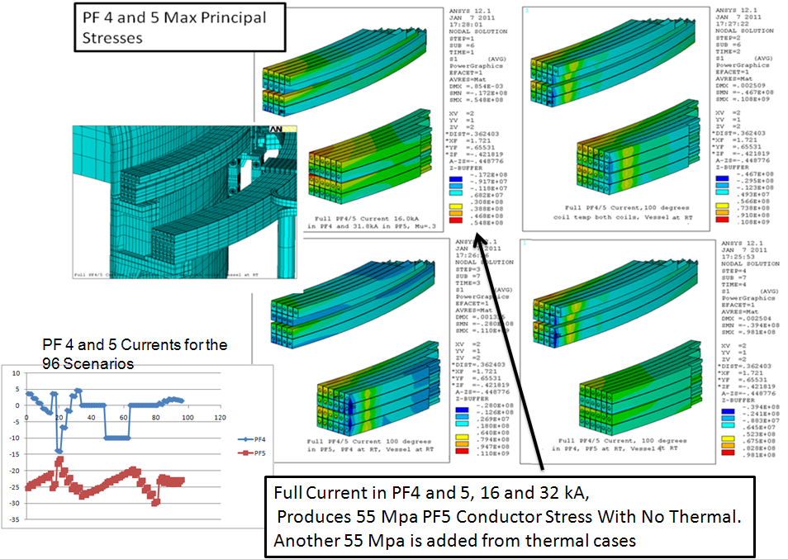

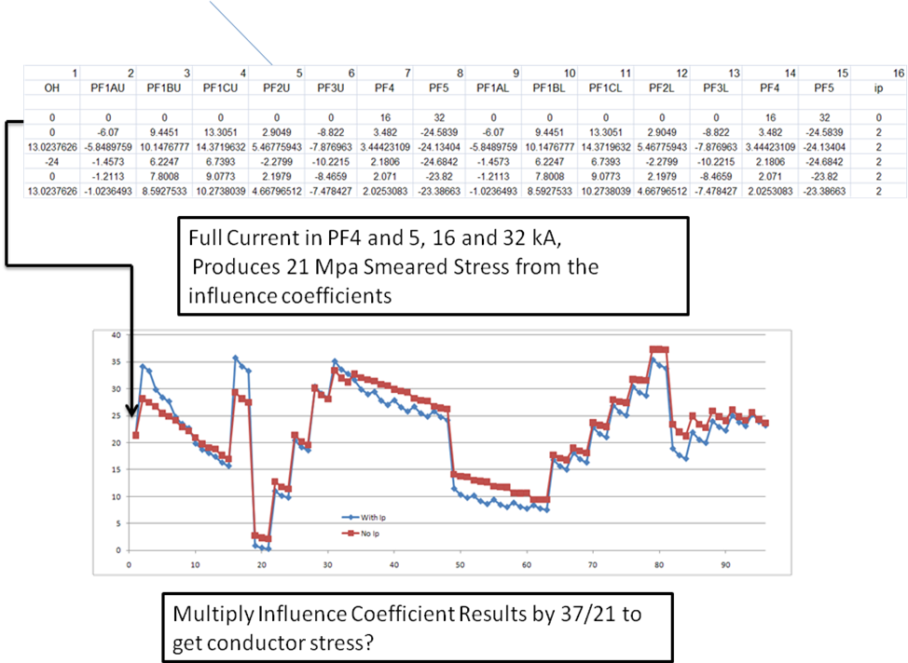

The procedure for calculating the peak hoop directed tension stress is to use the stress multipliers or influence coefficients multiplied by the coil currents, Multiply the result by 37/21 to account for the local conductor cross section multiplier, then add the 55 MPa thermal stress components. The peak stress in the plots of all scenarios is 38 MPa and the peak stress is then :

=38*37/21+55 = 122 MPa

This is a tension stress representative of the principal stress which needs to be compared with a fatigue allowable. -See Section 11

9.2 PF4 Coil Stress DCPS Input

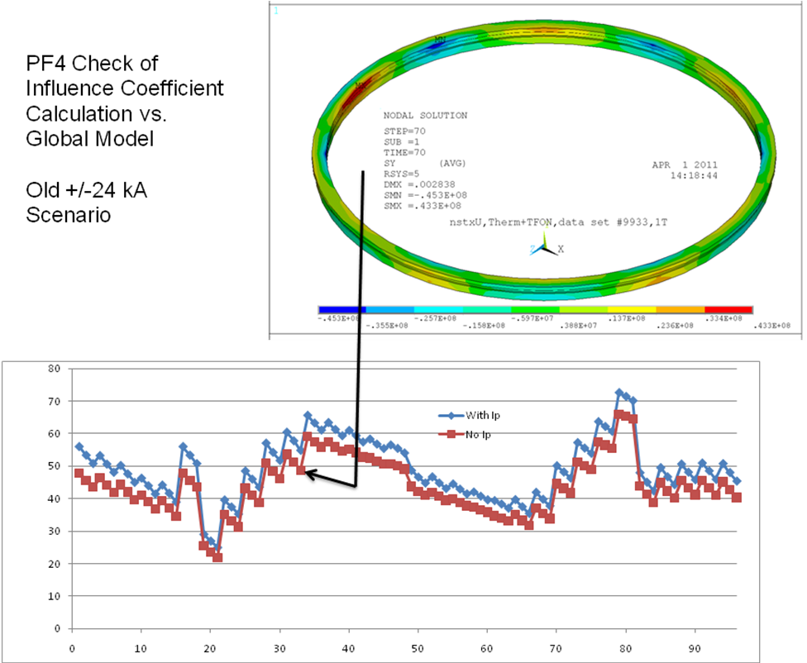

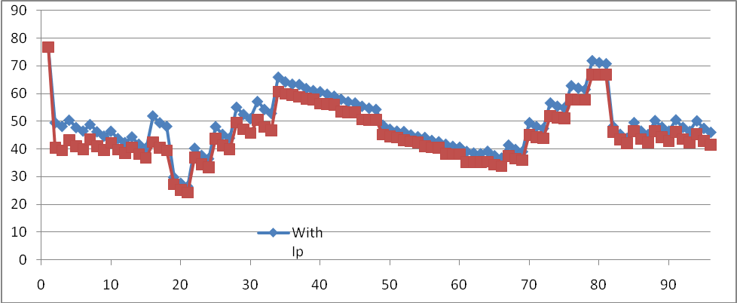

9.3 Existing Support Weld Stress Multipliers

This section derives from, reference 9, an analysis of coefficients to relate PF4 and 5 loads to the weld stress of the bracket pad. This is pertinant to the upgrade because it was used for a protection system that was implemented in 2010 in NSTX This same approach can be translated to DCPS requirements
The existing PF 4 and 5 supports were modeled and loads based on the upgrade design were applied. This analysis is representative of only the up-down symmetric attractive loads. The loads that were applied are shown in the table. These are 1/6th the loading that would be appropriate for the whole of PF4U and PF5U coils. These loads produced 30,555 psi in the weld that holds the bracket to the vessel. The allowable stress in the weld is a function of the weld profile and the QA/inspection level applied to the weld. For visual inspection, a weld efficiency of ,7 was assumed. If the weld was liquid penetrant inspected, I am assuming a weld efficiency of 1.0
Applied Loads on the model with a Resulting Weld Stress of 30555 psi | Allowable Load based on Visual weld inspection and an allowable weld stress of 14ksi | Allowable Load based on Visual Plus Penetrant weld inspection and an allowable weld stress of 20ksi
Due to PF4U: 17,000 Lbs  Plus PF5U: 20,000 Lbs = 37000 lbs | 16,900 Lbs | 24,200 Lbs

Applied Loads on the model with a 22,200 Lbs in the Strut i | Allowable Load based on Min AISC A307 bolting double shear allowable of 8.84 kips | Allowable Load based on for Fy=36ksi steel , like A-36. for a double shear allowable of 9.54
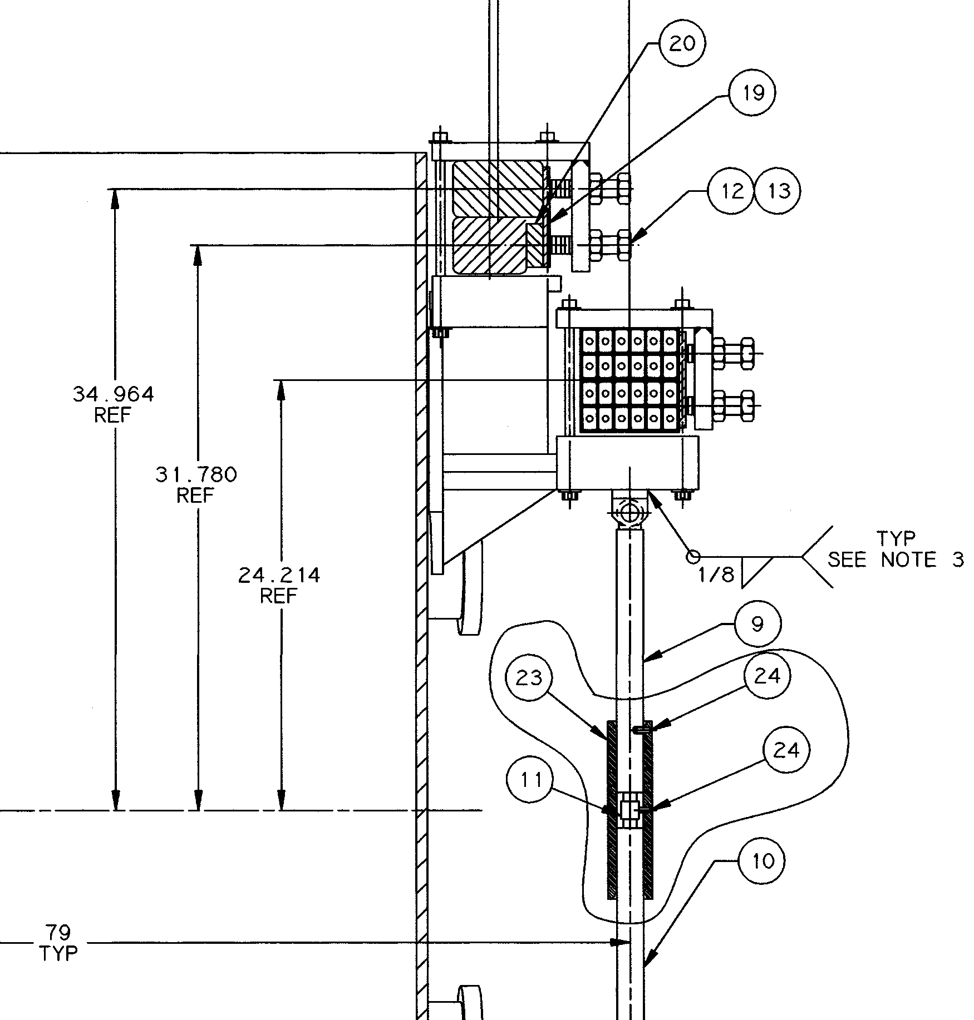
Fig 2 Existing PF4 and 5 Support
PF4U: +PF5U = 37000 lbs, | 14,700 Lbs | 15,900 Lbs
. The strut bolt stress is limiting for the case where the loads in PF4/5 are just attractive. Weld stresses double for the same loading if the strut is removed. If there is a net load on the PF4,5U+PF45L assembly, then the strut does not contribute to supporting this load component., and the allowable load from only a net assembly load would be 8 kips top and bottom or 16kips total. – So:

The (Attractive Load on PF4/5U to PF4/5L + The net load on (PF4/5U and L assembly) should be less than 16 kips

In this analysis I have grouped PF4 and 5 loads. PF5 loading has a larger moment arm and has a bigger effect on the weld and strut bolt stress. To be strictly correct, the PF5/PF4 load ratio should be as I assumed in the analysis. - I was trying to limit the complexity of the load summary. I have only looked at the bracket to vessel weld and the strut end bolts. I am assuming that buckling of the strut was addressed when it failed, and that there is plenty of margin against buckling. Also I am assuming only compression loads in the strut ( The 1/8 in welds that connect the strut clevis to the bracket are too small.

Analysis

The weld is nominally 5/16, but the QA report recommends that it be treated as an effective ¼ inch weld .To facilitate meshing the weld, an arbitrary cross section is used then the weld stress is scaled by the ratio of the weld section in the model to the actual weld section. In this case, the weld was intended as a fillet, but material has been added to accommodate the vessel curvature, and the resulting weld was derated. The weld is assumed to have a larger cross section than a fillet, so the .707 factor was not applied. Weld allowable is a function of the level of inspection that is applied. At PPPL only visual inspection is routine. ASME would require a weld efficiency of 0.7 or lower.

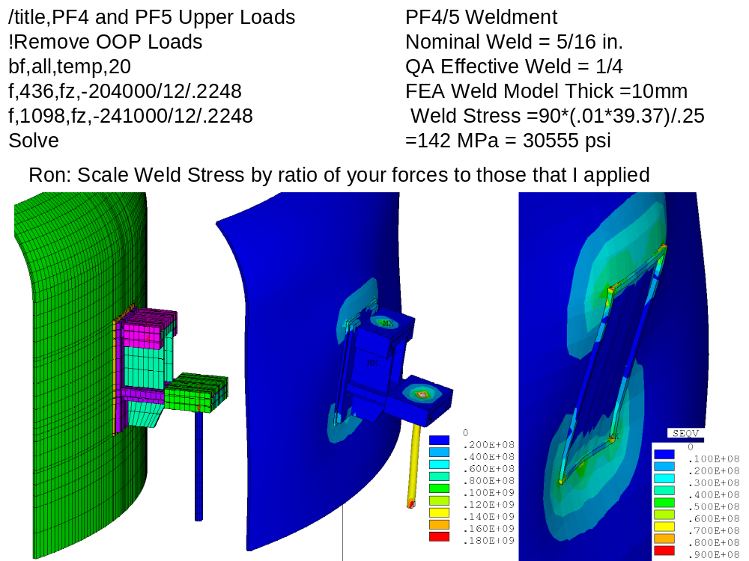
Fig 3 In-Plane PF4 and 5U Loads With Strut
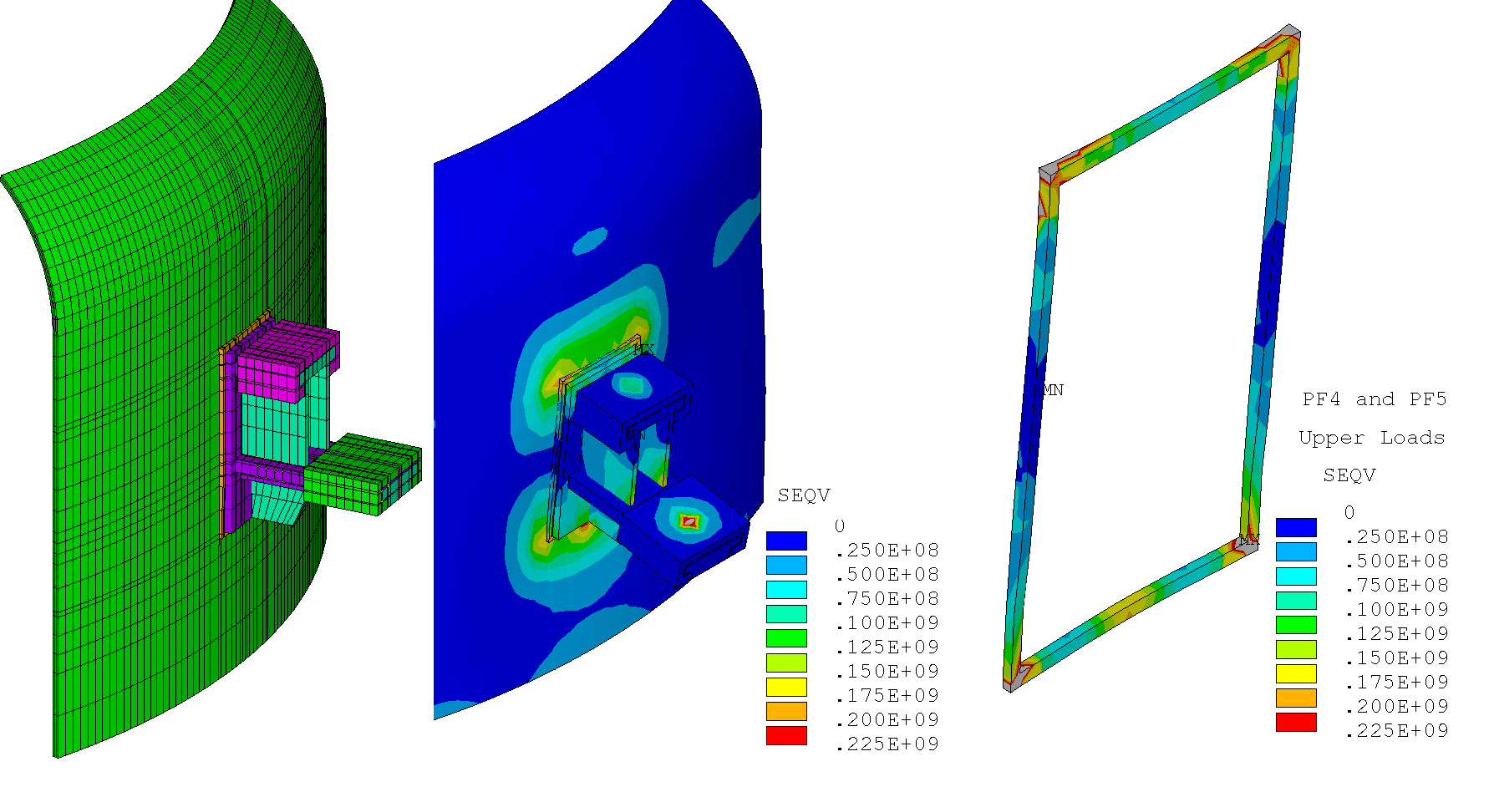
Fig 4 If the strut is removed, the weld stresses approximately double.

Bolt capacity
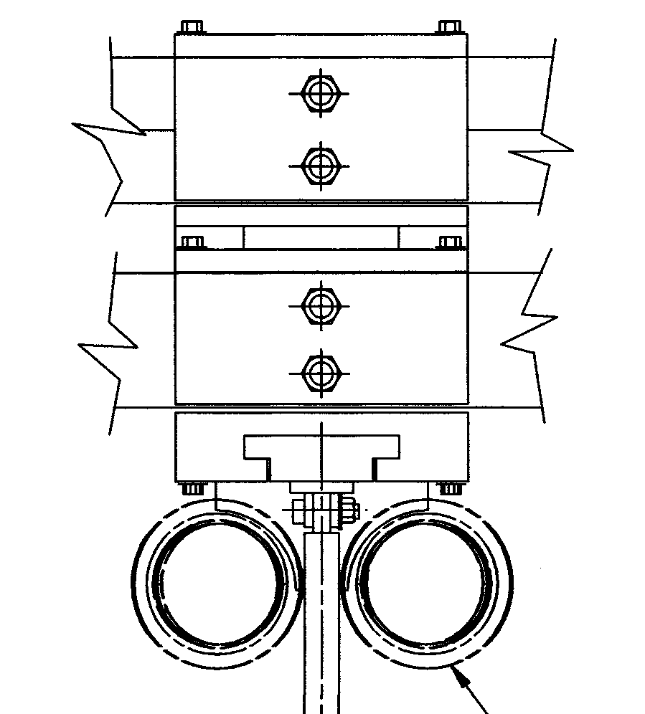
PF4 and 5
The strut is modeled as 3 cm in diameter. For the upgrade loads, the stress in the strut is about 140 MPa, so the load is 98.9lN or 22,200 lbs

The shoulder bolt that takes the strut compression load is a ¾ inch 304 SST bolt in double shear. The capacity of the bolt is

The AISC allowable for a A307 bolt is 8.84 kips or 9.54 kips for Fy=36ksi steel , like A-36, in double shear. . 304 bolting could have a 30 ksi yield, but probably is closer to the A36 from roll forming.

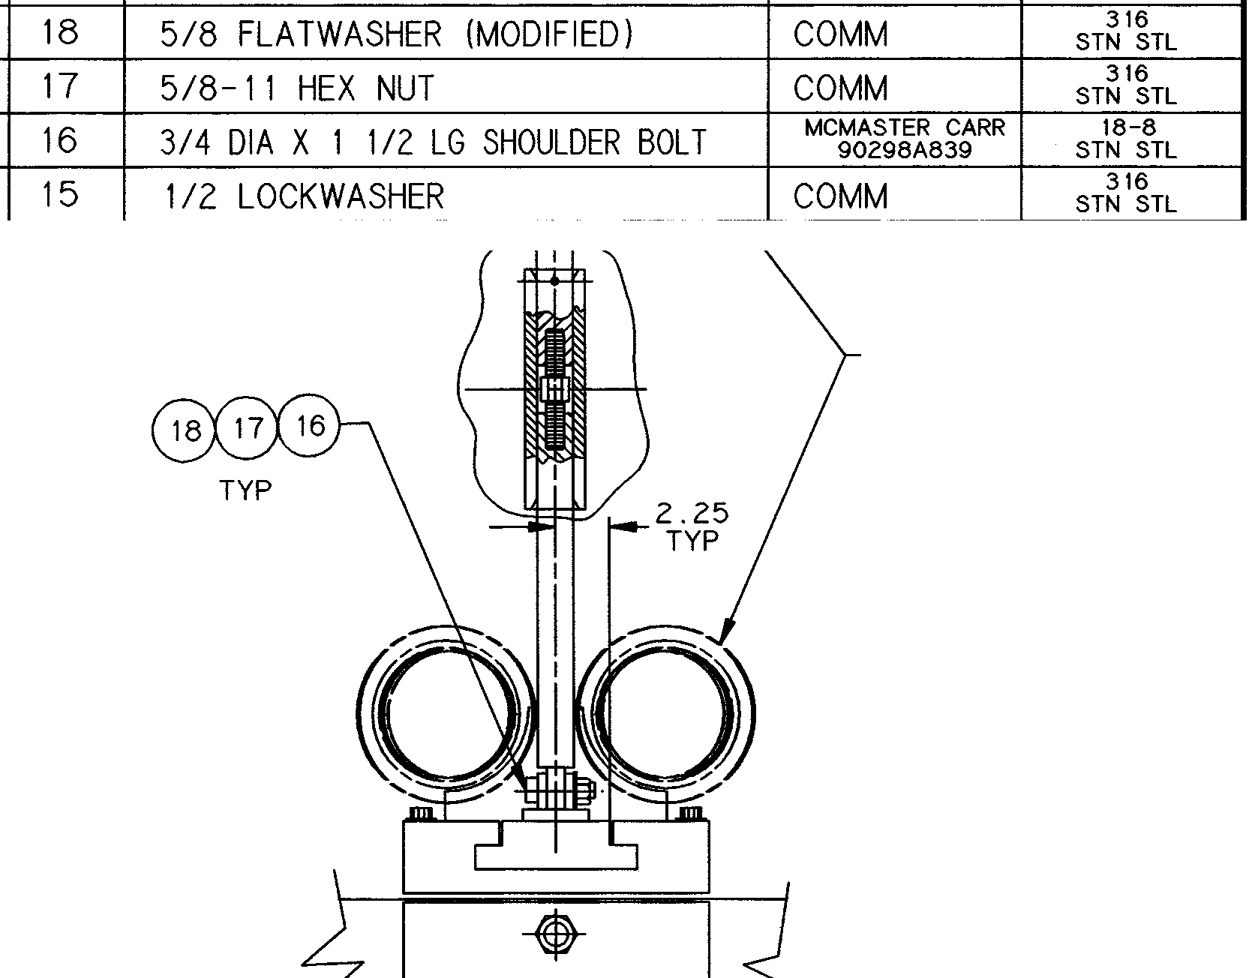

The Weld Allowable is 20 ksi with inspection and an efficiency of 1.0 and 14 ksi with a weld efficiency of .7 These are discussed in a figure in section 6

NSTX Centerstack Upgrade PF Loads
 | Fz(lbf) | PF4U | PF5U | PF5L | PF4L
 | Min | -204724 | -241452 | -50636 | -85361
 | Worst Case Min | -423491 | -523610 | -191878 | -151945
 | Max | 85361 | 50636 | 241452 | 186601
 | Worst Case Max | 151945 | 191878 | 523610 | 423491

Check of 20 kA current operation of PF5 with existing supports.

This calculation only has the loads from PF 4 and 5 upper and lower, and produces 60 kN compared with 80 kN from Ron Hatcher's with all PF currents active, and 241/6/.2248 = 179 kN for the upgrade with all coils active and

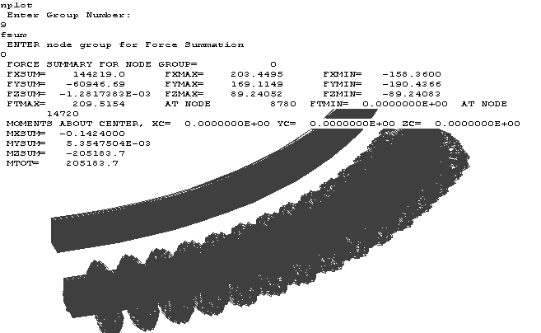

Ron calculated an attractive load of 80000 lbs in OPERA
10.0 Leads

Analysis of the PF4 and 5 leads has been included in the analysis of the PF4/5 supports because the logic of the 180 degree "fixed" supports allows "rigid" supports of the leads if they are positioned near the fixed coil support points.

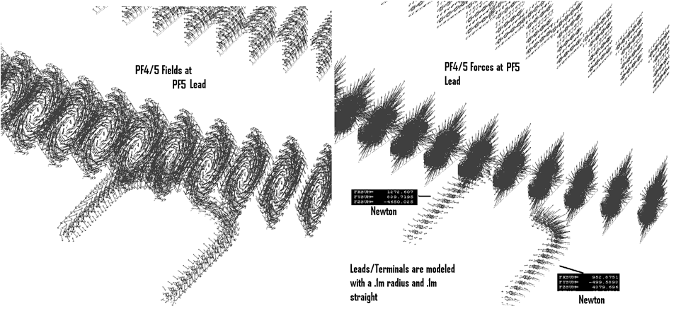
Cantelevered, un-supported leads produced excessive bending stresses due the Lorentz Loads caused by the local coil fields. The unsupported lead stresses are shown below.
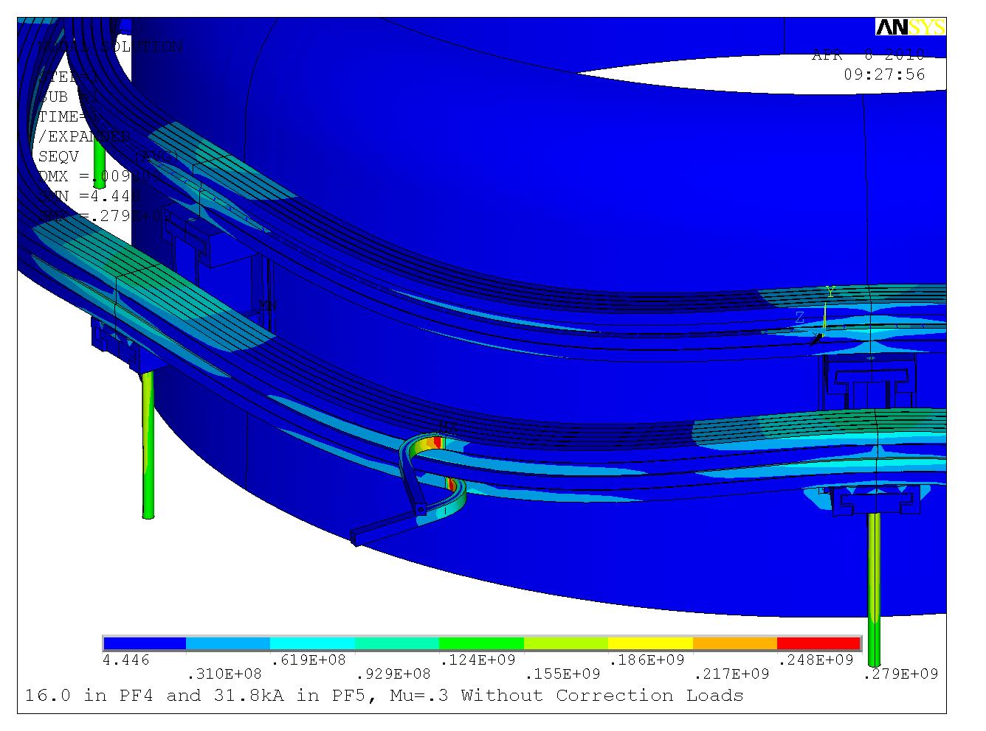
The bending stress would be relieved by taking credit for the connection to the bus bars on the unistrut at the support platform. This was modeled by displacement constraints. These would produce stresses if the coils move relative to the bus bar support. The PF4/5 support concept imposes fixity at two locations 180 degrees apart. Choosing one fixed point near the lead break-out will limit the differential displacement stress in the leads.

11.0 Fatigue Analysis
Principal stresses for the PF4 and 5 coils are shown below for full currents in PF4 and 5. for various combinations of temperatures. In section 9 the digital coil protection system stress multipliers were used to calculate the tensile stress in the hoop direction for all the available scenario currents with the 10% headroom applied and with and without plasma.
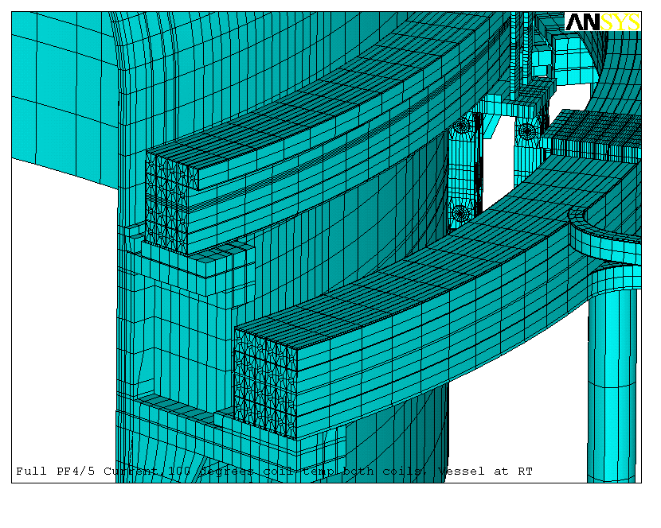

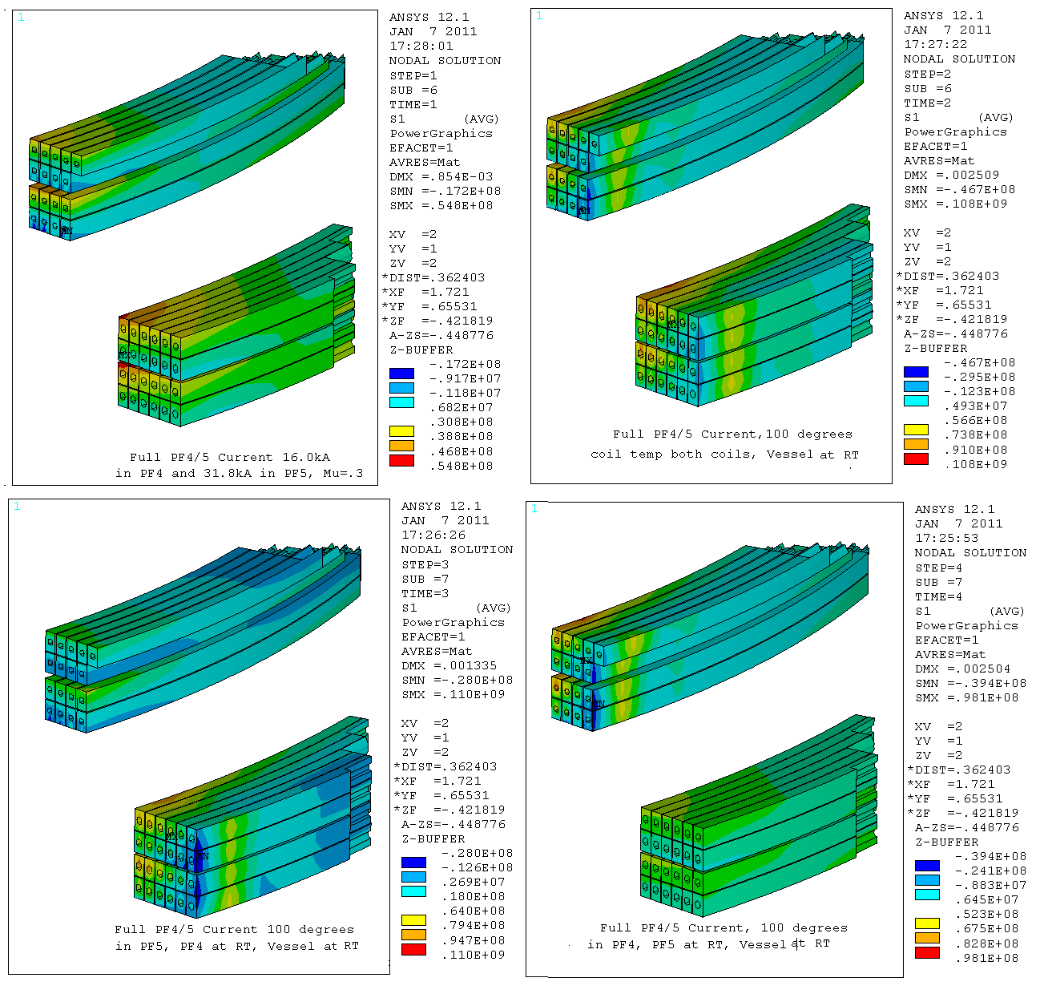
From Section 9, the peak Max Principal Stress in PF5 for all scenarios is
=38*37/21+55 = 122 MPa

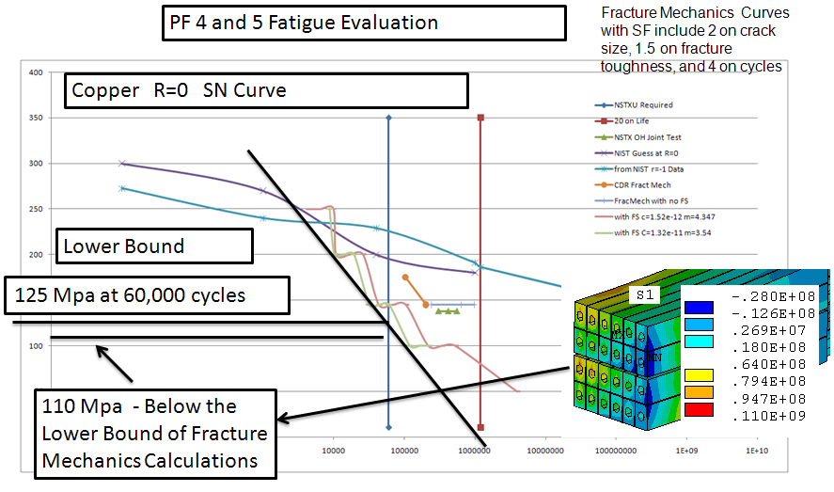
Fatigue Stress Evaluation for Full Currents in PF4 and 5 - No other PF currents

The PF5 Maximum Max Principal Stress for all scenarios, for all thermal conditions is 122 MPa -See Section 9.. The allowable stress to meet the cyclic fatigue limit was developed for the OH coil fatigue calculation, ref [7] and is 125 MPa

It should be emphasized that this evaluation assumed that all 60000 pulses utilize the scenario that produces the worst case stress, and that this stress occurred when the thermal stresses are at a peak.

12.0 Brackets, Hardware and Bracket to Vessel Welds

12.1 Existing Bracket to Vessel Welds

This is included in the upgrade calculations because this analysis was used in an early version of a DCPS which is currently in operation. The weld stress vs. load factors calculated here were applied during operation and the coil protection system disallowed a normal test shot. The problem is that the corners of the rectangular weld pattern have significant concentrations that would be plastically relieved, but the strain range would remain to effect the fatigue life. The corners were inspected, and no fatigue indications were noted. This region will be added to an inspection regimen during outages to ensure that fatigue sensitive welds are not developing cracks.

The weld is nominally 5/16, but the QA report recommends that it be treated as an effective ¼ inch weld .To facilitate meshing the weld, an arbitrary cross section is used, then the weld stress is scaled by the ratio of the weld section in the model to the actual weld section. In this case, the weld was intended as a fillet, but material has been added
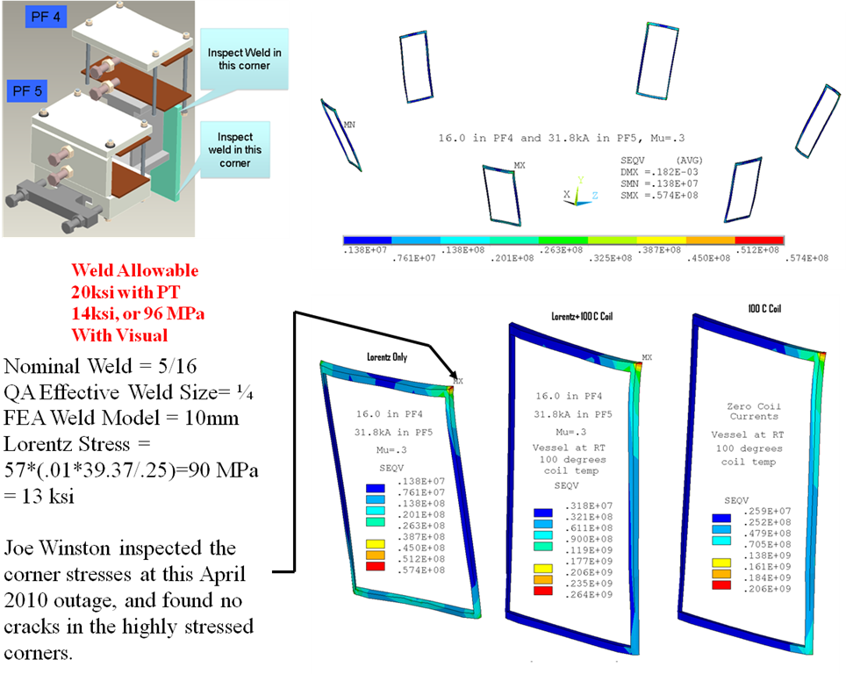to accommodate the vessel curvature, and the resulting weld was derated. The weld is assumed to have a larger cross section than a fillet, so the .707 factor was not applied. Weld allowable is a function of the level of inspection that is applied. At PPPL only visual inspection is routine. ASME would require a weld efficiency of 0.7 or lower.
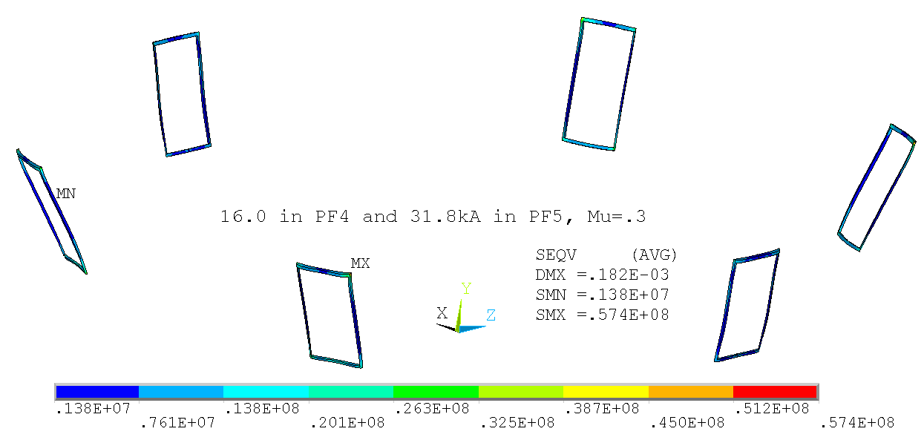
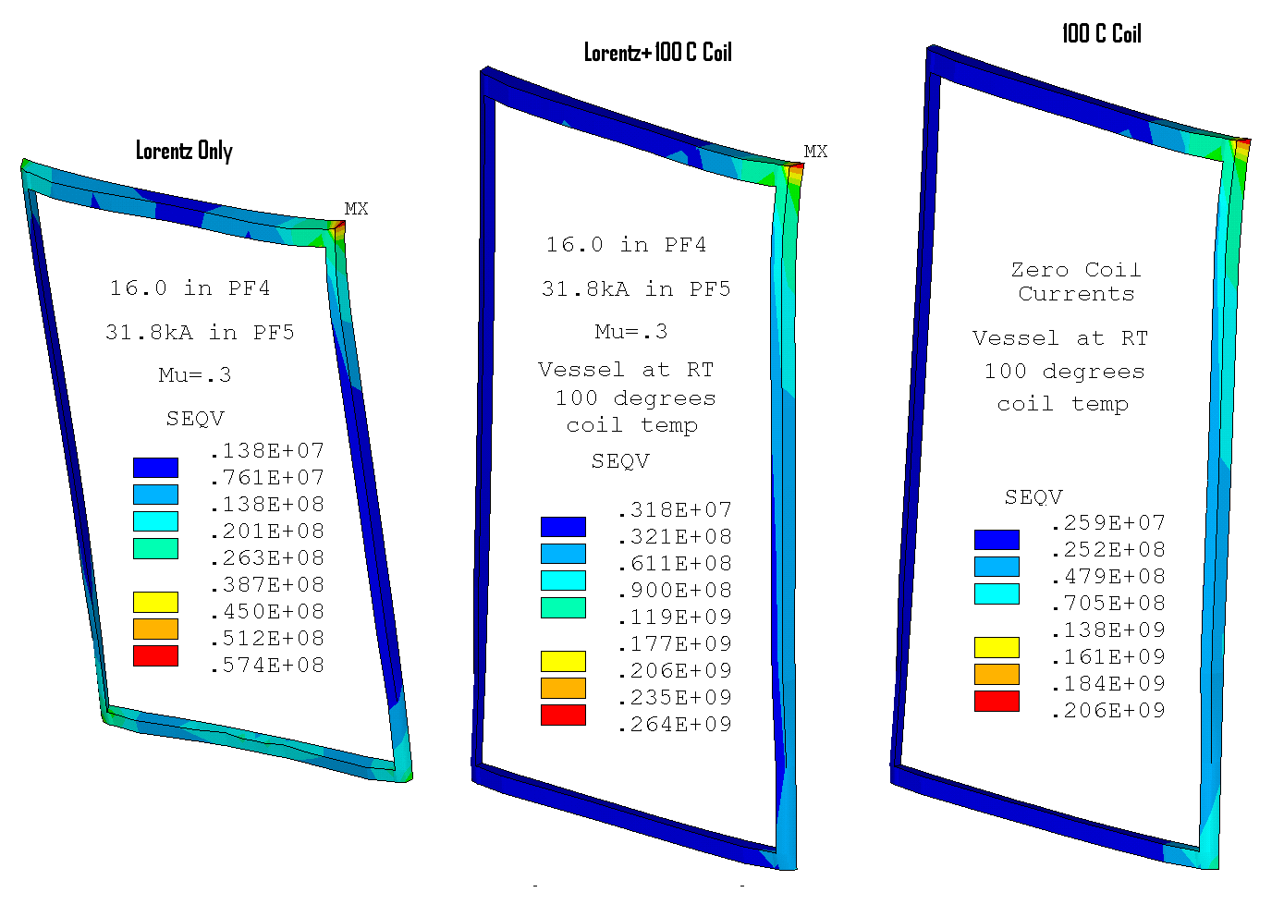

In-Plane PF4 and 5U Loads With Strut

12.2 Bracket Welds for Upgrade Loads

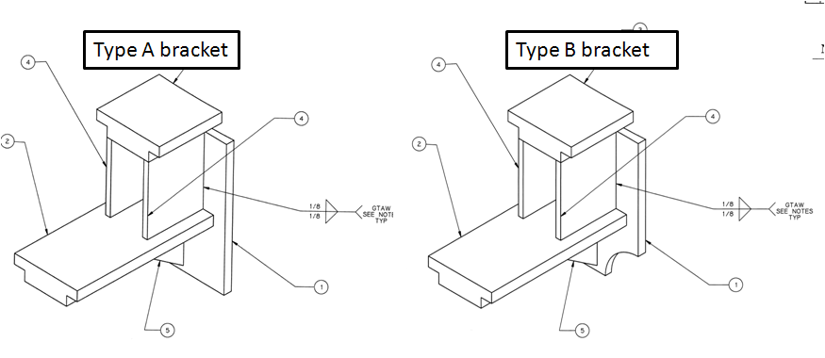

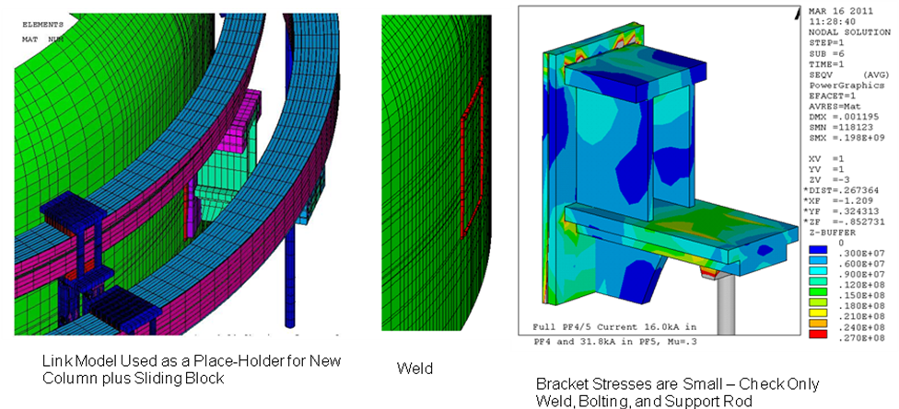

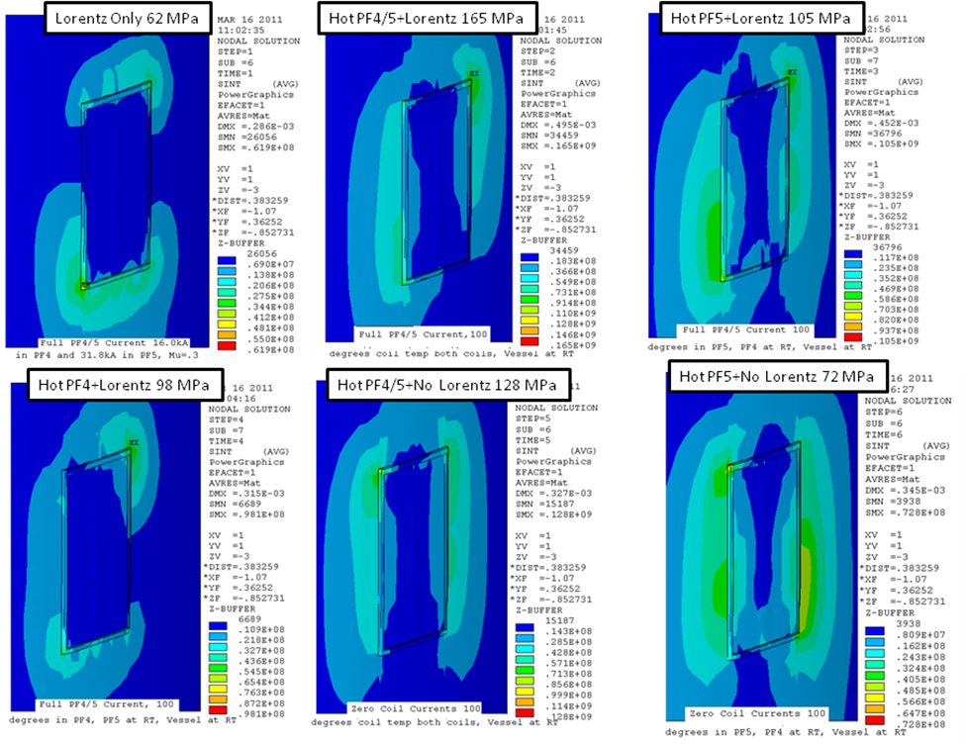

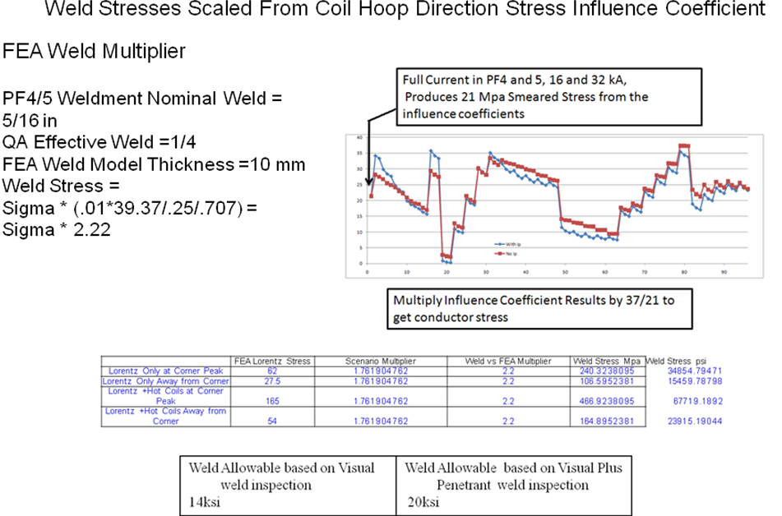

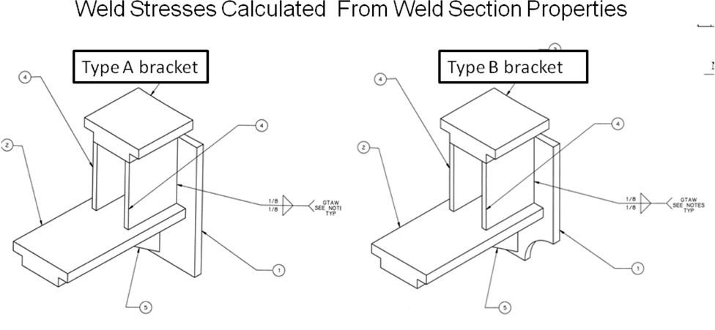

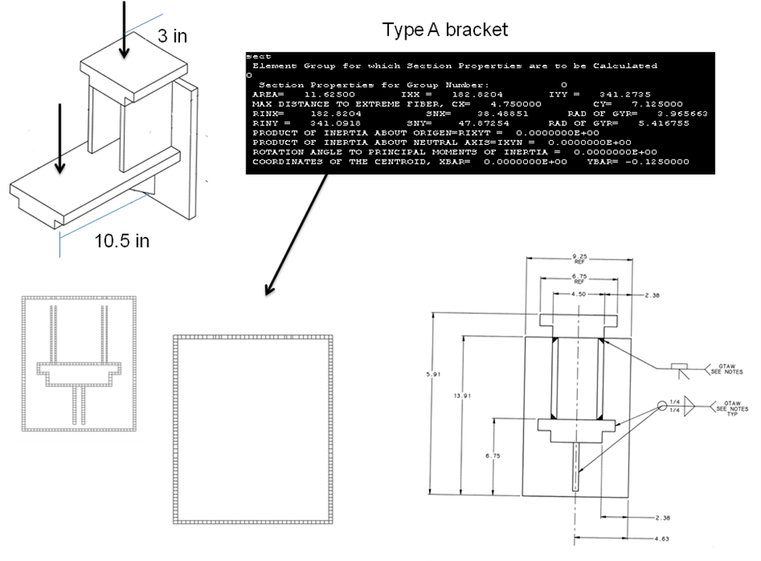

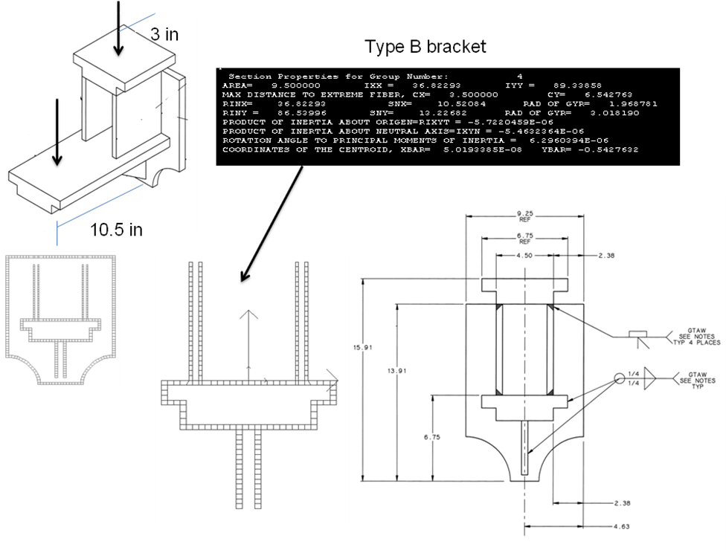

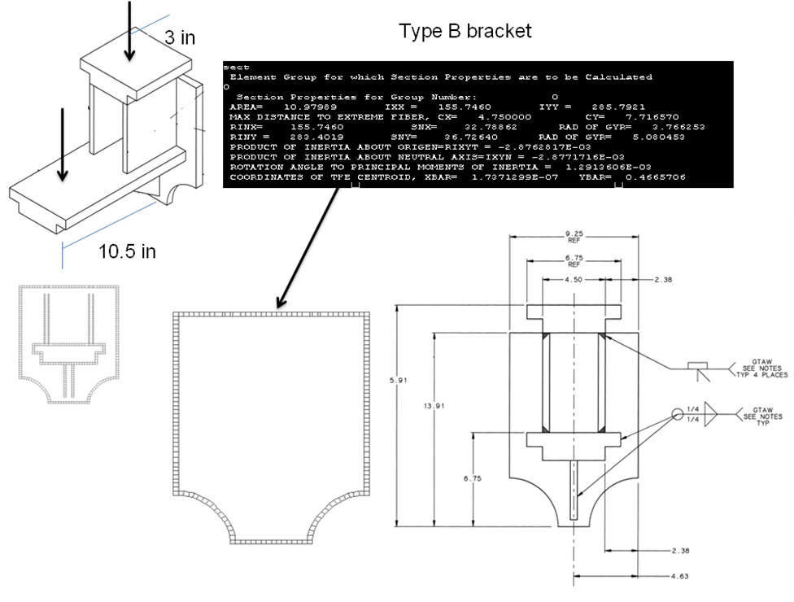

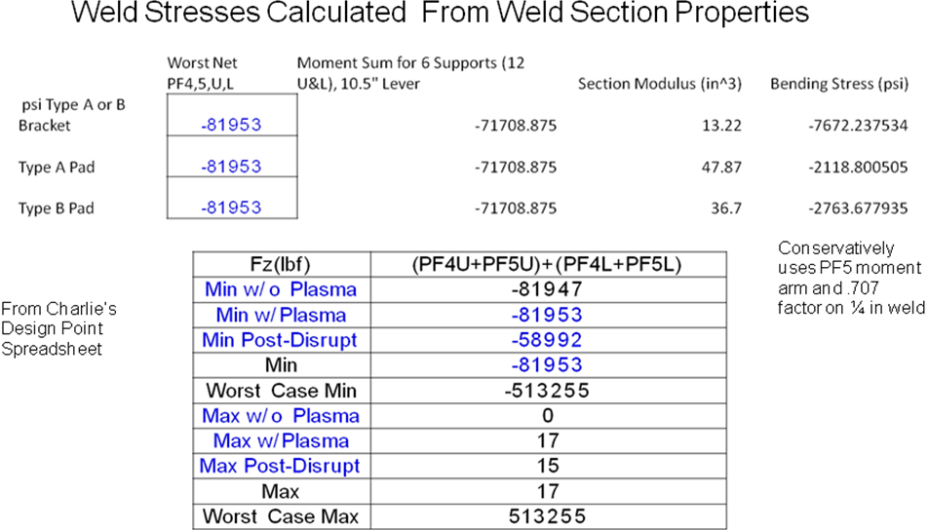

The weld stress in the weld of the backing plate/pad to the vessel are 2118 psi and 2763 psi for the type A and B brackets. These are well below the fatigue allowable calculated above. This is consistent with the findings of the inspection described inn Appendix A. Stresses in the weld between the back plate or pad and the bracket were calculated to be 7672 psi based on the 1/8 fillets on the vertical legs of the bracket.

12.3 PF5 Bracket Support Plate and Weld, With and without Existing Column

The existing Support bracket for PF 4 and 5 includes an extension to support PF5. During the operation of NSTX the support column between the existing upper and lower PF5 extensions buckled, and needed reinforcement. Early upgrade PF4/5 support concepts sought to remove this column because of it's weakness, and to ease clearance issues. In this section, bracket stresses are considered with and without the column. The cantilever load principally derives from attractive loads to the lower PF4 and 5 coil pair.

Without the strut, bending stress concentrates at the corners of the gusset plate weld. The global Moded [2]

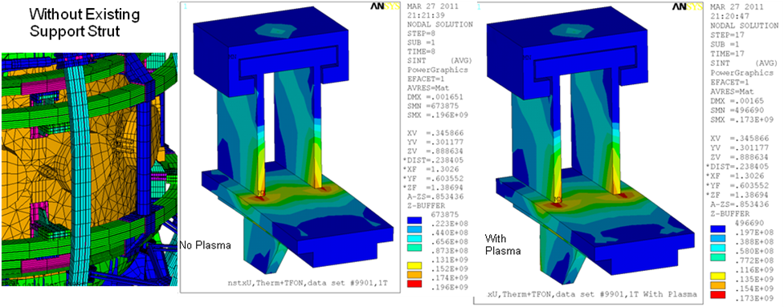
was run with and without the support strut.

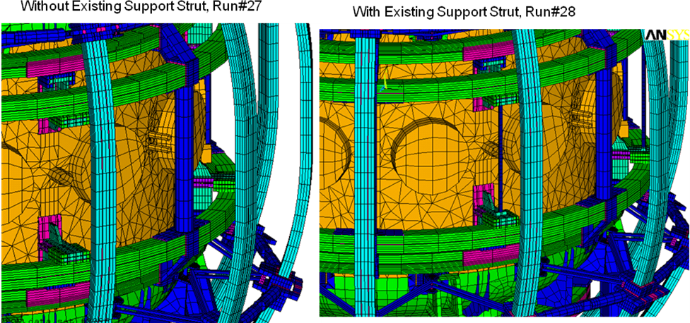

Even though the support strut is being retained, the "no strut" case is included here because it is relatively easy to construct stress multipliers for the bending stress in the cantilevered part of the support. This allow exploration of all the identified scenarios, with and without plasma's

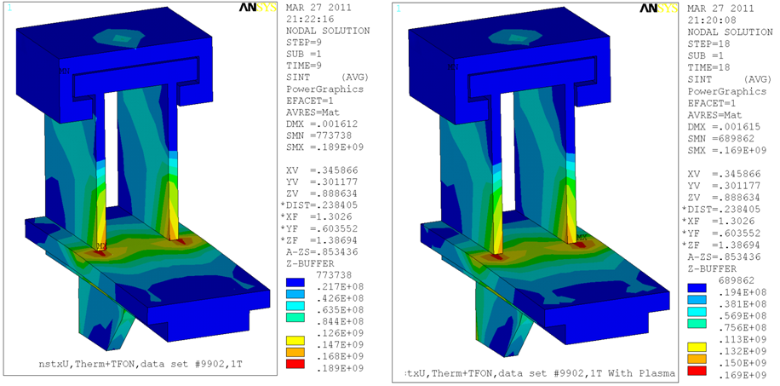

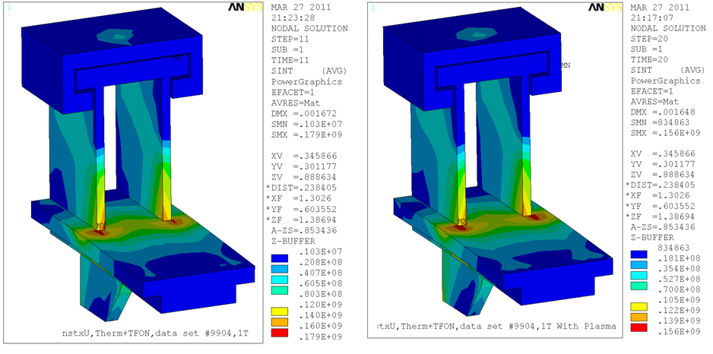

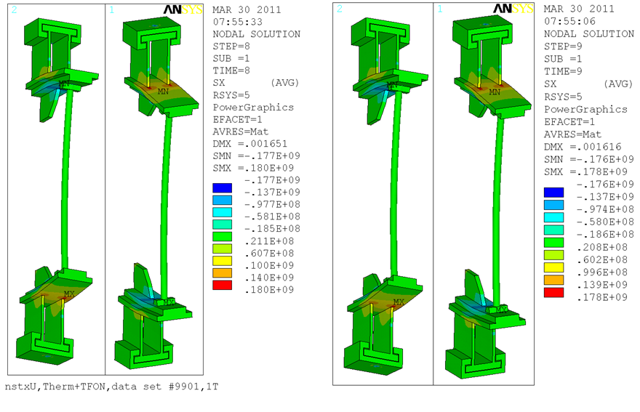
It is evident from this plot that the small diameter column does little to resist the cantelever bending of the PF5 support plate. A stiffer section is needed.

Bracket Stress by Influence Coefficients

If the bracket stress is determined primarily by the PF5 loads, the bracket stress can be related to coil current influence coefficients in a way similar to the coil stresses can be computed. This is not rigorous technically, because the rods/columns will introduced contributions from the lower coils. This section is not included in the DCPS for this reason, but it allows consideration of all 96 scenarios, with and without plasma.
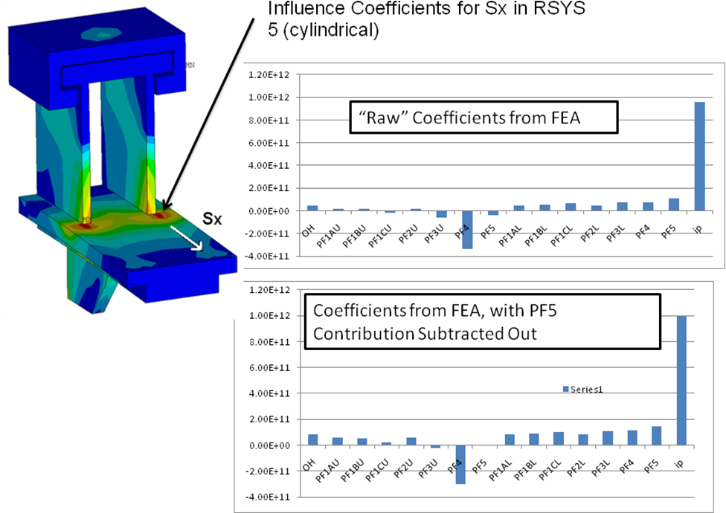

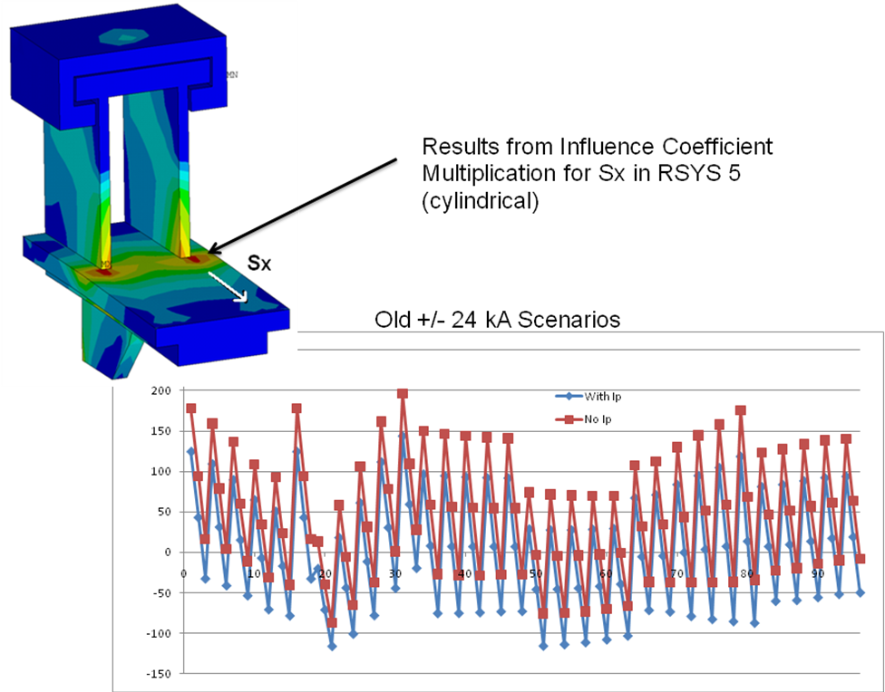

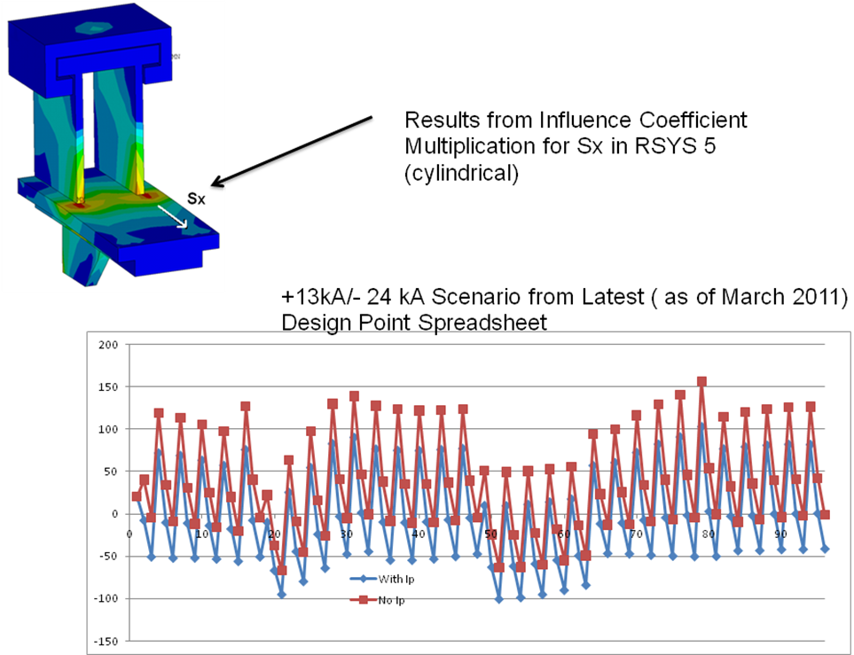

The peak stress in the plate near the weld toe is less than 150 MPa which is within the static allowable for the bracket material, but is probably a concern with respect to a weld fatigue issue. This is another reason why the existing column/rod should be stiffened.

12.4 Column Stresses from the Global Model

The global model [2] is available to provide column stresses in both the added column and the existing column. While the existing column/rod is not stiff enough to help the brackets welded to the vessel shell, the stresses in the columns and rods are small. -Less than 120 MPa in the rod and 30 MPa inthe 3 inch pipe column. This stress level does not require any further evaluation or consideration in the DCPS.
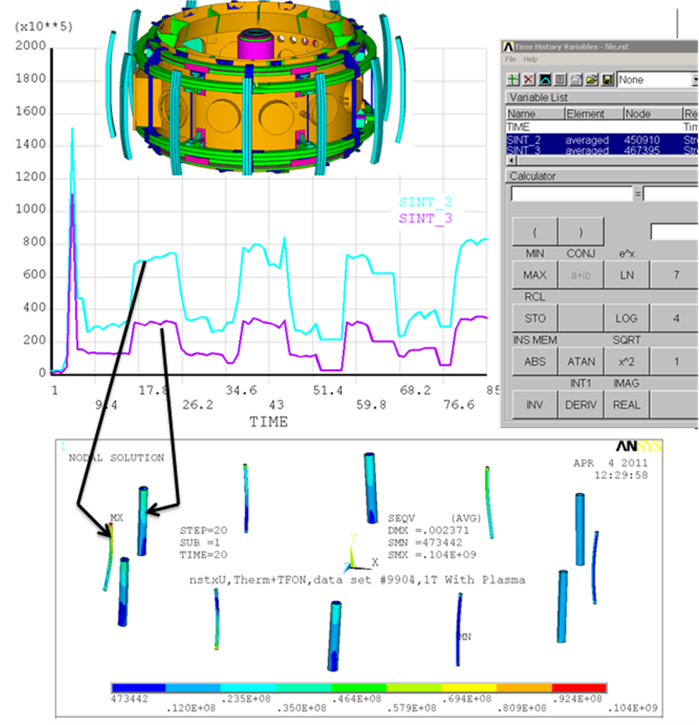

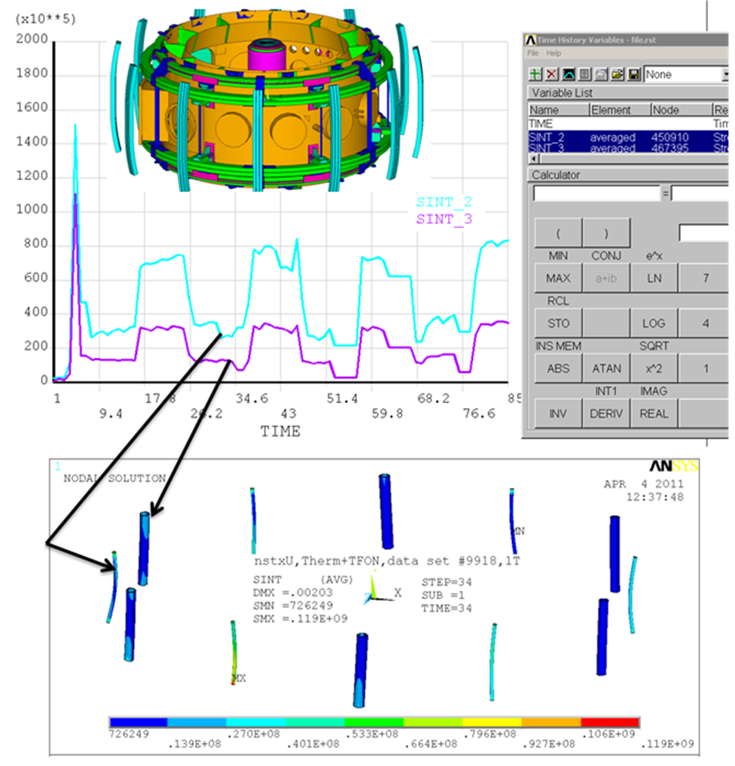

12.5 Coil Clamp Plate Bolting
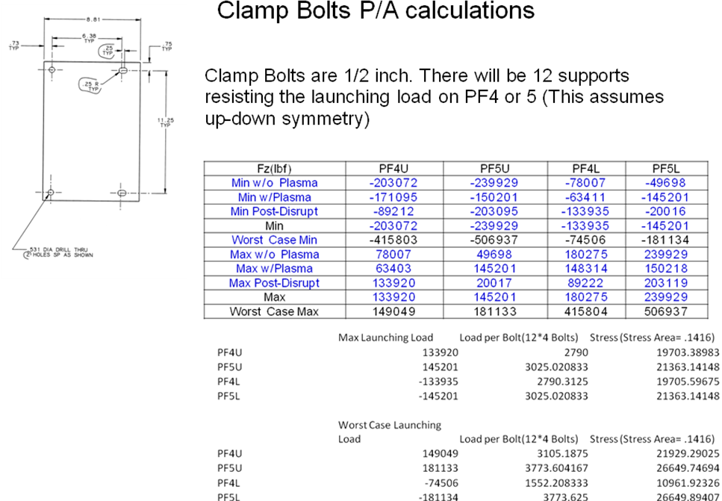

For loading that is up-down symmetric, that is the upper coils are being loaded upward and the lower loads are being loaded downward, then all 12 supports will resist the loads. Then there are four studs per clamp plate and 12 sets of clamp plates. The present FDR design used 3/4 bolts on the added column clamps. - but in this analysis it is assumed that 1/2 inch bolts are used everywhere.
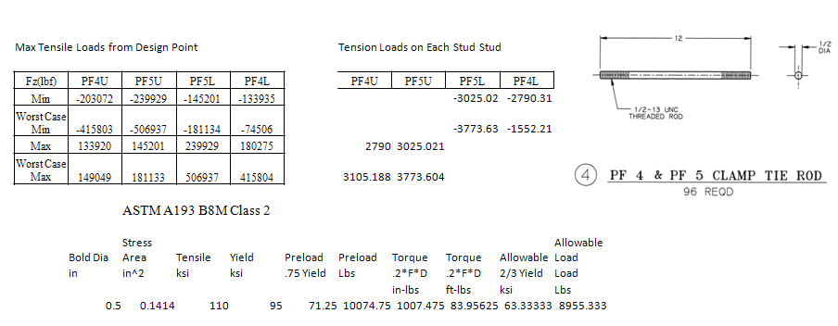
If the loads are not up-down symmetric, for example if upward loads on the upper coils are not equilibrated by the lower coils then the clamps welded to the vessel could see larger loads. If 6 support points are assumed, then the loads on the studs for the existing brackets could double from around 4000 lbs to 8000 lbs - still within the allowable for the recommended ASTM A193 B8M Class 2 bolts

12.6 T slot Stress

All supports, except those that are locked (near the leads and 180 degrees opposite) must allow independent radial motion of PF4 and 5. At the PDR a clamped concept was presented that didn't allow this motion. - or it was expected that the rubber pads would allow the relative motion. A rubber clamped version was run, and for the pad size assumed. the compliance was not good enough to allow the differential motion

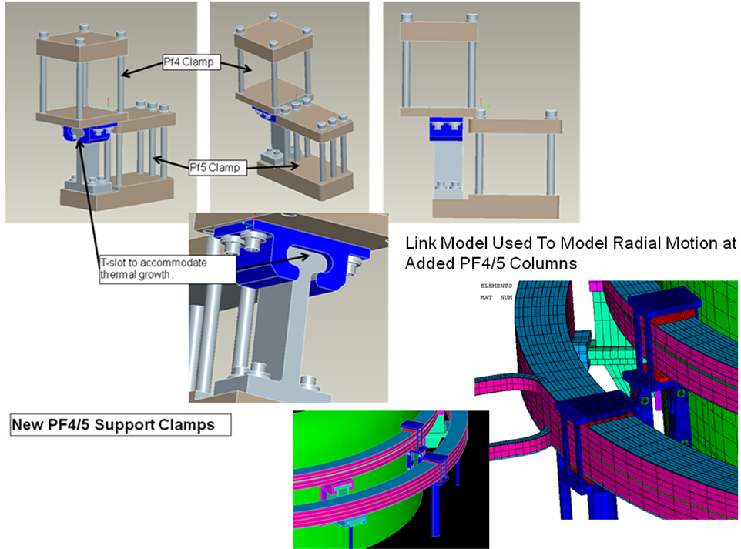
Figure 12.6-1 Dovetail or T slot sliding Block and Link Model Used to Simulate the Radial motion of the sliding block.

The FDR clamp is a design more similar to the existing sliding clamps. This latest design has only been partially analyzed but a link connected design that has the same mechanics has been. used to properly model the thermal stresses in the coils. . Each of the four tierods that hold PF4 down see about 4000 lbs (see table above). The T slot shown below will see the loads from four studs or 16000 lbs

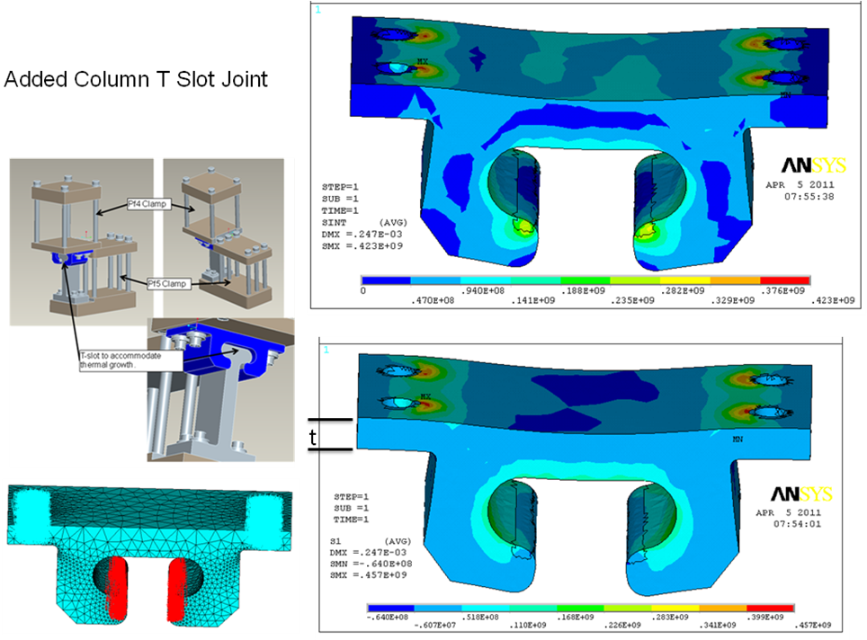
Part of the T slot has been analyzed with 16,000 lbs applied. The flange thickness should be increased.

12.7 Vessel Shell Stress
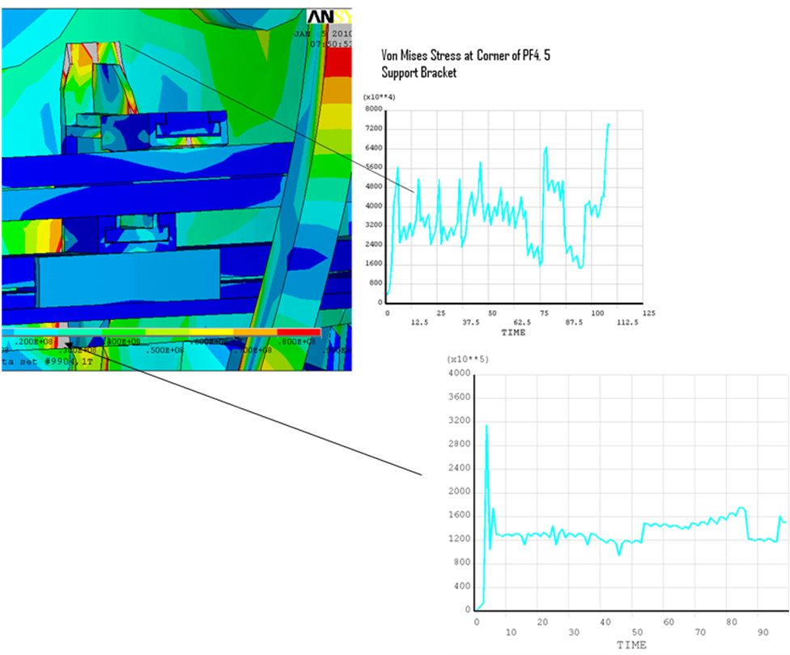
From the Jan 6 Wednesday Meeting Presentation. Vessel stresses are 160 MPa at the bottom and 64 MPa at the top

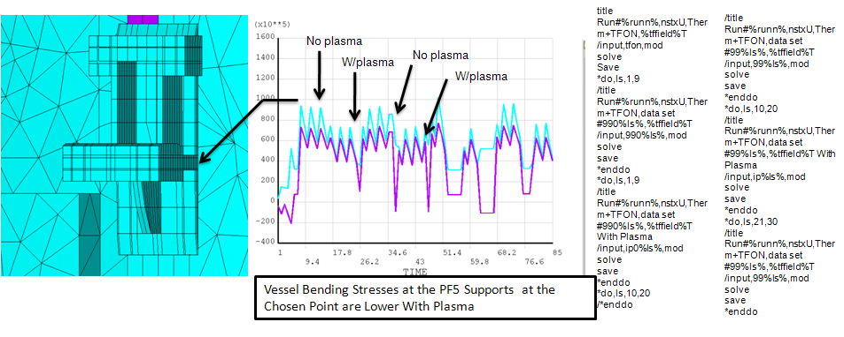

These results show the shell stress slightly higher with no plasma. In the load sequence first 10 load cases without plasma are analyzed then 10 load cases with plasma are run. The trend in coil tensile stress is the opposite - see section 9 - but the differences aren't great.

13.0 Bake-Out Thermal Stress

In an early analysis, the existing PF 4 and 5 support hardware were modeled as remaining at RT during bake-out. This produced a sharp gradient between the PF4/5 support bracket and the vessel shell. During a 2010 outage, the bracket was instrumented with thermocouples and the actual bake-out temperature gradient was measured. This was then imposed on the structural model and the stresses were found to be much reduced, particularly in the weld.
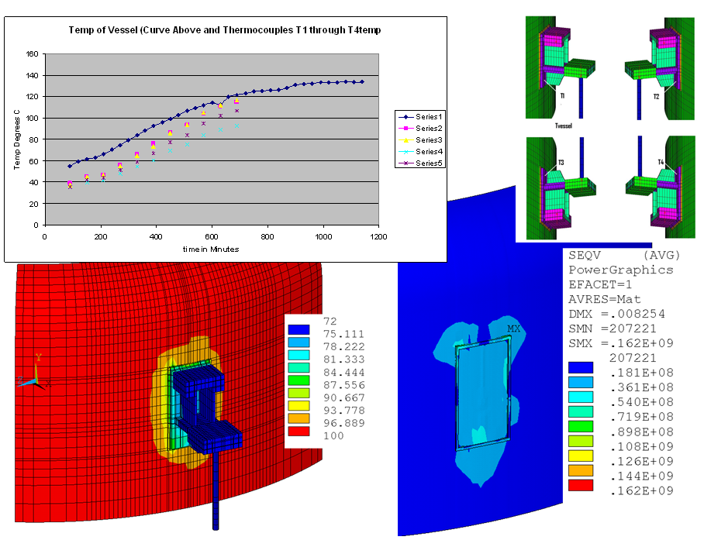

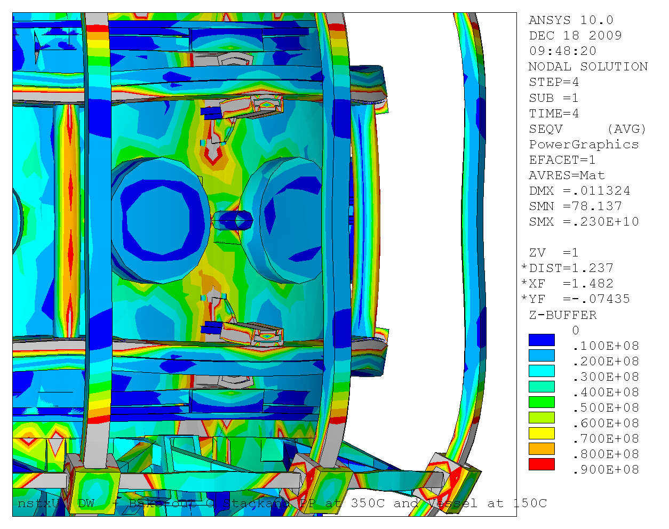

Bake-out stresses From the Jan 6 2010 Meeting report

Appendix A.0 Analysis of Earlier Concepts
Results for Added Columns and Rubber Support Pads A.2
Concept which Supports TF OOP Loads off the PF4 and 5 supports A.3
PDR Clamp Concept A.4

A.1 Feasibility of 6 vs, 12 Support Points

Currently both PF4 and 5 are supported by six support brackets welded to the vessel shell (12 incuding uppers and lowers). This study investigated use of 6 supports for the upgrade loads The PF5 insulation system is a mylar wrapped fusifab epoxy system. Because of the poor bonding of the mylar to epoxy and to the copper conductors, and because of copper stresses - particularly in PF4, twelve supports are necessary for the upgrade to reduce the spans and resulting bending stress.

Table a.1-1 Design Point Vertical Loads at the time of the Study
Fz(lbf) | PF4U | PF5U | PF5L | PF4L
Min | -204724 | -241452 | -50636 | -85361
Worst Case Min | -423491 | -523610 | -191878 | -151945
Max | 85361 | 50636 | 241452 | 186601
Worst Case Max | 151945 | 191878 | 523610 | 423491

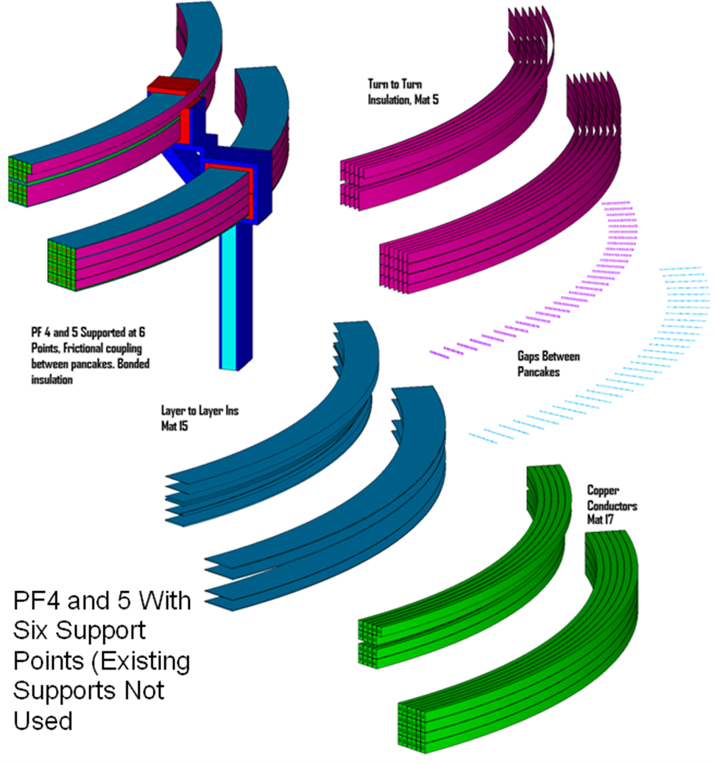

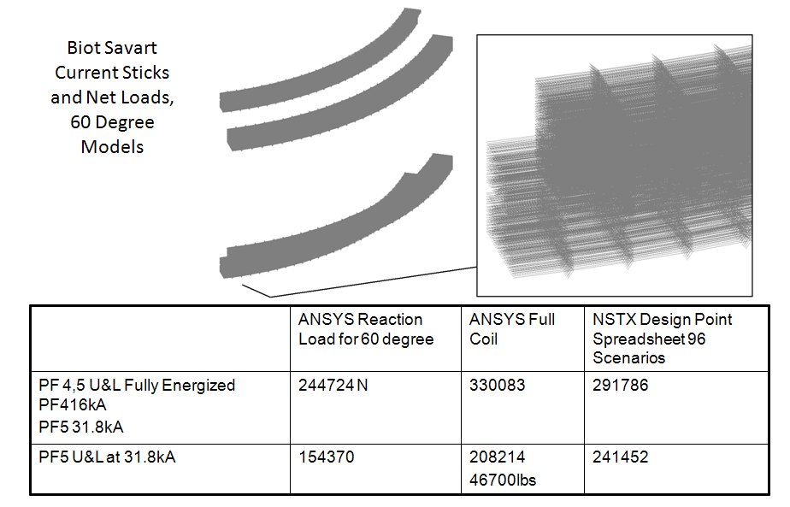

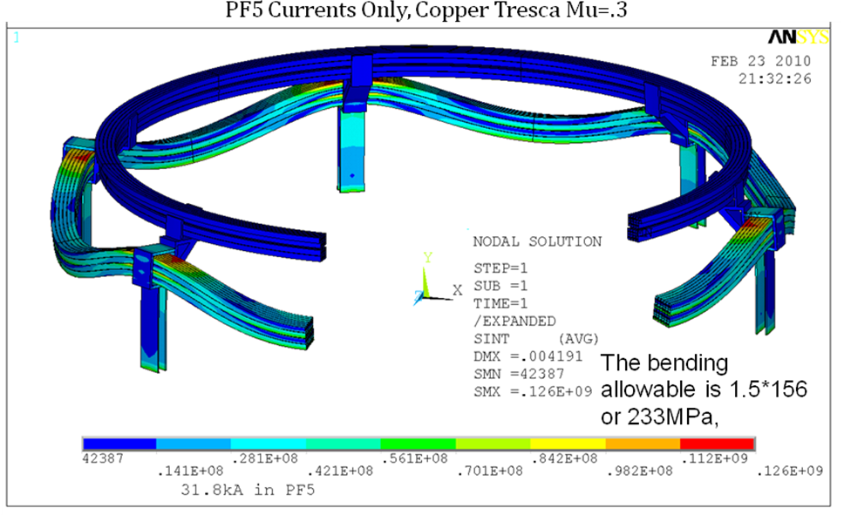

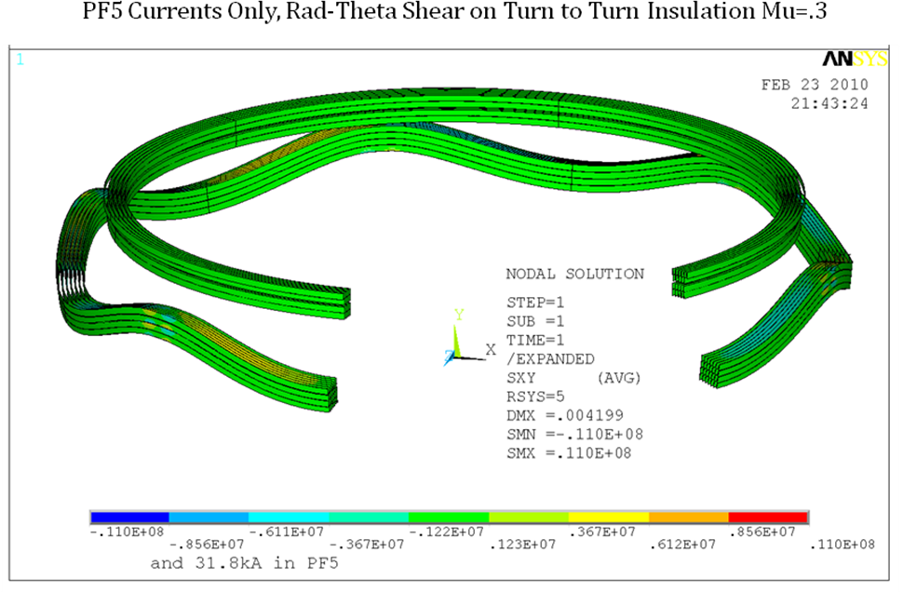
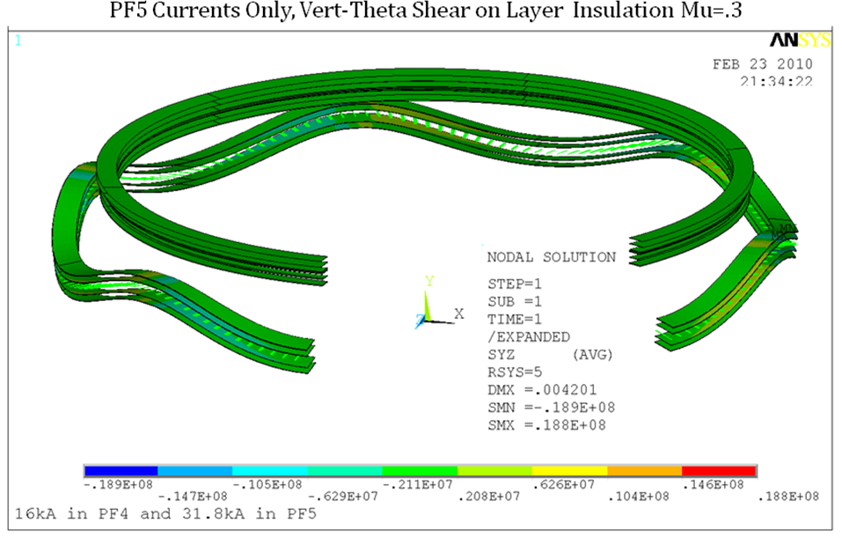
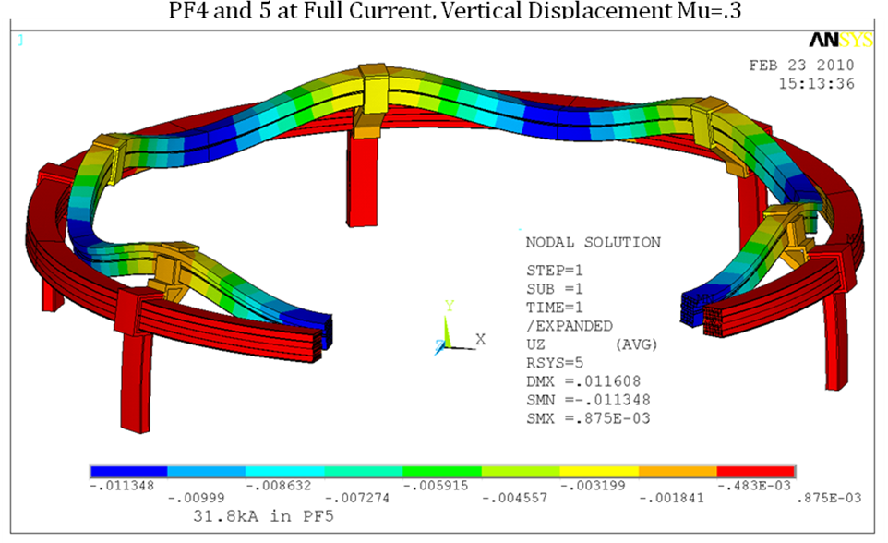

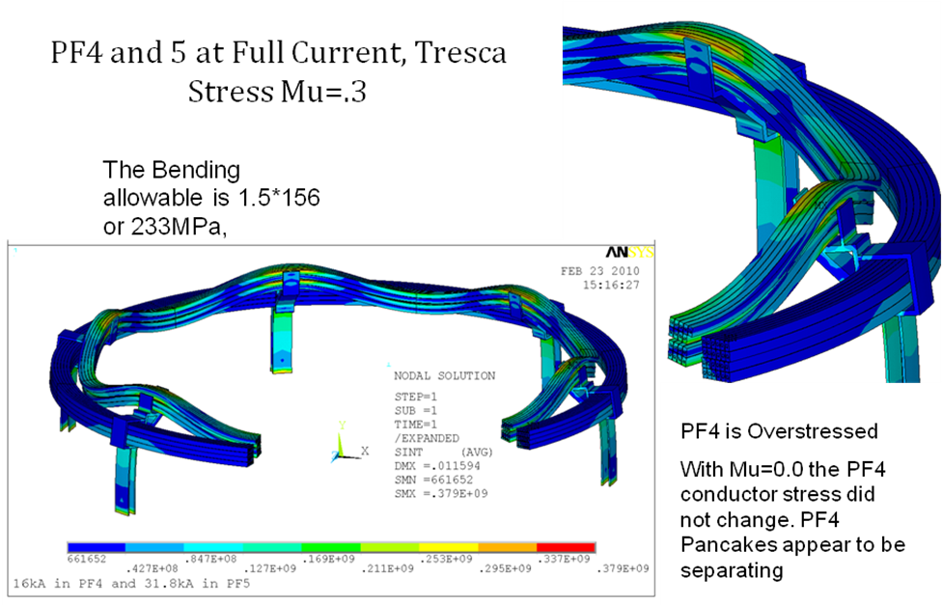

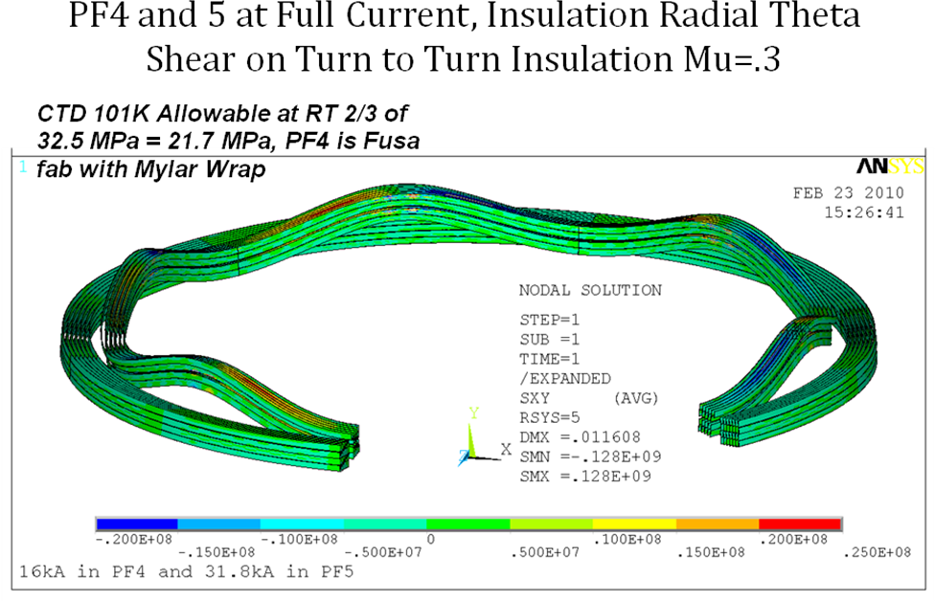
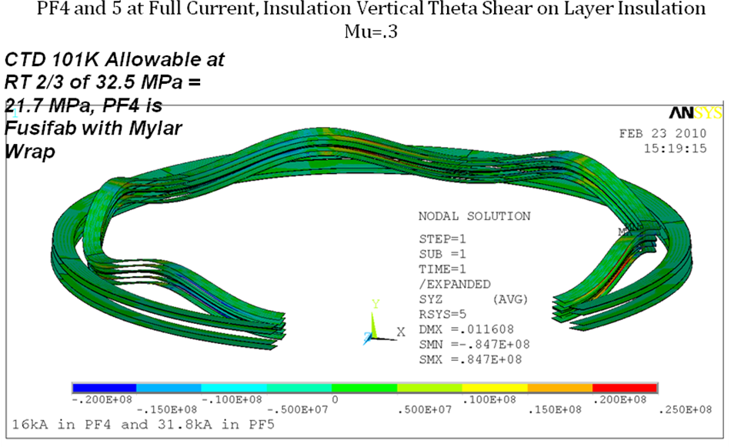

A.2 Support Concept in which the TF OOP loading is supported off the PF4 and 5 supports

This was a concept that attempted to transfer the out-of-plane loading to the vessel through the PF 4 and 5 support brackets. It put a twisting moment on the bracket and the weld stresses were unacceptable.
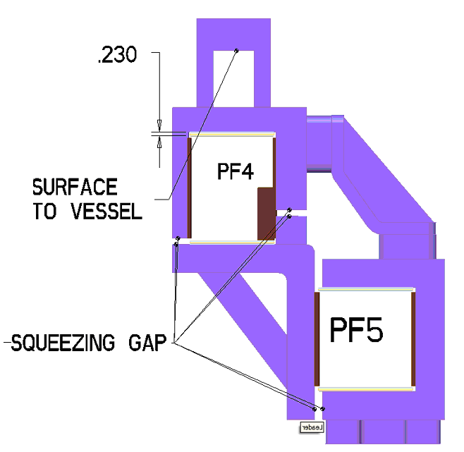
Table A.2-1 Net Loads on the PF4 and 5 Assembly
Fz(lbf) | (PF4U+PF5U)-(PF4L+PF5L)
Min | -502240
Worst Case Min | -1065883
Max | -108545
Worst Case Max | 44617

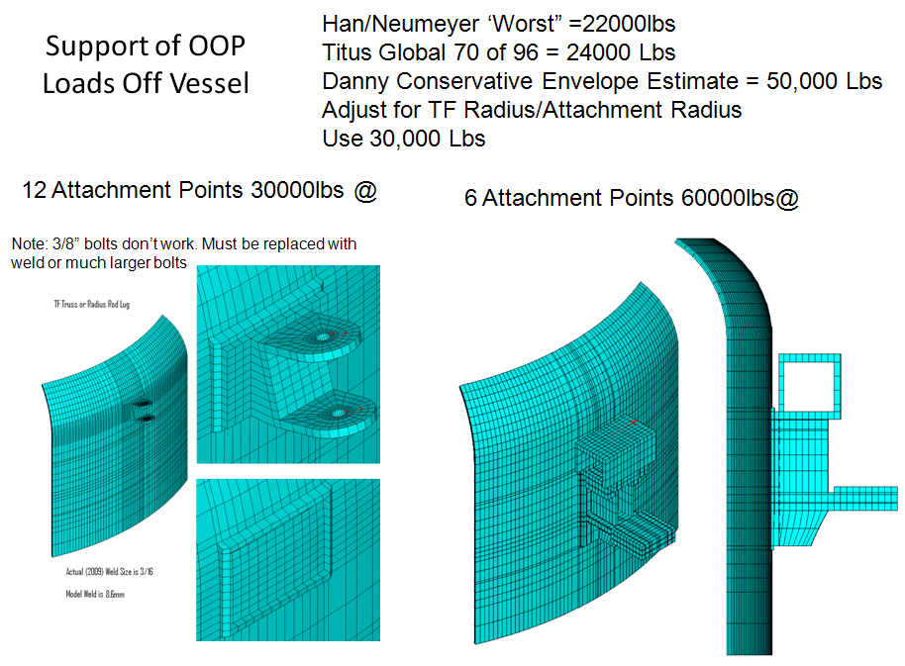

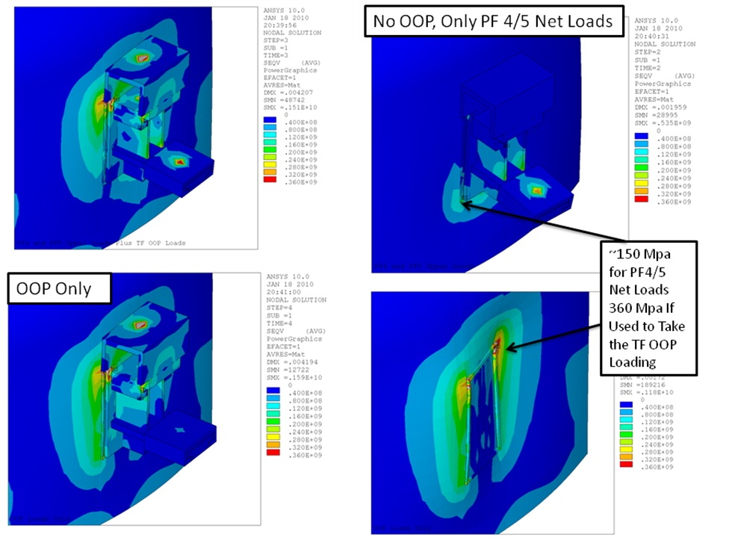

A.4 PDR Clamp Concept

This clamp detail which was presented at the PDR did not have a feature that would have allowed PF5 and PF4 to have different operating temperatures. Also the clamping behavior was difficult to implement and analyze because a common clamp was used for both coils.

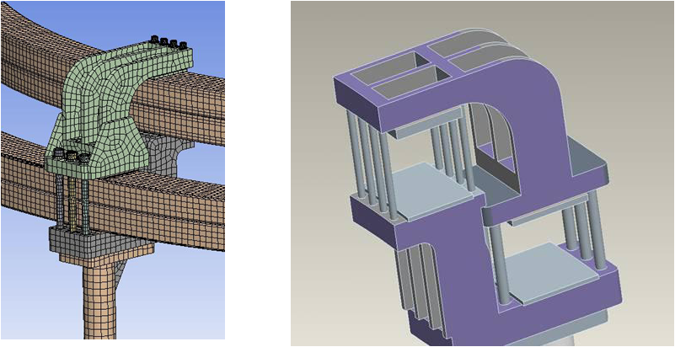
Appendix B
PF4/5 Bracket Support Weld Inspection

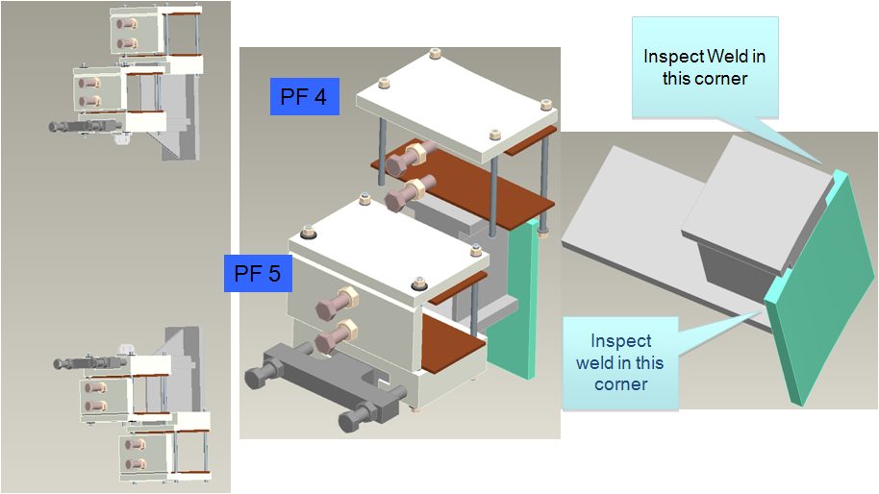
Pete,
The machine techs were able to get into several of the PF 4/5 support
brackets with a borescope to inspect the welds. They looked at the
brackets under TF coils 2,4,6,8,10,12. They were able to inspect the
upper coners in all cases and the lower corners in most cases. No
signs of any cracks or distress. Winston said if we wanted to look at
some in person they could get in again on Thursday evening.
Larry
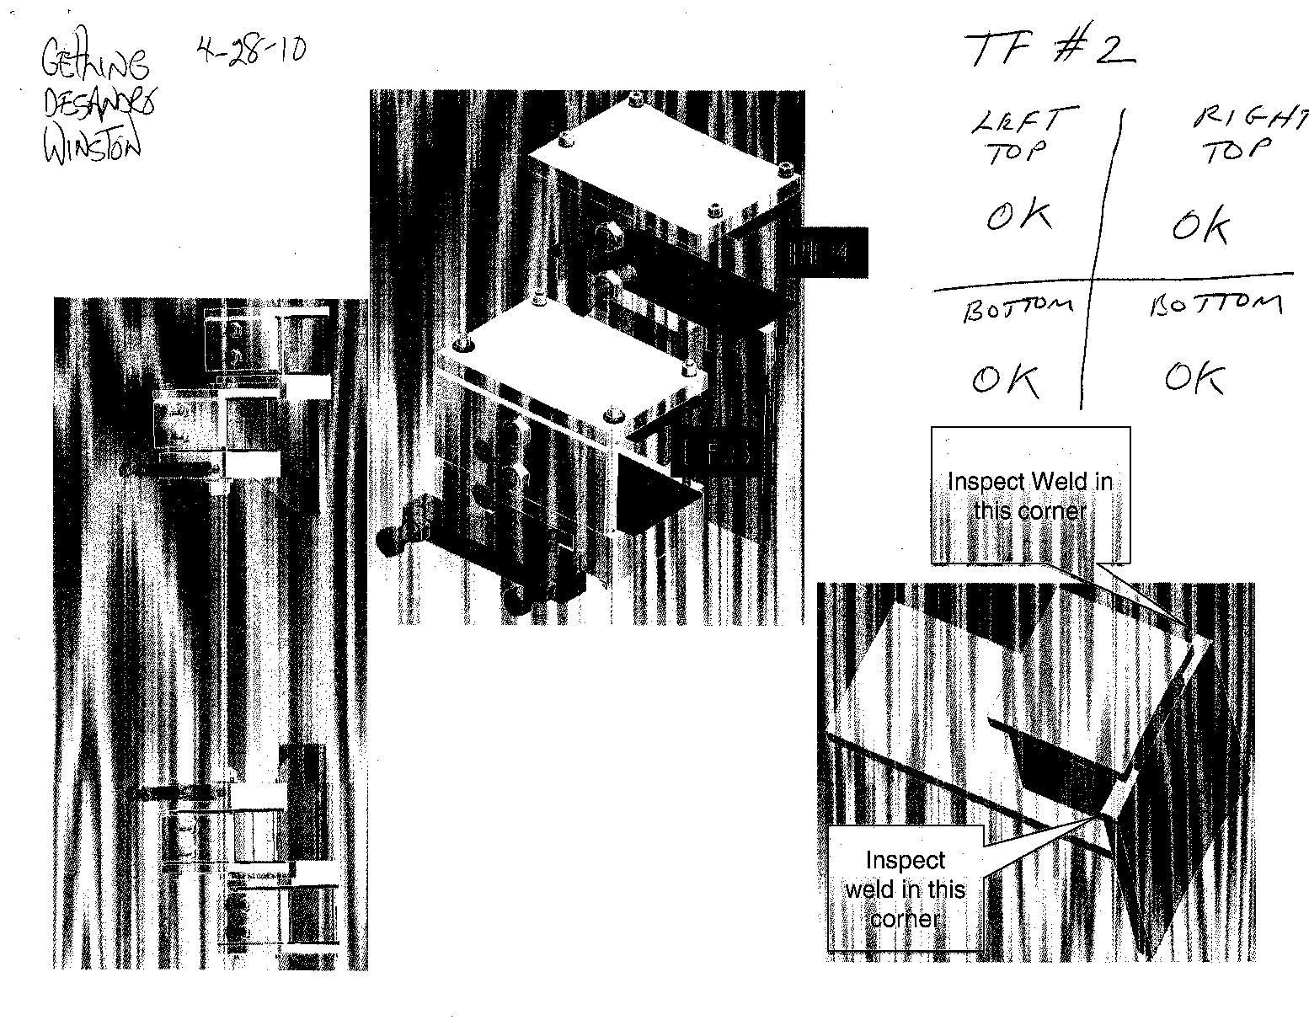

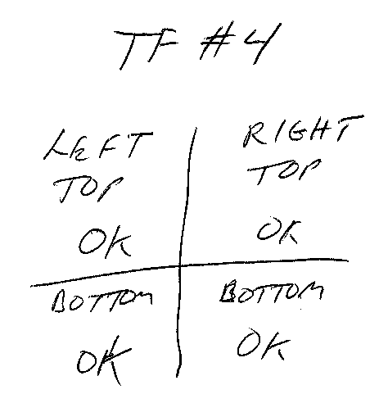
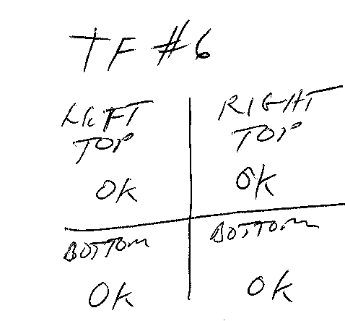

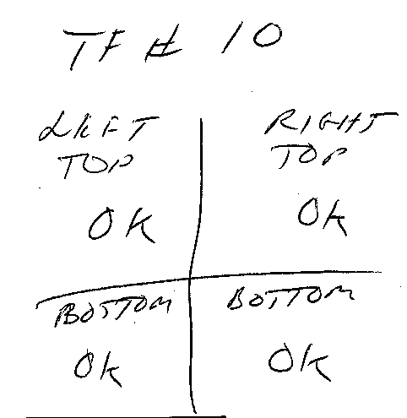
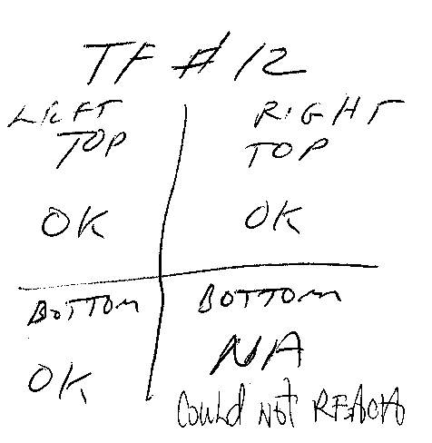
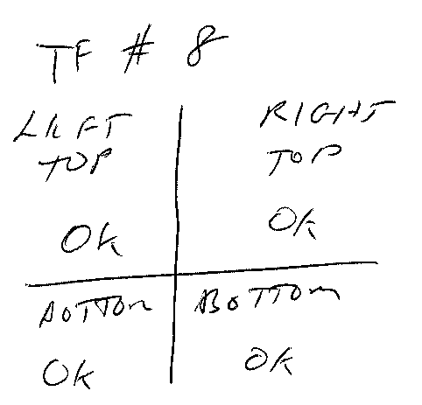
Appendix C References

Reference 11
Pete,

"LPPI" is a term I came up to describe the nominal upgrade target, namely a 5 second (long pulse) plasma flat top where the OH current does not complete the second swing, only delivering part of its double-swing flux. The remaining flux is supplied non-inductively. Thus LPPI stands for "Long Pulse Partial Inductive".

"SPFI" is another operating mode I felt the need to describe because it forces the design to contend with the full second swing current. In this case the pulse has a flat top less than 5 seconds (short pulse) but the full OH double-swing flux is used and it is sufficient to drive the current without reliance on non-inductive means. In this case it turns out that the flat top duration is limited by the OH I2T, not the available OH flux, which is more than sufficient per my plasma model.

So, these two cases bracket how the machine will operate.

You can see this here:

http://www.pppl.gov/~neumeyer/NSTX_CSU/PF_Coil_Summary.htm

I have not put this in the GRD, but I can if you like. In fact the SPFI condition is probably the design driver for many of the out-of-plane loads because it pushes the OH to -24kA second swing. The GRD calls for an OH flux of 2.0 Wb which we supply in the LPPI case. With the SPFI case and the full second swing we get 2.3Wb.

CHas

On Mar 29, 2011, at 2:27 PM, Peter Titus wrote:

Charlie: What do these mean? Long Pulse something? Short Pulse Someithing?
-Peter
Tmax_LPPI Tmax_SPFI

Charles L. Neumeyer
Princeton University, Plasma Physics Laboratory
Forrestal Campus, U.S. Route #1 North at Sayre Drive
P. O. Box 451
Princeton, N. J. 08543
Tel: 609-243-2159
Mobile: 609-313-4738
Fax: 609-243-3266

Reference 12

April 5 2011 email from Jim Chrzanowski:

Pete

FYI- The PF-2, PF-3 and PF-4 were all manufactured by PPPL. Their insulation scheme is (4) half-lapped layers of Mylar insulation, followed by (2) half-lapped layers of Fusa-Fab” B-stage insulation.

Jim

