**NSTX**

**Global Thermal Analysis of Center Stack**

**Heat Balance**

**NSTXU-Calc-11-01-00**

**June 1, 2011**

**Prepared By:**

___________________________________

Art Brooks, Engineering Analyst

**Reviewed By:**

**________________________________________**

Peter Titus, Branch Head, Engineering Analysis Division

**Reviewed By:**

_______________________________________

Phil Heitzenroeder, Head, Mechanical Engineering

**PPPL Calculation Form**

Calculation # **NSTXU-CALC-11-01-00** Revision # **0** WP: **1672**

**Purpose of Calculation:** (Define why the calculation is being performed.)

Assess the thermal response of the Center Stack (CS) during normal operation. The resulting temperature distributions and heat flows to active and passive cooling systems are presented. These results will feed further qualification analysis of associated components and systems.

**References** (List any source of design information including computer program titles and revision levels.)

1. NSTX_CSU-RQMTS-GRD General Requirements Documents, Rev 3
2. Design Point Spreadsheet “NSTX_CS_Upgrade_100504.xls”
3. ProE Model of Center Stack Tiles - aj_center_case_analysis_rev2.asm

**Assumptions** (Identify all assumptions made as part of this calculation.)

All tiles are ATJ graphite as dictated by project. The CSFW is assumed to be thermally insulated from the OH coil and radiation cooled. Assumed emissivity is 0.3 for Li operation and 0.7 without. The CSAS, IBDvs and IBDhs are assumed water cooled at 3 m/s.

**Calculation** (Calculation is either documented here or attached)

See body of report that follows

**Conclusion** (Specify whether or not the purpose of the calculation was accomplished.)

The results presented here show:

1. The highest tile temperature is the IBDhs which receives the largest fraction of power as expected.
2. Most of the heat deposited on the CS Tiles is removed by the CS Cooling tubes for the scenarios analyzed.
3. The CS Cooling tubes provide adequate protection of the neighboring coils and O-Rings
4. With modest back pressure the outlet water temperature will remain below boiling.
5. Cooling capacity demands are reasonable - heat loads have been thermally buffered.

Cognizant Engineer’s printed name, signature, and date

**I have reviewed this calculation and, to my professional satisfaction, it is properly performed and correct.**

Checker’s printed name, signature, and date

**Executive Summary**

An analysis was done to assess the thermal response of the Center Stack (CS) during normal operation. The resulting temperature distributions and heat flows to active and passive cooling systems are presented. These results will feed further qualification analysis of associated components and systems.

The cooled sections at the inboard diverter are needed to protect the neighboring coils as well as limiting temperatures in the CS casing. The analysis shows that the inclusion of Grafoil under the CSAS, IBDvs and IBDhs combined with the active cooling will significantly limit the thermal ratcheting of the tiles whether Li coated (with assumed emissivity of 0.3) or uncoated (with assumed emissivity of 0.7). The active cooling also offers adequate protection of the neighboring PF and OH coils and reduces the heating of the CS Casing. The flow rate and back pressure are high enough to avoid boiling of the water.

For the un-cooled portion of the CS casing Grafoil has less of an impact. With or without Grafoil, the CS casing ratchets up to roughly the same temperature. The time to reach the max temperature however is shorter with the Grafoil. Its use should be based on other considerations.

The results assumed the PP, VV and OD were actively cooled with surface temperatures staying below 100C. If the temperatures of those components are allowed to increase to 200C, there is only a modest increase in IBD temperature (~1 C) and the power to the cooling system. The CS casing is more sensitive since it is only cooled by radiation. Its temperature increases ~50 C from 250 C to 300 C.

**Introduction**

The NSTX Center Stack Upgrade will incorporate a CS with a larger radial build but otherwise similar in design to the original. The backbone structure is an inconel casing on which protective ATJ Graphite tiles will be mounted. The CS is composed of a number of sections which for design purposed are subject to different heating and cooling requirements.

The smallest section is referred to simply as the CS and First Wall (CSFW). The CSFW will have the lowest heating from the plasma of all the sections (the use of the CSFW as a natural diverter as done in the original CS is not planned). There is no active cooling of the CSFW; it relies solely on radiation cooling to the cooler outboard surfaces of the Vacuum Vessel (VV), Passive Plates (PP) and outboard Diverter (OD). The region adjacent to the CSFW is referred to as the Angled Section of the CS (CSAS). Next is the Inboard Diverter composed of two sections – the Vertical section (IBDvs) and the Horizontal Section (IBDhs). Of these the IBDhs is the most higher loaded.

The CSAS, IBDvs and IBDhs are mounted on the region of the CS that is radially large enough to accommodate cooling tubes on the surfaces outside the vacuum boundary. The cooling tubes are required for the protection of the neighboring coils (ie PF1a,b,c) and the O-rings at the Bellows and Ceramic Joint (see Figure 1 and Figure 2) and for cooling of the tiles. Part of the analysis herein was to determine how much heat could be safely removed by the cooling system without the risk of overheating (ie boiling) the water coolant. The tile mounting system, in particular the use of Grafoil to enhance thermal conduction to the tile, was examined to determine if there was an advantage to incorporating Grafoil into the design.

The plasma facing components (PFC, which include all tiles mounted on the CS and existing outboard components) are subject to heat fluxes as defined by the NSTX General Requirements Document (GRD). The machine is designed for 14 MW of power for a 5 sec pulse with a pulse reprate of 1200 sec. The design is governed by the heating power distribution for the Double Null (DN) operation where heat is distributed evenly between the upper and lower IBD. The Single Null (SN) operation are to withstand the specified power for whatever duration is allowable based on the choice of materials, geometry and cooling driven by the DN requirements.

The project has rejected the use of Carbon Fiber Composites (CFC) because of the high lithium retention in their porous structure. Consequently the machine performance may be limited by the use of isotropic graphite such as the ATJ. This will be addressed in subsequent structural analyses of the tiles.



Figure CS Coils and O-Ring Locations



Figure Cooling at CS Casing

**Assumptions**

The CSFW is assumed to be thermally insulated from the OH coil in that no credit is taken for heat loss to the OH during normal operation. (The adequacy of the insulation needs to be assessed to assure it provides protection of the OH during normal and off normal events).

The CSAS, IBDvs and IBDhs are assumed cooled by two tubes top and two tubes bottom which spiral thru the inside adjoining surfaces of the CS casing. Even though the heat transfer (film) coefficient between the water and the tube ID is large, the cooling is shown to be limited by the amount of water that can be pushed thru (ie m_dot*Cp). At flow velocities limited to ~3 m/s, the flow rate is 0.15 kg/s thru the 3/8” OD tubes. The tubes are not modeled explicitly; the analysis uses an effective heat transfer coefficient on the cooled surfaces that includes the impact of the water-tube film coefficient, the conduction thru the structure and the mass transport as shown in figure 5. This leads to an effective surface heat transfer coefficient of ~300 w/m-C. Allowing ~50 C rise in temperature going thru the tubes leads to an average cooling capacity of 30 kW per tube or 120 kW in total. The average input power over the full pulse is 14 MW *5/1200 = 58.3 kW. The inboard tubes should provide adequate cooling if the heat load is thermally buffered.

The analysis considers two conditions for the radiation environment – a surface emissivity of graphite (0.7) on all PFCs and the assumption that all surfaces may be Li coated with a much lower surface emissivity of 0.3.

The plasma heating on specific tiles is given in the table based on the GRD specs. This accounts for ~2/3 of the 14 MW. The balance is applied as the average thermal radiation from the plasma which is assumed to be uniform distributed over all plasma viewing surfaces.

**Method of Analysis**

An ANSYS 2D Axisymmetric Thermal Radiation Model was generated of the CS and outboard VV, PP & OD using PLANE55 elements as shown in . The radiation exchange between all vacuum surfaces was modeled with MATRIX50 elements as shown in Figure 4 as are the cooled and heated surfaces.

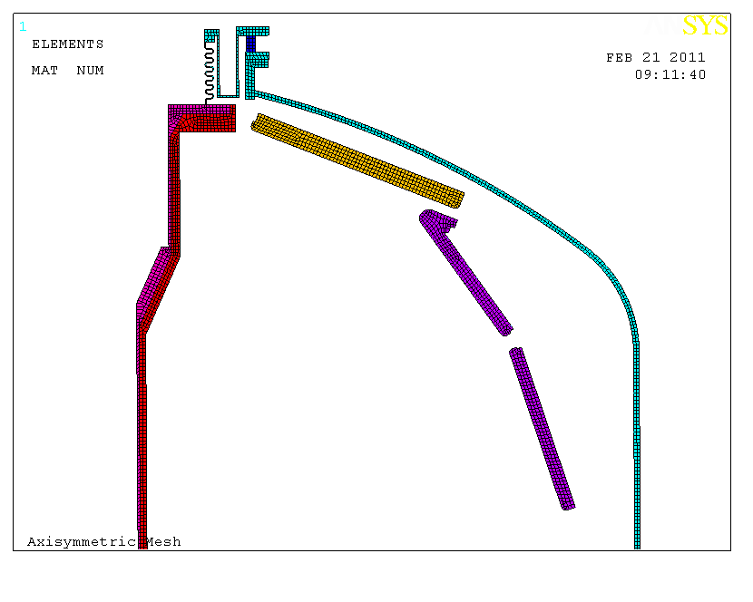

Figure ANSYS Axisymmetric Mesh

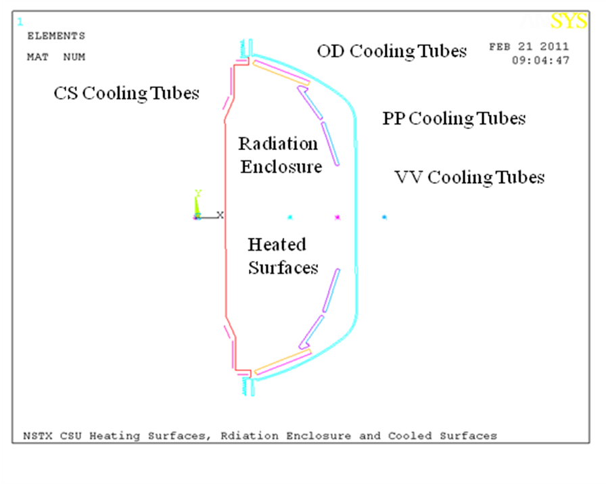

Figure Heating Surfaces, Radiation Enclosure, and Cooled Surfaces

Figure Effective Surface Heat Transfer

Table Effect Surface Head Transfer

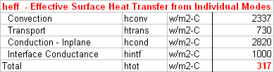



Table Applied Heat Fluxes

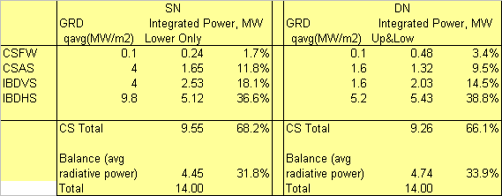

**Results**

The model was run for the DN with surface emissivity=.3 &.7 to bracket the expected surface emissivity with and without Li Coating on Graphite Tiles. The design is to be driven by the DN. The tile temperatures are shown to be only slightly sensitive to surface emissivity since the tiles subject to the highest heat loads are actively cooled and the CS which is radiation cooled has low heat loads.

Figure 6 thru **Error! Reference source not found.** below show results for DN at e=.7 then e=.3. These results assumed active cooling only at the IBDhs , IBDvs and the CSAS. They also assume good thermal contact between the tiles and the casing. The CSFW is only radiation cooled.

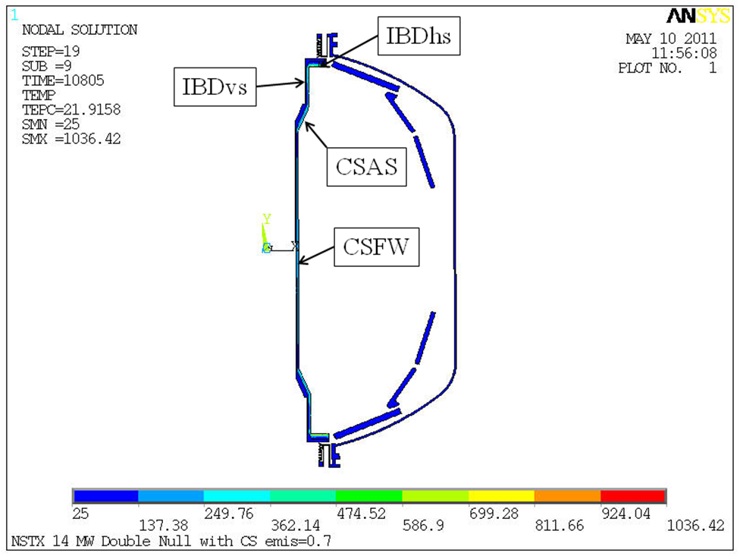

Figure Ratcheted Temperature Distribution DN , e= 0.7

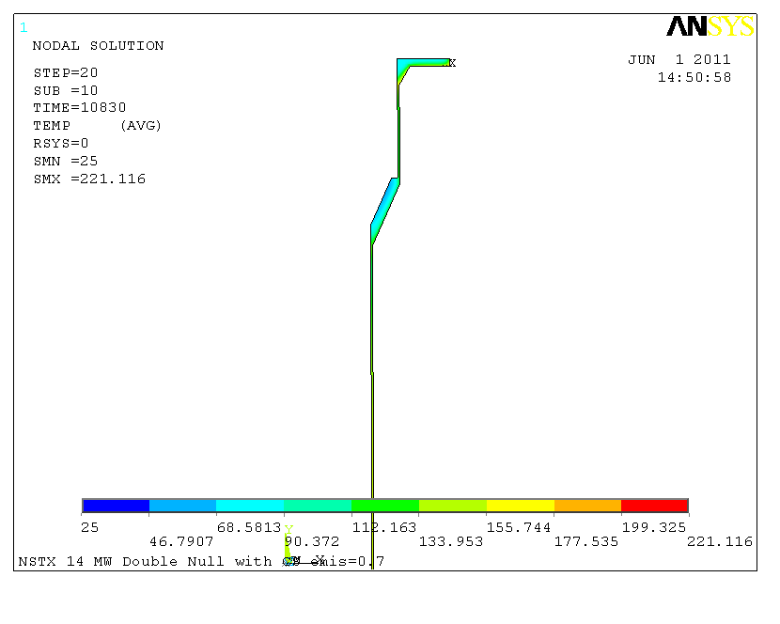

Figure CS Casing - Ratcheted Temperature Distribution DN with 0.7 emissivity

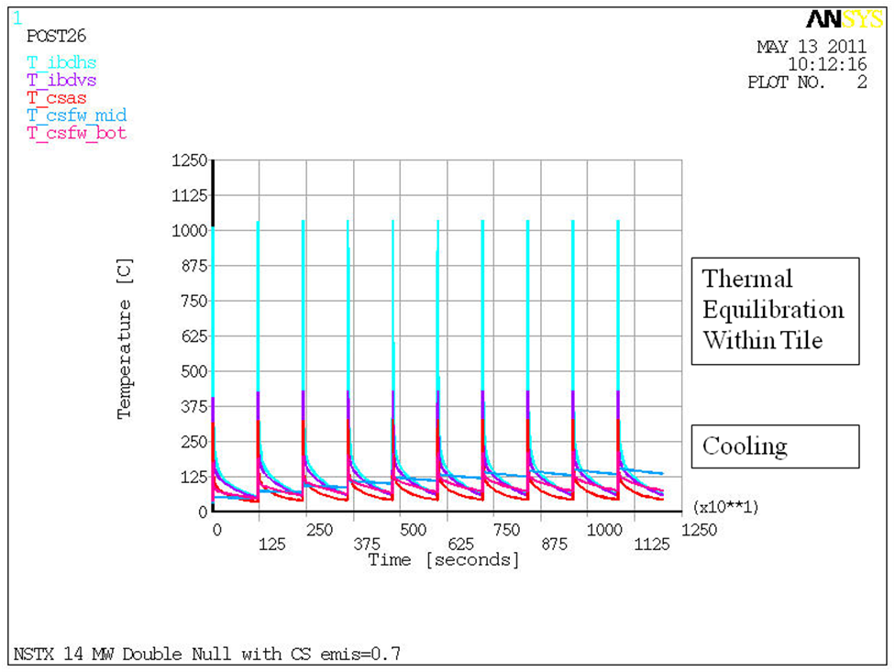

Figure CS Transient Temperature Response, DN, e=0.7

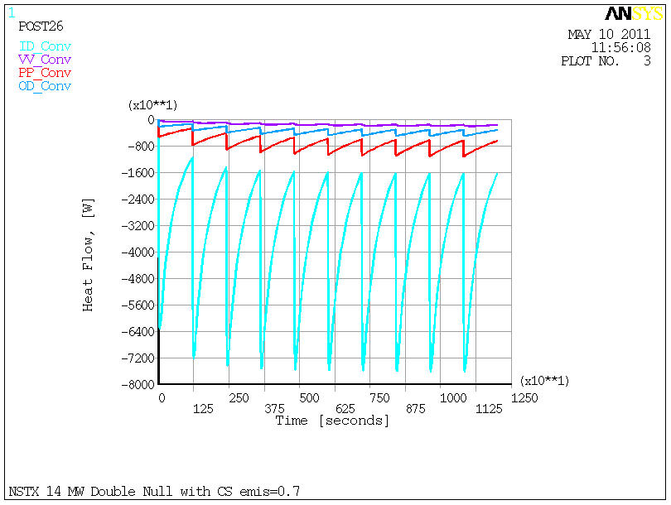

Figure Heat Flow to Cooling Systems DN e=.7

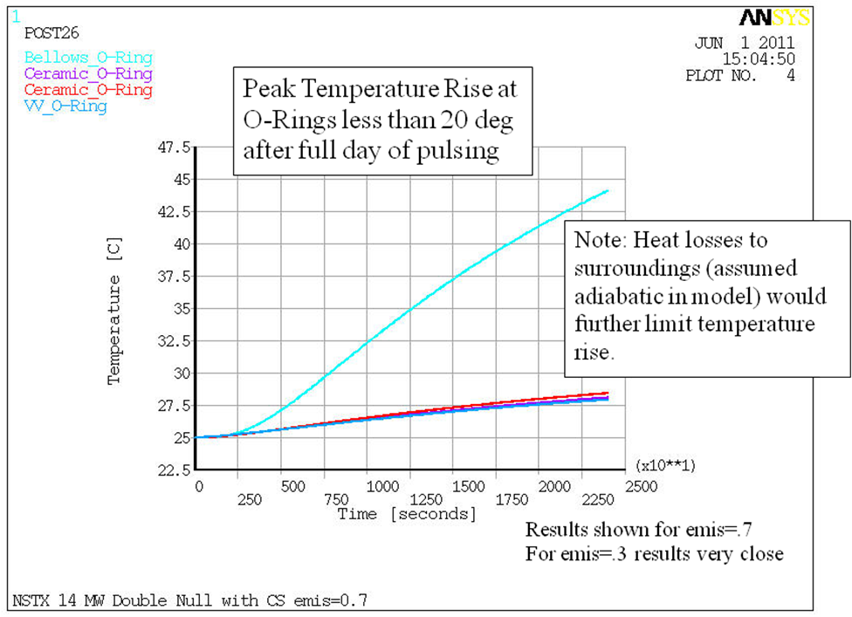

Figure Temperature rise at O-rings for emis=.7

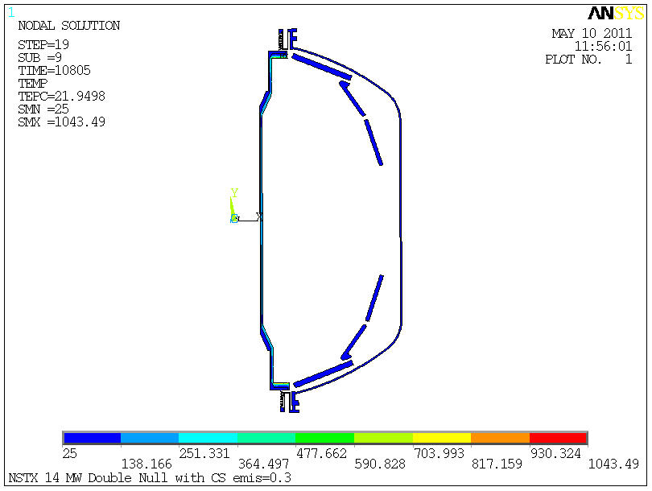

Figure Ratchet Temperature Distribution DN e=.3

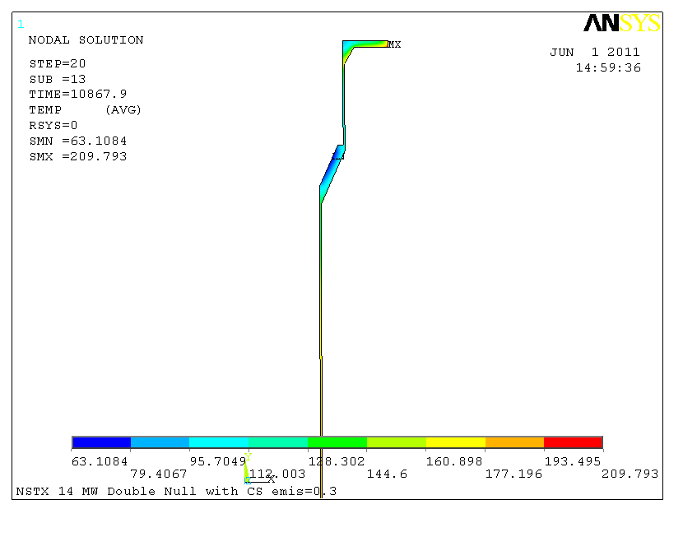

Figure CS Ratcheted Temperature Distribution, DN, e=.3

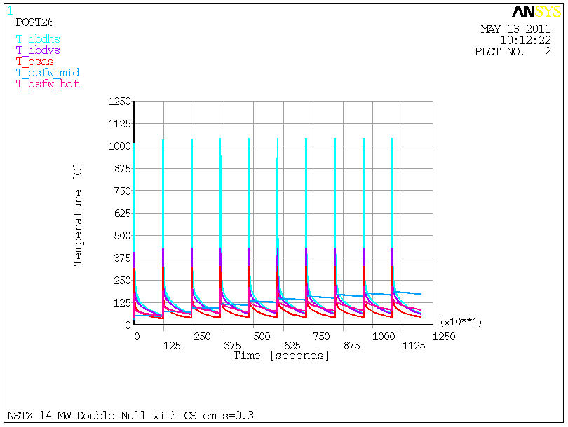

Figure CS Transient Temperature Response, DN, e=.3

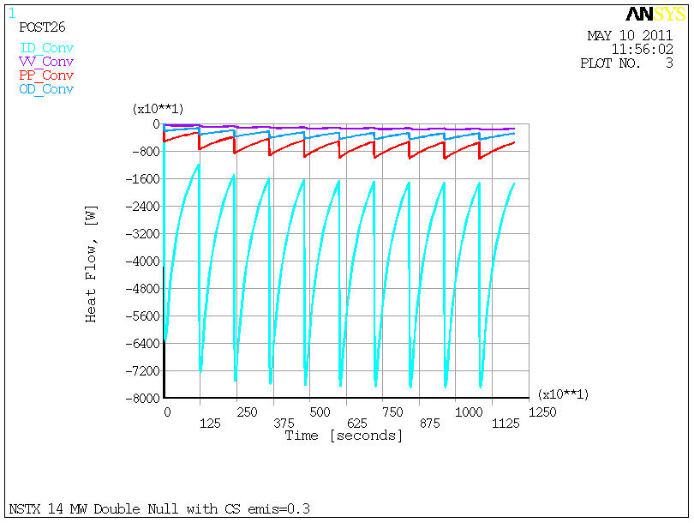

Figure Heat Flow to Cooling Systems, DN, e=.3

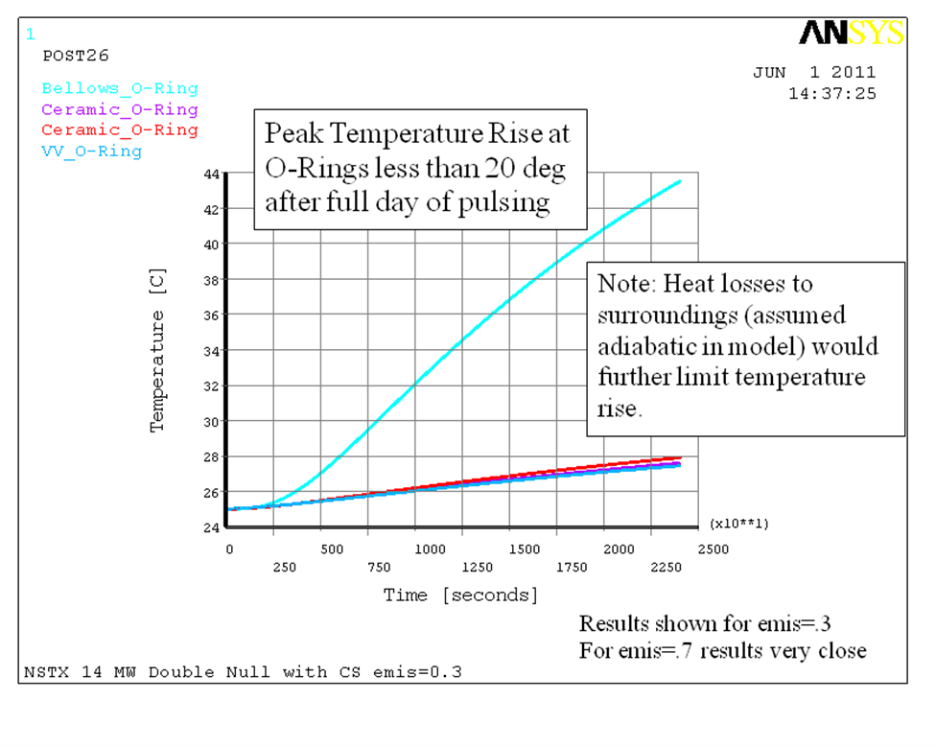

Figure Temperature rise at O-rings for emis=0.3



Figure Estimate of SN pulse length to limit temperature to DN level of 1000 C

Summary

The results presented here show:

1. The highest tile temperature is the IBDhs which receives the largest fraction of power as expected.
2. Most of the heat deposited on the CS Tiles is removed by the CS Cooling tubes for the scenarios analyzed.
3. The CS Cooling tubes provide adequate protection of the neighboring coils and O-Rings
4. With modest back pressure the outlet water temperature will remain below boiling.
5. Cooling capacity demands are reasonable - heat loads have been thermally buffered.