NSTX

THERMAL STRESSES ON OH-TF COILS

NSTX-xxxx-xx-xxx-xx

June 11, 2009

Prepared By:

___________________________________
Srinivas Avasarala, PPPL Mechanical Engineering
Reviewed By:
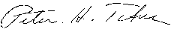
________________________________________
Peter Titus, Branch Head, Engineering Analysis Division
Reviewed By:

_______________________________________
Phil Heitzenroeder, Head, Mechanical Engineering

Executive Summary
The objective of this analysis was to estimate the anticipated hoop stresses in the OH coil during the unusual occurrence of the TF at its peak temperature from a normal pulse, and a cold un-energized CS. The CS was to have been assumed wound on the TF with no gap in-between. This fault condition is expected to be the worst loading consequence of having no gap between the coils. Stresses were found to be acceptable, supporting the “no gap” design choice.
The OH coil is cooled to 12 C (53.6 F) and the TF coil is heated up to 100 C (212 F). Both the coils are made up of Copper and there is Epoxy glass insulation in between the OH and TF coils, and also between each of the TF coils. A stress pass is then run on this model that showed a maximum Von-Mises stress of approximately 22 ksi on the inner diameter of the OH coil. Also, the stresses due to stress concentration near the cooling holes on the TF coil were found to be near 24 ksi. Although the maximum stress in the model is 35 ksi, this region is near the ends and the high stresses could be attributed to the relative deformation between the insulation and the coils. Symmetry is taken advantage of, and a 90 degree solid is modeled and appropriate boundary conditions are applied. The mesh has 47583 nodes and 7696 elements. When the mesh is refined and the nodes are increased to 64907, the stress rise is with in 3%. This shows that the mesh is adequate.

Table of Contents
List of Figures 4
List of Tables 4
Modeling 5
Boundary conditions for Steady State Thermal Analysis 6
Boundary condtions for Structural Analysis 7
Results 7

List of Figures
Figure 1. Finite Element Model of the OH-TF Coil Assembly. 5
Figure 2. Temperature Distribution on the OH-TF Coil Assembly 6
Figure 3. Displacement Constraints on the OH-TF Coil Assembly. 7
Figure 4. Stress Distribution on the OH-TF Coil Assembly 8
Figure 5. Stress Distribution on the OH-TF Coil Assembly with Refined Mesh. 8

List of Tables
Table 1. Mesh Statistics. 5
Table 2. Material Properties of Copper Alloy. 5
Table 3. Material Properties of Epoxy Glass. 6
Table 4. Results. 7
Table 5. Mesh (Refined) Statistics 8

Modeling:

The solid model of the coil assembly has no insulation and the gaps between the coils were filled with insulation. The 360 degree model is cut into 90 degree model and imported into workbench. The model is then meshed (workbench automatically chooses the element type depending on the analysis) and appropriate boundary conditions are applied.

Figure1: FE model of the OH-TF coil assembly 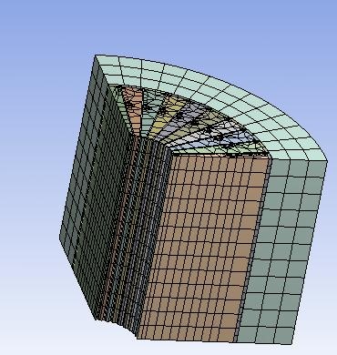
TABLE 1
Model > Mesh
Relevance | 0
Element Size | Default
Nodes | 47583
Elements | 7696

The OH and TF coils are made up of Copper and the insulation is made up of Epoxy glass.
TABLE 2
Copper Alloy > Constants
Young's Modulus | 1.5954e+007 psi
Poisson's Ratio | 0.34
Thermal Expansion | 1.e-005 1/°F
Thermal Conductivity | 5.3633e-003 BTU/s·in·°F
TABLE 3
Epoxy Glass > Constants
Young's Modulus | 1.e+006 psi
Poisson's Ratio | 0.3
Thermal Expansion | 1.6667e-005 1/°F
Thermal Conductivity | 6.6874e-005 BTU/s·in·°F

Boundary Conditions for Steady State Thermal Analysis:

The OH coil was held at 12 C and the TF coils are held at 100 C and the results were trivial. The results were then input as a thermal condition in the analysis.

Figure 2: Temperature distribution on the OH-TF coil assembly
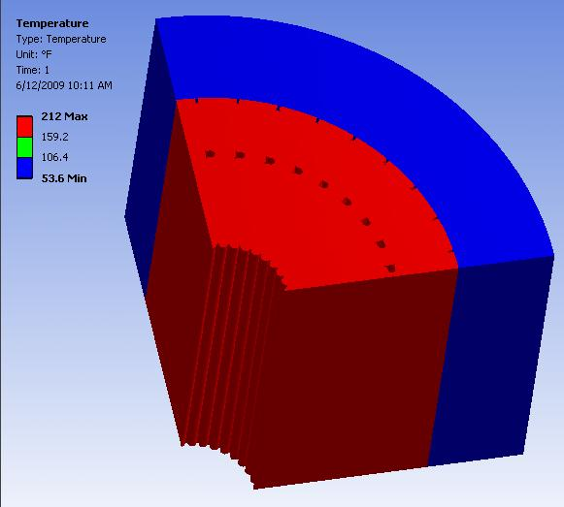

Boundary Conditions for Structural Analysis:

The bottom of the OH-TF coil is constrained vertically (Y) the two faces are constrained in X and Z direction as shown in the following figure.

Figure 3: Displacement constraints on the OH-TF assembly
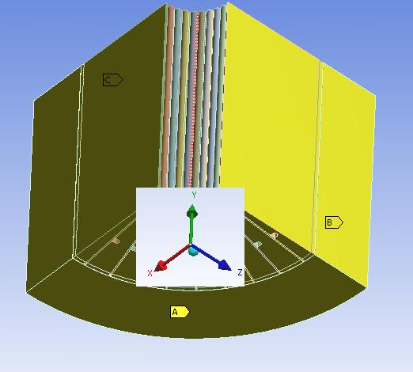

Results:

A stress pass is run and the results are as follows.

TABLE 4
Model > Static Structural > Solution > Results
Object Name | Equivalent Stress | Total Deformation
State | Solved
Type | Equivalent (von-Mises) Stress | Total Deformation
Display Time | End Time
Results
Minimum | 141.79 psi | 4.4794e-005 in
Maximum | 34296 psi | 1.9603e-002 in

Figure 4: Stress distribution on the OH-TF assembly
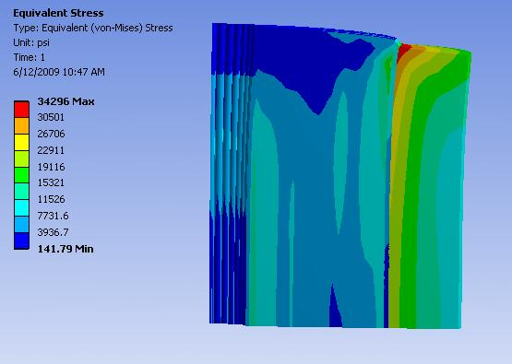

The max stress occurs at the interface between the insulation and the OH coil. This is due to the bonded contact between the two surfaces and can be ignored. Therefore, the maximum hoop stress in the model is found to be around 22 ksi. To validate the results, the mesh was refined and no appreciable rise in stresses was found.

TABLE 5
Model > Mesh (Refined)
Relevance | 40
Element Size | Default
Nodes | 64907
Elements | 10736

Figure 5: Stress distribution on the OH-TF assembly with refined mesh
