

NSTX Upgrade

OH Conductor Fatigue and Fracture Mechanics Analyses

NSTXU-CALC-133-09-00

Rev 0

Nov 2010

Prepared By:

___________________________________

Peter Titus, PPPL Mechanical Engineering

Reviewed By:

________________________________________

Irving Zatz Engineering Analysis Division

________________________________________

James Chrzanowski NSTX Cognizant Engineer

PPPL Calculation Form

Calculation # NSTXU-CALC-133-09-00 Revision # 00 WP #, 1672

(ENG-032)

Purpose of Calculation: (Define why the calculation is being performed.)

To establish a fatigue allowable for the OH coil conductor planned for use in the NSTX upgrade

References (List any source of design information including computer program titles and revision levels.)

[1] OH Stress Analysis, A. Zolfaghari, Calc #NSTXU-CALC-133-08

[2] Memo: Fatigue life of VS coil made of pure copper C11000 To:Peter Titus From:Jun Feng Date: 12/21/2009

[3] Memo to Charlie Neumeyer, NSTX distribution From: Peter Titus, Jun Feng Subject: Fatigue Analysis of OH Conductor Date: November 24 2009

Assumptions (Identify all assumptions made as part of this calculation.)

The fracture mechanics calculations have been performed for three crack areas: .125,.25 and .5 mm^2 which are taken to correspond to crack depths of .353, .5, and .7 mm. The ratio a/b or crack depth to width is taken as 1.0

Calculation (Calculation is either documented here or attached)

See the Body of the calculation

Conclusion (Specify whether or not the purpose of the calculation was accomplished.)

Hoop Stress, or max principal stress peak in the OH conductor must remain below 125 MPa to satisfy fracture based fatigue requirements.

Cognizant Engineer’s printed name, signature, and date

James Chrzanowski

I have reviewed this calculation and, to my professional satisfaction, it is properly performed and correct.

Checker’s printed name, signature, and date

Irving Zatz

Table of Contents

Title Page 1

Eng-33 Cover Sheet 2

Table of Contents 3

Executive Summary 4

Digital Coil Protection System (DCPS) Input 5

Static Criteria 5

Fatigue Criteria 5

Fatigue Data 6

NSTX OH Conductor Braze Test Results (Excerpt) 7

PDR Fracture Mechanics Evaluation, and Procedure: 8

Analysis Results 9

Selected Results in Spreadsheet form 10

Appendix A

FAT2.FOR ( written by J. Feng of MIT-PSFC, Modified slightly by P. Titus) 11

Appendix B

Memo: Fatigue life of VS coil made of pure copper C11000 Memo To:Peter Titus

From:Jun Feng Date: 12/21/2009 17

Executive Summary:

The OH coil was originally sized based on static allowables. Two areas were checked, The peak ID Tresca stress, which must be below 1.5*Sm, and the average stress in the cross section which must be below Sm. These evaluations have been carried out in the OH coil stress calulation, ref [1].

NSTX structural criteria, and the GRD require fatigue to be addressed. The criteria allows either SN or fracture mechanics evaluations of fatigue. For SN evaluations, the more restrictive of 2 on stress and 20 on life must be met. For the Fracture mechanics evaluation a factor of 2 on flaw size, 1.5 on fracture toughness, and 2 on life must be met. The stress levels in the NSTX-U OH coil satisfy the fracture mechanics criteria, and therefore satisfy the NSTX structural requirements.

|  |  |  |  |
| --- | --- | --- | --- |
| Criteria | Stress Level ant Type | Actual ref [1] |  |
| SN 2 on stress | 112 MPa (Tresca) | 142 | Fails |
| SN 20 on life | 180 (Tresca) | 142 | Passes |
| Fracture Mechanics with a flaw size less than .7mm  1.5 on KIc and 2 on Cycles | 140 MPa (Max Principal or Hoop) | 101 | Passes |
| 4 on cycles | 125 MPa (Max Principal or Hoop) | 101 | Passes |

The fracture mechanics calculation forms the basis of the qualification of the OH stresses and potentially other copper conductors used in PF system. A lower bound on the fracture mechanics results and other data is used to develop an allowable. Flaw sizes are assumed at this point, but will have to be imposed as an inspection requirement for teh OH conductor manufacturer. Measured NSTX OH conductor braze joint fatigue life is included in the evaluation, as well as published SN data for comparison.

The fracture mechanics calculations have been performed for three crack areas: .125,.25 and .5 mm^2 which are taken to correspond to crack depths of .353, .5, and .7 mm. The ratio a/b or crack depth to width is taken as 1.0

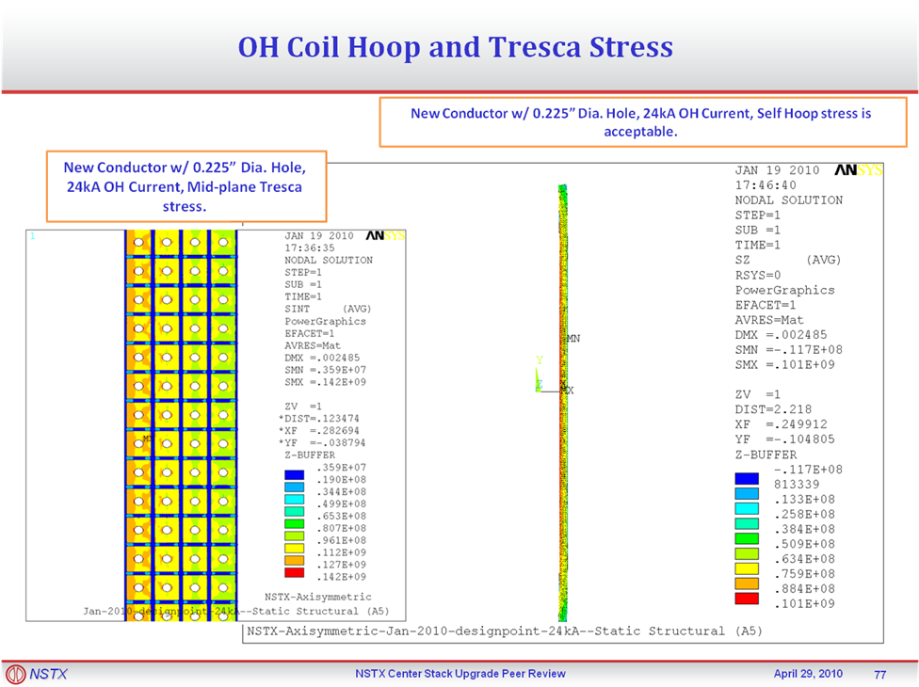

Figure 1 Stress Results from Ref [1] presented at the PDR

Digital Coil Protection System (DCPS) Input

Input to the DCPS will be developed in the OH stress calculation, and in other calculations using similar copper conductors such as the coax cable calculation . The max principal stress in the conductor must be kept below 125 MPa.

Criteria – Static Allowables for Coil Copper Stresses

The TF copper ultimate is 39,000 psi or 270 MPa . The yield is 38ksi (262 MPa). Sm is 2/3 yield or 25.3ksi or 173 MPa – for adequate ductility, which is the case with this copper which has a minimum of 24% elongation. Note that the ½ ultimate is not invoked for the conductor (It is for other structural materials) . These stresses should be further reduced to consider the effects of operation at 100C. This effect is estimated to be 10% so the Sm value is 156 MPa.

* From: I-4.1.1 Design Tresca Stress Values (Sm), NSTX_DesCrit_IZ_080103.doc
* • (a) For conventional (i.e., non-superconducting) conductor materials, the design Tresca stress values (Sm) shall be 2/3 of the specified minimum yield strength at temperature, for materials where sufficient ductility is demonstrated (see Section I-4.1.2). *
* It is expected that the CS would be a similar hardness to the TF so that it could be wound readily. For the stress gradient in a solenoid, the bending allowable is used. The bending allowable is 1.5*156 or 233MPa,

Criteria – Fatigue Allowables for Coil Copper Stresses

From the NSTX_DesCrit_IZ_080103.doc:

A fatigue strength evaluation is required for those NSTX CSU components with undetectable flaws that are either cycled over 10,000 times or are exposed to cyclic peak stresses exceeding yield stress.

Criteria Document

Mean Stress Effect:

Salt

Seq = ___________

1 - (Smean/Su)

where Su = tensile strength

From the NSTX GRD:

For engineering purposes, number of NSTX pulses, after implementing the Center Stack Upgrade, shall be assumed to consist of a total of ~ 60,000 pulses based on the GRD specified pulse spectrum.

The NSTX criteria document requires either a SN fatigue qualification or a fracture mechanics qualification. The SN qualification requires use of the tresca to enter the SN curve with factors of safety based on the worst of 2 x Stress or 20 on Life. The design stress in the OH is well beyond what can be qualified. The alternative is to use fracture mechanics and to implement appropriate NDE on the conductor manufacture to ensure flaw sizes are acceptable for the required life.

Section I-4.2.3 Crack Growth Limitation

The following commentary and interpretation and numerical example is offered pertaining to the NSTX Design Criteria Document's discussion of Crack Growth Limitations:

- A maximum permissible initial flaw in any component, for a given specified load and environmental condition, shall be determined either analytically, in which case the initial flaw size would be backcalculated assuming four (4) times the number of design life cycles, or experimentally, based on appropriate component testing, where the initial flaw size would be based on twice the number of cycles to failure of the test article.

##### I-4.2.3.1 Stress Analysis

Fatigue crack growth (stage 2) is controlled primarily by maximum principal stresses (or strains). Fatigue cracks will usually propagate in the direction normal to a uniaxially applied load and the rate and direction of crack growth can be affected by loads and restraints in other directions as well as environmental conditions.

##### I-4.2.3.2 Material Inspection Requirement

For inspection, a back calculated initial flaw size, based on a failure scenario, cannot be smaller than twice the minimum flaw that can be resolved by nondestructive testing of the same material in a comparable geometry. The inspection procedure and results shall be included in the design documentation, along with the description of any calibration fixtures used.

An established LEFM methodology shall be used to account for the mean stress effect on crack growth rates, where deemed appropriate. The effects of closure and interaction for applicable load scenarios and values of R shall be considered.

Fatigue Data

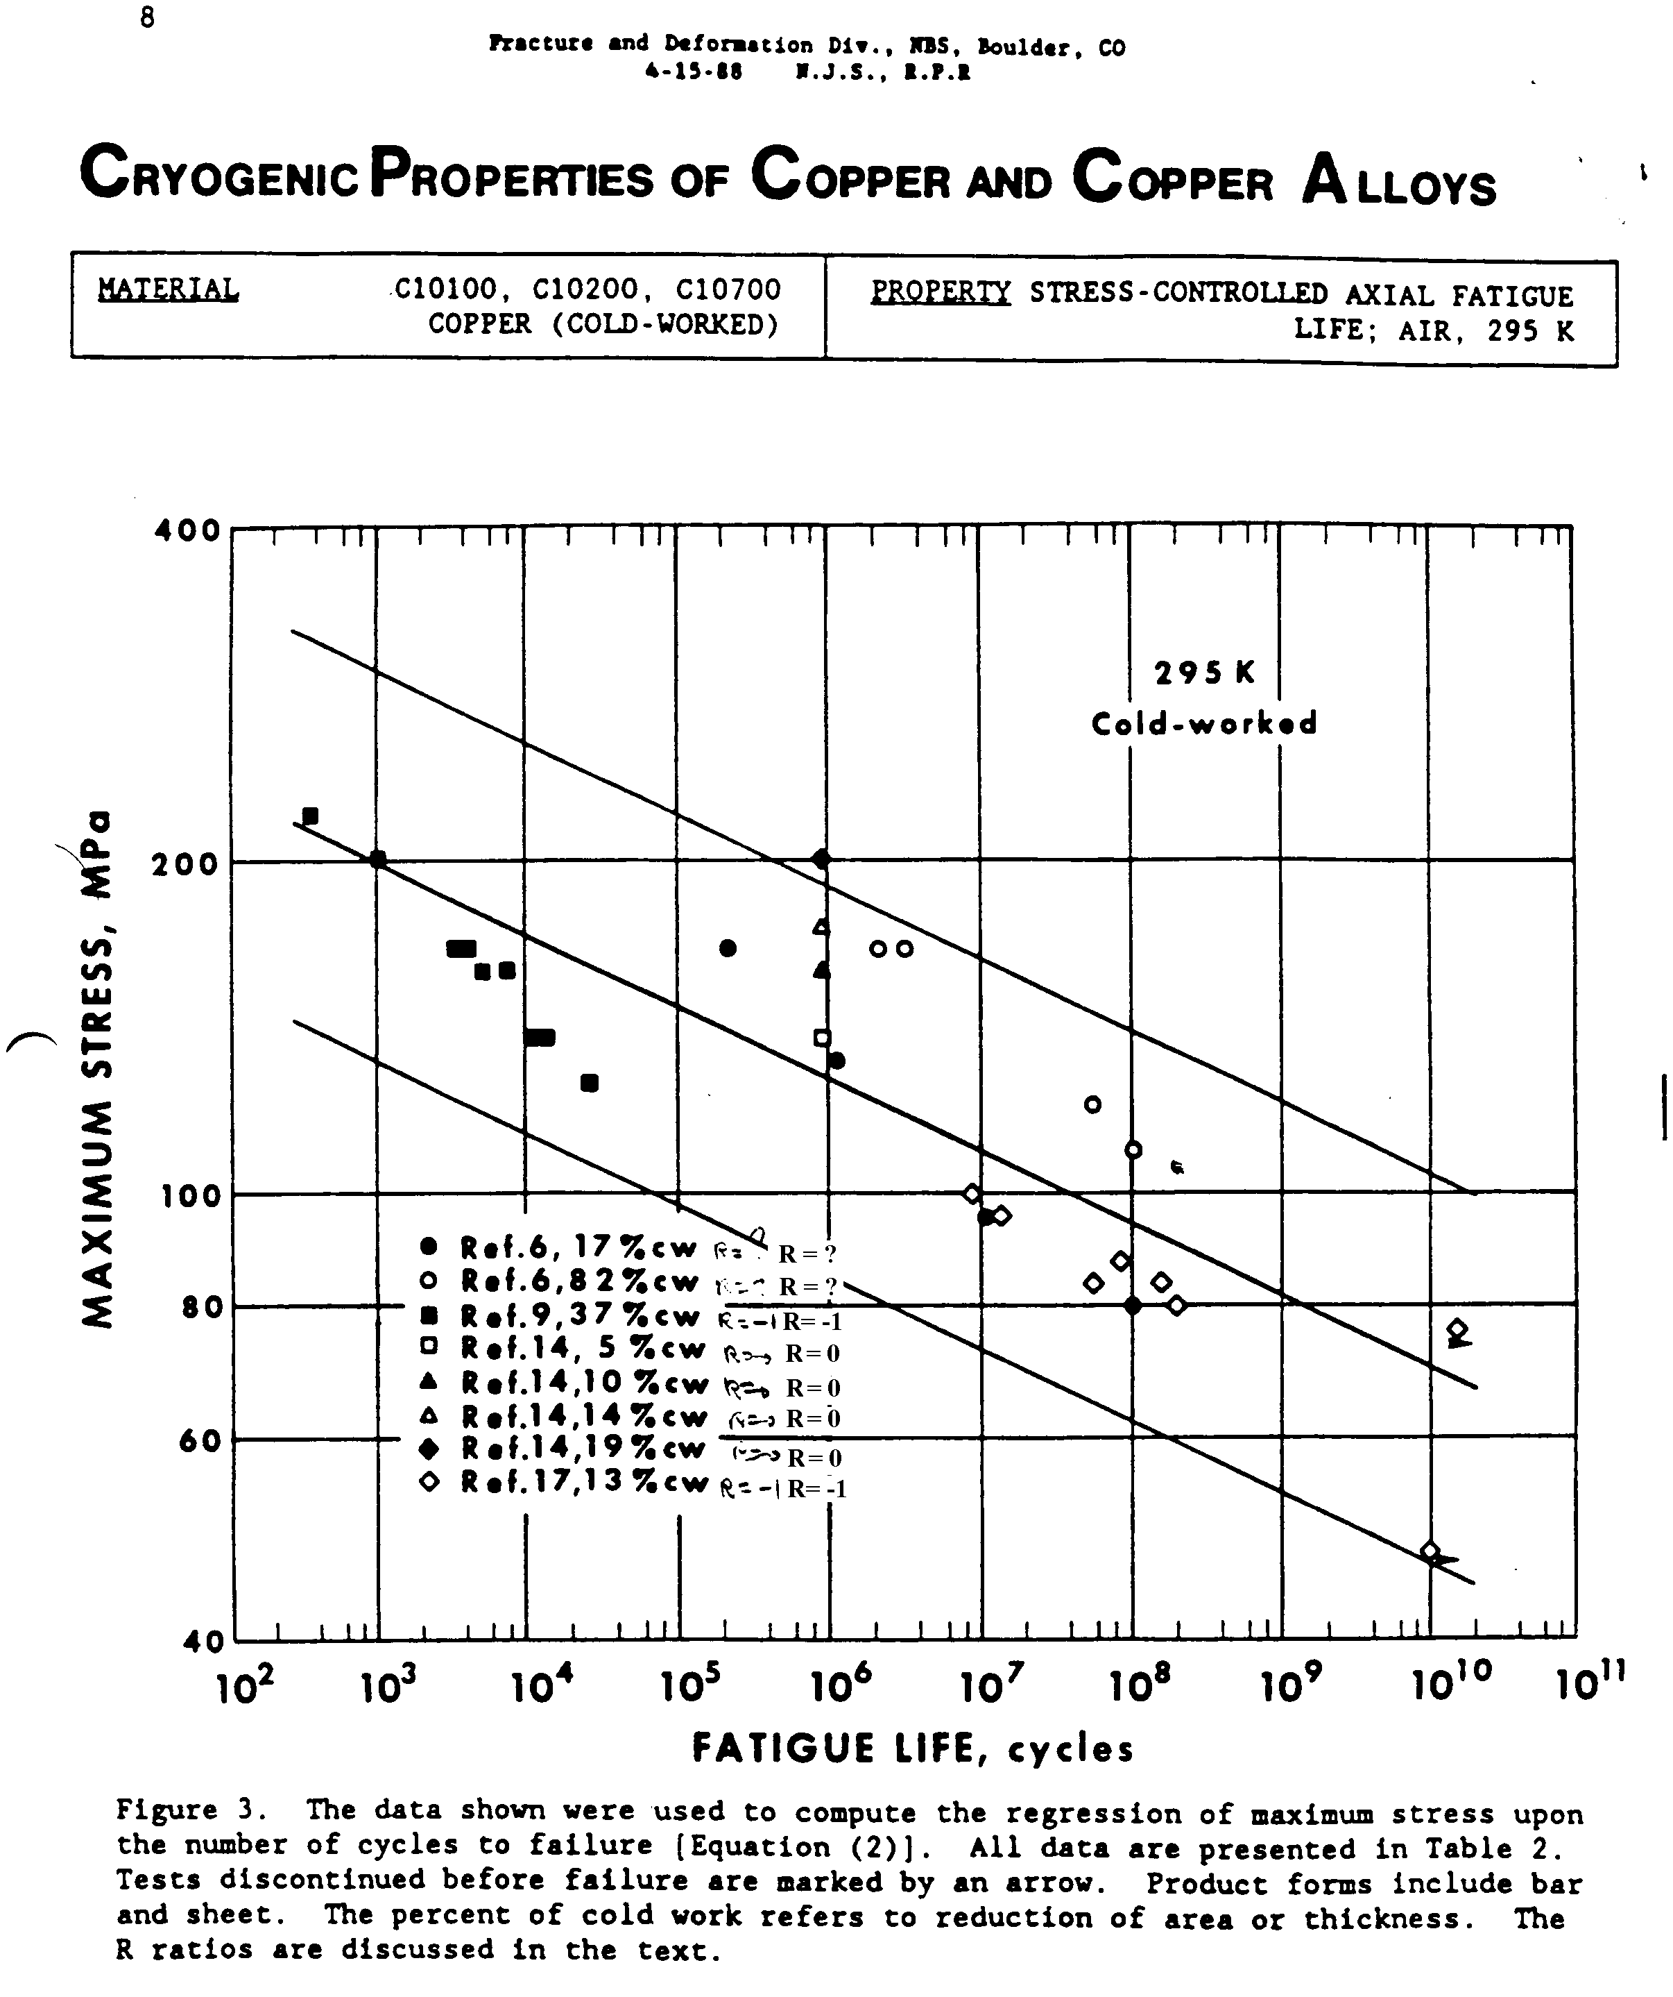

NATIONAL SPHERICAL TORUS EXPERIMENT

CENTER STACK

RESEARCH AND DEVELOPMENT

FINAL REPORT

No. 13-970430-JHC

Prepared By: James H. Chrzanowski

April 30, 1997

PRINCETON UNIVERSITY

PLASMA PHYSICS LABORATORY

Table No. 4-11

FATIGUE TEST RESULTS-OH TYPE VII JOINT

Note: Joints were restrained with side clamps (loosely held) to minimize moment in joint.

|  |  |  |  |  |  |
| --- | --- | --- | --- | --- | --- |
| Specimen ID  No. | Conductor Area  (in2)* | Conductor Loading (psi.) | Cyclic Loading (Lbs.) | Completed Cycles  ~ | Location of Failure |
|  |  |  |  |  |  |
| E | 0.184 | 20,000 | 350-3680 | 302,100 | In conductor away from joint |
| F | 0.1845 | 20,000 | 350-3680 | 417,980 | In conductor away from joint |
| G | 0.1844 | 20,000 | 350-3688 | 555,730 | In conductor away from joint |
|  |  |  |  |  |  |

* Measured prior to start of cyclic test

PDR Fracture Mechanics Evaluation, and Procedure:

These calculations were done based on some informal communications with Jun Feng and documented in a memo [3]. This formed the basis for subsequent calculations. Current calculations reference Jun's ITER in-vessel coil calculation which has better Paris parameters. The ITER memo is included as an appendix to this calculation.



Material

Hardened copper; Paris parameter: C=1.52e-12 m/cycles, m=4.347 ; Fracture toughness : ; Walker’s coef: 0.8.

Sample geometry

Width: 30mm (assumed) Thickness: 7.7mm

Load history

0 to 149 MPa along axial direction. Stress gradient at the hole edge is neglected.

Crack configuration

Surface crack at the edge of the hole; Initial crack dimension: 0.25mm2, 0.5mm2; Initial aspect ratio: 1.

Safety factors:

On crack size: 2; On fracture toughness: 1.5.

Results of fatigue crack growth life

|  |  |  |
| --- | --- | --- |
| Safety factor | Initial crack size (mm2) | |
| 0.25 | 0.5 |
| Safety Fact Not Applied | 701,000 | 446,000 |
| Safety Factor Applied | 446,000 | 277,000 |

Titus CDR Calcs (Jun’s Program) .5mm^2 crack area

.707mm crack x 2= .00144 m crack

with Safety Factor:

145 MPa 201244 cycles

175 MPa 103416 cycles

Analysis Results

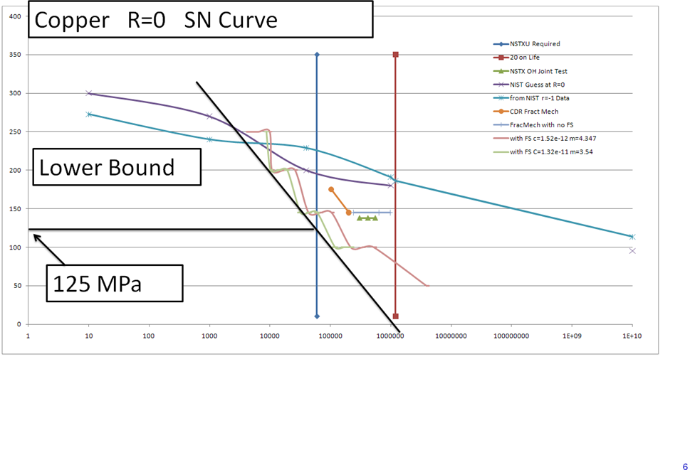

Figure 2 SN and Fracture Mechanics Fatigue Life

This is a compilation of copper R=0 fatigue data The vertical lines are at 60,000 cycles and 1200000 cycles which represents 20 times the required 60,000 pulses as specified in the GRD. The fit line represents the lower bound of the data. The plot includes NIST data, measured data for the NSTX brazed OH conductor, and the results of fracture mechanics calculations( the wavy lines) NIST data used in this plot is shown below. The "FractMech with FS" line is wavy because for each stress level three crack area are plotted together: .353 .5, and .7 mm. The fracture mechanics calculations include factors of 2 on flaw size (so the simulations were run for .707,1, and 1.414 mm), 1.5 on fracture toughness, and 4 on cycles. To meet the required 60000 cycle life, with flaw sizes less than .7mm, 125 MPa would pass the fracture mechanics criteria in the NSTX criteria document. The criteria document makes a distinction between component and material tests for establishing the required factor of safety on life. NSTX has the three brazed conductor sample tests which show performance better than the fracture mechanics calculations. Based on the SN NIST data, 180 MPa would pass the 20 on life, but not two on stress. Approximately 112 MPa would be the allowable based on 2 on stress.

Selected Results of Fracture Mechanics Calculations - FDR calculations - See EXCEL spreadsheet copper SN Curve 2.xls and Fat2results.xls

|  |  |  |  |  |  |  |  |  |  |  |  |  |
| --- | --- | --- | --- | --- | --- | --- | --- | --- | --- | --- | --- | --- |
|  |  |  |  |  |  |  |  |  |  |  |  |  |
|  |  |  | No Safety Factor | | |  |  |  |  |  |  |  |
| Crack | c | m | k1c | wm | Width | Thickness | b/a | b | peak1 | r | num of | nlife |
| Area |  |  |  |  |  |  |  |  |  |  | Peaks |  |
| 0.125 | 1.52E-12 | 4.347 | 150 | 0.8 | 0.03 | 0.0077 | 1 | 0.000354 | 145 | 0 | 1 | 971659 |
| 0.25 | 1.52E-12 | 4.347 | 150 | 0.8 | 0.03 | 0.0077 | 1 | 0.0005 | 145 | 0 | 1 | 640022 |
| 0.5 | 1.52E-12 | 4.347 | 150 | 0.8 | 0.03 | 0.0077 | 1 | 0.000707 | 145 | 0 | 1 | 418834 |
| 1 | 1.52E-12 | 4.347 | 150 | 0.8 | 0.03 | 0.0077 | 1 | 0.001 | 145 | 0 | 1 | 270882 |
|  |  |  |  |  |  |  |  |  |  |  |  |  |
|  |  |  | With Safety Factor of 2 on crack and 1.5 on Fracture Toughness | | | | | | | |  |  |
| Crack | c | m | k1c | wm | Width | Thickness | b/a | b | peak1 | r | num of | nlife |
| Area |  |  |  |  |  |  |  |  |  |  | Peaks |  |
| 0.125 | 1.52E-12 | 4.347 | 100 | 0.8 | 0.03 | 0.0077 | 1 | 0.000707 | 145 | 0 | 1 | 418334 |
| 0.25 | 1.52E-12 | 4.347 | 100 | 0.8 | 0.03 | 0.0077 | 1 | 0.001 | 145 | 0 | 1 | 270882 |
| 0.5 | 1.52E-12 | 4.347 | 100 | 0.8 | 0.03 | 0.0077 | 1 | 0.001414 | 145 | 0 | 1 | 173083 |
| 1 | 1.52E-12 | 4.347 | 100 | 0.8 | 0.03 | 0.0077 | 1 | 0.002 | 145 | 0 | 1 | 108323 |
|  |  |  |  |  |  |  |  |  |  |  |  |  |
| 0.125 | 1.52E-12 | 4.347 | 100 | 0.8 | 0.03 | 0.0077 | 1 | 0.000707 | 100 | 0 | 1 | 2103380 |
| 0.25 | 1.52E-12 | 4.347 | 100 | 0.8 | 0.03 | 0.0077 | 1 | 0.001 | 100 | 0 | 1 | 1363689 |
| 0.5 | 1.52E-12 | 4.347 | 100 | 0.8 | 0.03 | 0.0077 | 1 | 0.001414 | 100 | 0 | 1 | 870333 |
| 1 | 1.52E-12 | 4.347 | 100 | 0.8 | 0.03 | 0.0077 | 1 | 0.002 | 100 | 0 | 1 | 544790 |
|  |  |  |  |  |  |  |  |  |  |  |  |  |
| 0.125 | 1.52E-12 | 4.347 | 100 | 0.8 | 0.03 | 0.0077 | 1 | 0.000707 | 50 | 0 | 1 |  |
| 0.25 | 1.52E-12 | 4.347 | 100 | 0.8 | 0.03 | 0.0077 | 1 | 0.001 | 50 | 0 | 1 |  |
| 0.5 | 1.52E-12 | 4.347 | 100 | 0.8 | 0.03 | 0.0077 | 1 | 0.001414 | 50 | 0 | 1 | 15732952 |
| 1 | 1.52E-12 | 4.347 | 100 | 0.8 | 0.03 | 0.0077 | 1 | 0.002 | 50 | 0 | 1 | 10567053 |
|  |  |  |  |  |  |  |  |  |  |  |  |  |
| 0.125 | 1.52E-12 | 4.347 | 100 | 0.8 | 0.03 | 0.0077 | 1 | 0.000707 | 200 | 0 | 1 | 103380 |
| 0.25 | 1.52E-12 | 4.347 | 100 | 0.8 | 0.03 | 0.0077 | 1 | 0.001 | 200 | 0 | 1 | 66937 |
| 0.5 | 1.52E-12 | 4.347 | 100 | 0.8 | 0.03 | 0.0077 | 1 | 0.001414 | 200 | 0 | 1 | 42770 |
| 1 | 1.52E-12 | 4.347 | 100 | 0.8 | 0.03 | 0.0077 | 1 | 0.002 | 200 | 0 | 1 |  |
|  |  |  |  |  |  |  |  |  |  |  |  |  |
| 0.125 | 1.52E-12 | 4.347 | 100 | 0.8 | 0.03 | 0.0077 | 1 | 0.000707 | 250 | 0 | 1 | 39190 |
| 0.25 | 1.52E-12 | 4.347 | 100 | 0.8 | 0.03 | 0.0077 | 1 | 0.001 | 250 | 0 | 1 | 25375 |
| 0.5 | 1.52E-12 | 4.347 | 100 | 0.8 | 0.03 | 0.0077 | 1 | 0.001414 | 250 | 0 | 1 | 16214 |
| 1 | 1.52E-12 | 4.347 | 100 | 0.8 | 0.03 | 0.0077 | 1 | 0.002 | 250 | 0 | 1 |  |

Appendix A

FAT2.FOR ( written by J. Feng of MIT-PSFC, Modified slightly by P. Titus)

program mastersc

c master program for surface crack (two pulses with diff peak and r)

common /cons/ c,rm,rkc,wm,t,w

common /result/ af,bf,nc1,nc2

! namelist /param/c,rm,rkc,wm,t,w

! open(12,file='constsc.dat',status='old')

! read(12,param)

! close(12)

print *, ' Fracture Mechanics Program for a Surface Crack'

print *, ' (two pulses with different peaks and r values)'

print *, ' Units are meters and MPa'

print *, ' (two pulses with different peak Stresses and r values)'

print *, 'Input:'

print *, ' Paris constant parameters: c, rm, rkc, wm, t, w'

print *, ' 1 Enter Your Own Data'

print *, ' 2 ITER TF Case 316 Forging at 4K'

print *, ' 3 NIST 316 data'

print *, ' 4 ITER EU/KFK ICMC M2-H-03 Casting data'

print *, ' 5 C=9.54e-11, m=2.09'

print *, ' 6 C=5.43e-12, m=2.95'

print *, ' 7 C=4.41e-11, m=2.25'

print *, ' 8 Hardened Copper'

print *, ' Enter option number:'

read(5,*) nopt

print *, ' Initial crack Ratio and Width: b_ai=(b/a)i, bi'

print *, ' Pulse 1: peak1, r1 and n1 cycles/per repeat'

print *, ' Pulse 2: peak2, r2 and n2 cycles/per repeat'

print *, 'Output:'

print *, ' final crack: af,bf'

print *, ' nc1 pulse 1, nc2 pulse 2 (in the finalrepeat)'

print *, ' -'

if (nopt.eq.1) then

print *,'Enter: c,rm,rkc,wm,t,w'

read(5,*) c,rm,rkc,wm,t,w

end if

if (nopt.eq.2) then

c=6.65e-13

rm=3.34

rkc=200.

wm=0.64

t=0.1

w=1.0

end if

if (nopt.eq.3) then

c=(9.54e-11+5.43e-12+4.42e-11)/3

c=(4.8398e-12+5.43e-12)/2

c=5.43e-12

rm=(2.09+2.95+2.25)/3

rm=2.95

rkc=100.

wm=0.64

t=0.0190500

w=1.0

end if

if (nopt.eq.4) c=6.619e-14

if (nopt.eq.4) rm=3.856

if (nopt.eq.5) c=9.54e-11

if (nopt.eq.5) rm=2.09

if (nopt.eq.6) c=5.43e-12

if (nopt.eq.6) rm=2.95

if (nopt.eq.7) c=4.41e-11

if (nopt.eq.7) rm=2.25

rkc=100.0

wm=0.64

t=0.0190500

w=1.0

if (nopt.eq.8) then

cThe Paris parameters for the alloy CuCrZr are not available so far. However, for time being,

can approximate data is adopted from a hardened copper alloy with similar yielding strength. [5]

c The Walker's coef representing load ratio effect is estimated from several load ratio test results

cfrom a hardened copper alloy.[5]

cParis parameters Cinm/cycle:

C=1.52e-12

rm=4.347

cWalker's coef:

w=0.8

end if

print*, 'Enter: b_ai,bi,peak1,r1,n1,peak2,r2,n2'

print*, ' Stresses in MPa and bi (initial crack) in meter'

read(5,*) b_ai,bi,peak1,r1,n1,peak2,r2,n2

print*, b_ai,bi,peak1,r1,n1,peak2,r2,n2

print *, 'Paris constant parameters: c, rm, rkc, wm, t, w'

print*,c,rm,rkc,wm,t,w

print*, 'c=',c

print*, 'exponent m=',rm

print*, 'fracture toughness, K1c',rkc

print*, 'Walker coefficient, wm',wm

print*, 'Center Crack panel thickness t and width w, t,w=',t,w

call sclife(b_ai,bi,peak1,r1,n1,peak2,r2,n2,nlife)

print*, 'Initial b/a: ',b_ai

ai=bi/b_ai

print*, 'Initial crack Dimensions,ai,bi:',ai,bi

print*, 'Final crack Dimensions,af,bf: ',af,bf

print*, 'nc1, nc2',nc1,nc2

print*, 'nlife:',nlife

c print*, af,bf,nc1,nc2,nlife

stop

end

subroutine sclife(b_ai,bi,peak1,r1,n1,peak2,r2,n2,nlife)

c code for surface crack loaded by two pulses with diff peaks and R

c **** terminology ****

c V~~~~~~V~~~~~~V~~~~~~V~~~~~~V~~,n1=1,n2=6,nc1=5,nc2=2,nlife=31

c initial crack: b_ai=(b/a)i, bi

c pulse 1: peak1, r1 and n1 cycles/per repeat

c pulse 2: peak2, r2 and n2 cycles/per repeat

c final crack: af,bf, nc1 pulse 1, nc2 pulse 2 (in the finalrepeat)

c constant parameters: c, rm, rkc, wm, t, w

c

common /cons/ c,rm,rkc,wm,t,w

common /result/ af,bf,nc1,nc2

b1=bi

a1=bi/b_ai

da1=0.

db1=0.

nc1=0

nc=0

1 do 21 i=1,n1

call sc_an(b1,a1,db1,da1,peak1,r1,b2,a2,db2,da2,rka,rkb)

b1=b2

a1=a2

da1=da2

db1=db2

nc1=nc1+1

nc=nc+1

if (b2.gt.t) goto 101

if ((rkb.gt.rkc).or.(rka.gt.rkc)) goto 101

21 continue

nc2=0

do 22 i=1,n2

call sc_an(b1,a1,db1,da1,peak2,r2,b2,a2,db2,da2,rka,rkb)

b1=b2

a1=a2

da1=da2

db1=db2

nc2=nc2+1

nc=nc+1

if (b2.gt.t) goto 101

if ((rkb.gt.rkc).or.(rka.gt.rkc)) goto 101

22 continue

goto 1

c

c final fracture

101 nlife=nc

bf=b2

af=a2

b_a=bf/af

return

end

c

c

subroutine sc_an(bi,ai,dbi,dai,st,r,bf,af,dbf,daf,rka,rkb)

c crack growth of sc_an per cycle

common /cons/ c,rm,rkc,wm,t,w

pi=3.14159

b=bi

a=ai

da=dai

db=dbi

c

1 if (a.lt.w) then

atemp=a+da/2

btemp=b+db/2

call surface_a(atemp,btemp,t,w,yatemp)

call surface_b(atemp,btemp,t,w,ybtemp)

rkatemp=yatemp*st*sqrt(pi*btemp)

rkbtemp=ybtemp*st*sqrt(pi*btemp)

dkatemp=rkatemp*(1.-r)**wm

dkbtemp=rkbtemp*(1.-r)**wm

dadn=c*dkatemp**rm

dbdn=c*dkbtemp**rm

da=dadn

db=dbdn

a=a+da

b=b+db

call surface_a(a,b,t,w,ya)

call surface_b(a,b,t,w,yb)

rka=ya*st*sqrt(pi*b)

rkb=yb*st*sqrt(pi*b)

else

btemp=b+db/2

call sen(btemp,t,ybtemp)

rkbtemp=ybtemp*st*sqrt(pi*btemp)

dkbtemp=rkbtemp*(1.-r)**wm

dbdn=c*dkbtemp**rm

db=dbdn

b=b+db

call sen(b,t,yb)

rkb=yb*st*sqrt(pi*b)

endif

daf=da

dbf=db

af=a

bf=b

return

end

c

c

subroutine surface_b(a,b,tt,w,yf)

pi=3.141593

if (b.le.a) then

rm1=1.13-0.09*(b/a)

rm2=-0.54+0.89/(0.2+b/a)

rm3=0.5-1/(0.65+b/a)+14*(1.-b/a)**24

g=1.

fphi=1.

fw=sqrt(1/cos(pi*a*sqrt(b/tt)/(2*w)))

fs=(rm1+rm2*(b/tt)**2+rm3*(b/tt)**4)*g*fphi*fw

ek=sqrt(1.+1.464*(b/a)**1.65)

yf=fs/ek

else

rm1=sqrt(a/b)*(1.+0.04*a/b)

rm2=0.2*(a/b)**4

rm3=-0.11*(a/b)**4

g=1.

fphi=sqrt(a/b)

fw=sqrt(1/cos(pi*a*sqrt(b/tt)/(2*w)))

fs=(rm1+rm2*(b/tt)**2+rm3*(b/tt)**4)*g*fphi*fw

ek=sqrt(1.+1.464*(a/b)**1.65)

yf=fs/ek

endif

return

end

c

c

subroutine surface_a(a,b,tt,w,yf)

c c Y factor at edge points (10/13/94)

pi=3.141593

if (b.le.a) then

rm1=1.13-0.09*(b/a)

rm2=-0.54+0.89/(0.2+b/a)

rm3=0.5-1/(0.65+b/a)+14*(1.-b/a)**24

g=1.+(0.1+0.35*(b/tt)**2)

fphi=sqrt(b/a)

fw=sqrt(1/cos(pi*a*sqrt(b/tt)/(2*w)))

fs=(rm1+rm2*(b/tt)**2+rm3*(b/tt)**4)*g*fphi*fw

ek=sqrt(1.+1.464*(b/a)**1.65)

yf=fs/ek

else

rm1=sqrt(a/b)*(1.+0.04*a/b)

rm2=0.2*(a/b)**4

rm3=-0.11*(a/b)**4

g=1.+(0.1+0.35*(a/b)*(b/tt)**2)

fphi=1.

fw=sqrt(1/cos(pi*a*sqrt(b/tt)/(2*w)))

fs=(rm1+rm2*(b/tt)**2+rm3*(b/tt)**4)*g*fphi*fw

ek=sqrt(1.+1.464*(a/b)**1.65)

yf=fs/ek

endif

return

end

c

c

subroutine sen(b,tt,yf)

pi=3.141593

if (b.ge.tt) b=0.999999*tt

temp=0.5*pi*b/tt

yf1=sqrt(tan(temp)/temp)

yf2=0.752+2.02*b/tt+0.37*(1.-sin(temp))**3

yf3=cos(temp)

yf=yf1*yf2/yf3

return

end

Appendix B

Note

Date: 12/21/2009

To: Peter Titus

From: Jun Feng

Subject: Fatigue life of VS coil made of pure copper C11000

Introduction

There is a great life margin for VS coil if CuCrZr is applied for VS coil. Therefore, Titus suggested to use less expensive material, e.g. pure copper. Meanwhile, the required total life cycles for the VS coil decreases to 30,000 cycles - the same as for the total number of  
shots.

The following sections report the estimation data. The OFHC copper (C10100 to C10700) is very similar to C11000.

Material

Pure copper (C11000), electrolytic tough-pitch copper

99.96% Cu, 0.04% O

Mechanical Properties

|  |  |  |
| --- | --- | --- |
| Tensile (ksi) | Yielding (ksi) | Elongation (%) |
| 32-66 | 10-53 | 4-55 |

* depending on: cold work, grain size, temperature etc.

Paris parameter: C=1.32e-11 m/cycles, m=3.54 [1,2];

Fracture toughness is assumed to be no less than ;

Walker’s coef: 0.8.

Sample geometry

Width: 50mm (assumed)

Thickness: 8.75mm

Load history

*Case 1: residual stress is removed during post-heat treatment*

VS coil: each machine pulse includes: 10 large stress cycle and 100 small stress cycle

Large stress cycle from 55 to 75 MPa ,

Small stress cycle from 55 to 60 MPa .

*Case 2: residual stress remains large about 0.5 yield strength (~25MPa)*

VS coil: each machine pulse includes: 10 large stress cycle and 100 small stress cycle

Large stress cycle from 80 to 100 MPa ,

Small stress cycle from 80 to 85 MPa .

Crack configuration

Surface crack at the edge of the hole;

Initial crack dimension: 0.25mm2, 0.5mm2;

Initial aspect ratio: 0.2

Safety factor

Crack size: 2;

Fracture toughness: 1.5.

Results of fatigue crack growth life

|  |  |  |
| --- | --- | --- |
| Residual stress | Initial crack size (mm2) | |
| 0.25 | 0.5 |
| No | 1e7 cycles | 6.3e6 cycles |
| Applied | 7.3e6 cycles | 5.1e6 cycles |

Conclusion

Pure copper can be used to replace CuCrZr for VS coils.

However, it is noted that work hardening can increase copper fatigue resistance, but the water environment, higher temperature and irradiation can decrease its fatigue resistance.

References

[1] N.J. Simmon and R.P. Reed, “Cryogenic properties of copper and copper alloy,” NBS, DOE, 1987.

[2] N.J. Simmon, E.S. Drexier, and R.P. Reed, “Properties of copper and copper alloys at cryogenic temperature,” NIST Monograph 177, 1992.