

**NSTX**

**HHFW (High Harmonic Fast Wave) Eddy Current Analysis for Antenna**

**NSTX-CALC-24-03-01**

**June 1, 2011**

**Prepared By:**

___________________________________

Han Zhang, PPPL Mechanical Engineering

**Reviewed By:**

**________________________________________**

Ron Hatcher, PPPL Electrical Division

**Reviewed By:**

_______________________________________

Robert Ellis, PPPL Analysis Division

**PPPL Calculation Form**

Calculation # **NSTXU-CALC-24-03** Revision # **00** WP #, if any **1511**

(ENG-032)

**Purpose of Calculation:** (Define why the calculation is being performed.)

The model was first built for NSTX to verify the eddy current effect on antenna during plasma disruption. Then it is modified to simulate plasma disruption case for NSTX upgrade. Only mid-plane disruption is considered and VDE is not included.

Plasma is modeled to be torus shape and current disappears linearly in 1 ms. Then a background field with Bvertical and Btoroidal is added to calculate the Lorentz force of the induced eddy current in the components. The force data was transferred to the structural model to calculate stress in antenna and Faraday cage and loads on the fixtures.

**References** :(List any source of design information including computer program titles and revision levels.)

1. PPPL HHFW Team, “NSTX High Harmonic Fast Wave Antenna Upgrade Final Design Review”, April 29, 2008
2. Stefan Gerhardt, “Disruption Force and Current Estimation for NSTX Upgrade”.

**Assumptions:** (Identify all assumptions made as part of this calculation.)

Plasma is modeled to be torus shape which parameters are from NSTX. NSTX upgrade has larger plasma radius but not reflected in this model. Also centerstack is not included.

Background field data are given and added to the model by specify the vector potentials.

The electrical feedthroughs and some structural fixations (e.g. ceramic plug assembly) are too complicated and thus simplified in the model.

**Calculation :**(Calculation is either documented here or attached)

See the attached document.

**Conclusions:** (Specify whether or not the purpose of the calculation was accomplished.)

For NSTX the typical disruption time is 9 ms but the simulation uses 1 ms, very conservative. Stresses in the antenna and Faraday cage are low and they are safe enough.

With NSTX upgrade, displacement of antenna is within 0.6 mm and maximal Von Mises stress is in the strips of Faraday cage, 155 MPa (22.5ksi), within allowable. Loads in the fixtures are extracted and will be analyzed by Robert Ellis.

Bdot data at different positions are calculated to compare with other disruption simulation results.

Cognizant Engineer’s printed name, signature, and date

**I have reviewed this calculation and, to my professional satisfaction, it is properly performed and correct.**

Checker’s printed name, signature, and date

**Executive Summary**

A model including plasma, 4 antennas and vacuum vessel was built to simulate the eddy current and resulting stress in antenna during plasma disruption. The model of vacuum vessel and antenna is imported from CAD model but with adequate modifications. The plasma is modeled as a torus according to the parameters of NSTX. 1ms disruption time is used to obtain more conservative result. Only midplane disruption is considered and VDE is not included.

For NSTX, the electromagnetic model is run first to calculate eddy current. Then, use the same model, reading the eddy current in to run a steady state but with two external magnetic field Bporoidal=0.4T and Btoroidal=0.4T added, to calculate the force. Finally a structural model (removing the air element and adding some structural fixation) is run to calculate the stress.

This model is then modified to have higher plasma current 2MA and run again for NSTX upgrade to obtain Bdot to compare results from Opera.

**Results for NSTX**

For NSTX, according to previous analysis, the plasma disrupts in 9ms. I used 1ms to obtain conservative result. First the electromagnetic model is run to calculate eddy current. Then, use the same model, reading the eddy current in to run a steady state but with two external magnetic field Bporoidal=0.4T and Btoroidal=0.4T added, to calculate the force. Finally a structural model (removing the air element and adding some structural fixation) is run to calculate the stress.

Figure 1: Electro-magnetic model

Fig. 2 shows the eddy current pattern in the antenna. Fig. 3 show the Von Mises stress in Pa. The ends of antenna are fixed to vessel but I didn’t model the fixture, only couple some nodes together, which causes the high stress (red spots in the figure). Since the stresses are low enough, it won’t be necessary for further analysis. Eddy current also generates at the vessel cylinder and flows around the holes and some high current density around the edge of the hole can be easily seen. This is because I defeature the ports and leave the holes. This analysis aims at the antenna. This simplification should not be a problem. But if analyze the vessel, port extension and cover should be kept and eddy current will flow to them and distribute more uniformly. In vessel, the high stress points are the places connecting to the antenna and back plate of Faraday case by directly coupling nodes. Since these stresses are low enough and no need for further analysis.

The loads on the connection between the center ground post and antenna strap and back plate were quantified. The results from ANSYS have been applied through hand calculations to the screws that make up this connection. The stresses in the screws based on Mohr's circle have a factor of safety of 10. The connection between the end of the strap and feed through is over stressed and a compliant center conductor section similar to the C-Mod four strap antenna is being designed and will decouple these forces from the feed-through.

Figure 2: Eddy current pattern of antenna at 1ms (A/m2).

Figure 3: Von Mises stress in the antenna (Pa).

**Table of Contents**

List of Figures 6

List of Tables 6

Modeling 7

Results for NSTX 9

Results for NSTX upgrade 13

**List of Figures**

Figure 1: Electro-magnetic model. 7

Figure 2: Materials of antenna. 8

Figure 3: Some electrical and structural connections are simplified in the model. 8

Figure 4: Eddy current pattern of antenna at 1ms (A/m2). 10

Figure 5: Von Mises stress in the antenna (Pa). 11

Figure 6: Von Mises stress in Faraday shield (Pa). 11

Figure 7: At 1ms, eddy current pattern in vessel (A/m2). 12

Figure 8: Von Mises stress in vessel (Pa). 12

Figure 9: Nine positions are arbitrarily chosen to calculate Bdot. 13

Figure 10: History plot of Br (x axis—Time(s), y axis—B (Tesla), Plasma disrupts from 1ms to 2ms ). 14

Figure 11: History plot of Bt (x axis—Time(s), y axis—B (Tesla), Plasma disrupts from 1ms to 2ms ). 15

Figure 12: History plot of Bz (x axis—Time(s), y axis—B (Tesla), Plasma disrupts from 1ms to 2ms ). 16

Figure 13: Eddy current pattern in antenna (A/m2). 17

Figure 14: Eddy current pattern in Faraday cage (A/m2). 18

Figure 15: Eddy current pattern in the back plate of Faraday cage (A/m2). 19

Figure 16: Eddy current pattern in the vessel (A/m2). 20

Figure 17: Structural connections are simplified in the model. 21

Figure 18: Displacement and Von Mises stress in antenna. 21

Figure 19: Beam connection between the middle of antenna and back plate of Faraday cage. 22

Figure 20: Beam connection between the end of antenna and vessel. 23

Figure 21: Beam connection between back plate of Faraday cage and vessel. 24

**List of Tables**

Table I: In cylindrical coordinate, radial component of B and calculated Br_dot (T/s). 13

Table II: Toroidal component of B with time and calculated Bt_dot (T/s). 15

Table III: Poloidal component of B with time and calculated Bz_dot (T/s). 16

**Modeling**

This is a transient analysis. The model of vacuum vessel and antenna is imported from CAD model but with adequate modifications. Only 1/12 (30°) of vacuum vessel and 4 antennas (Fig.1) are included. In this way, it assumes the whole model is by repeating this portion 12 times. But in real machine, the vacuum vessel is not perfectly cyclic and antennas are not distributed along the whole 360°. To save space and time, these differences are neglected. The materials are listed in Fig. 2. Some parts are made of composite material. Equivalent resistivity is calculated for them according to the dimension and resistivity of pure material and then applied to the parts. The electrical feedthroughs and some structural fixations (i.e. ceramic plug assembly) contain stainless steel flanges, conductors, bellows and ceramic insulation which are too complicated and thus simplified in the model (Fig. 3).

Figure 1: Electro-magnetic model.

**Figure 2: Materials of antenna.**

**Figure 3: Some electrical and structural connections are simplified in the model.**

The plasma is modeled as a torus with major radius of 0.8540m, minor radius of 0.6778m, maximal current of 1.5MA (uniformly distributed ) and linear decay in 9ms (Fig. 1), which is according to the parameters of NSTX. In this model, 1ms disruption time is used to obtain more conservative result. Only midplane disruption is considered and VDE is not included. This model is used to run the NSTX upgrade disruption later to obtain Bdot to compare with other analysis, which will be described in the following chapters of this document.

**Results for NSTX**

For NSTX, according to previous analysis, the plasma disrupts in 9ms. I used 1ms to obtain conservative result. First the electromagnetic model is run to calculate eddy current. Then, use the same model, reading the eddy current in to run a steady state but with two external magnetic field Bpoloidal=0.4T and Btoroidal=0.4T added, to calculate the force. Finally a structural model (removing the air element and adding some structural fixation) is run to calculate the stress.

Fig. 4 shows the eddy current pattern in the antenna. Fig. 5 and Fig. 6 show the Von Mises stress in Pa. The ends of antenna are fixed to vessel but I didn’t model the fixture, only couple some nodes together, which causes the high stress (red spots in the figure). Since the stresses are low enough, it won’t be necessary for further analysis. Eddy current pattern in vessel is plotted in Fig. 7. Eddy current mainly generates at the cylinder and flows around the holes and some high current density around the edge of the hole can be easily seen. This is because I defeature the ports and leave the holes. This analysis aims at the antenna. This simplification should not be a problem. But if analyze the vessel, port extension and cover should be kept and eddy current will flow to them and distribute more uniformly than this figure shows. Fig. 8 shows the Von Mises stress in vessel. The high stress points are the places connecting to the antenna and back plate of Faraday cage by directly coupling nodes. Since these stresses are low enough and no need for further analysis.

The loads on the connection between the center ground post and antenna strap and back plate were quantified. The results from ANSYS have been applied through hand calculations to the screws that make up this connection. The stresses in the screws based on Mohr's circle have a factor of safety of 10. The connection between the end of the strap and feed through is over stressed and a compliant center conductor section similar to the C-Mod four strap antenna is being designed and will decouple these forces from the feed-through.

**Figure 4: Eddy current pattern of antenna at 1ms (A/m2).**

**Figure 5: Von Mises stress in the antenna (Pa).**

**Figure 6: Von Mises stress in Faraday shield (Pa).**

**Figure 7: At 1ms, eddy current pattern in vessel (A/m2).**

Figure 8: Von Mises stress in vessel (Pa).

**Results for NSTX upgrade**

Then the electromagnetic model is modified to have 2MA plasma current uniformly distributed and linearly decay in 1ms to simulate the disruption of NSTX upgrade. But NSTX upgrade has bigger plasma major radius which is neglected in the model just to simplify the modifications. This analysis is mainly to calculate the Bdot to compare with other’s Bdot result from Opera. I arbitrarily select 9 positions (Fig. 9) to output the B and calculate Bdot using excel. The Bdot data are listed in Table 1 to 3 and plotted in Fig. 10 to 12.

**Figure 9: Nine positions are arbitrarily chosen to calculate Bdot.**

Table I: In cylindrical coordinate, radial component of B and calculated Br_dot (T/s).

**Figure 10: History plot of Br (x axis—Time(s), y axis—B (Tesla), Plasma disrupts from 1ms to 2ms ).**

**Table II: Toroidal component of B with time and calculated Bt_dot (T/s).**

**Figure 11: History plot of Bt (x axis—Time(s), y axis—B (Tesla), Plasma disrupts from 1ms to 2ms ).**

**Table III: Poloidal component of B with time and calculated Bz_dot (T/s).**

**Figure 12: History plot of Bz (x axis—Time(s), y axis—B (Tesla), Plasma disrupts from 1ms to 2ms ).**

Figs. 13-16 plot the eddy current pattern in antenna, Faraday cage and vessel. Plasma disrupts from 1ms to 2ms.

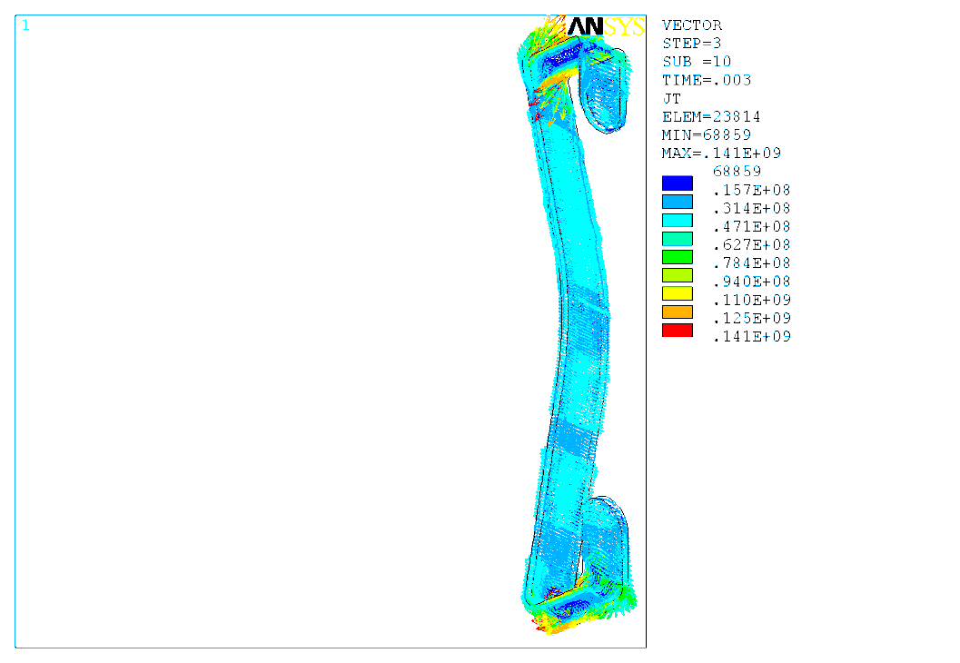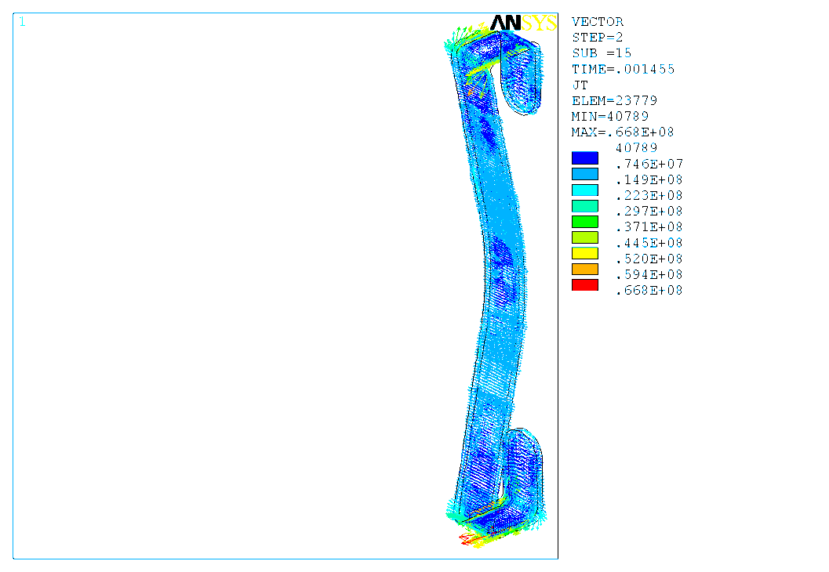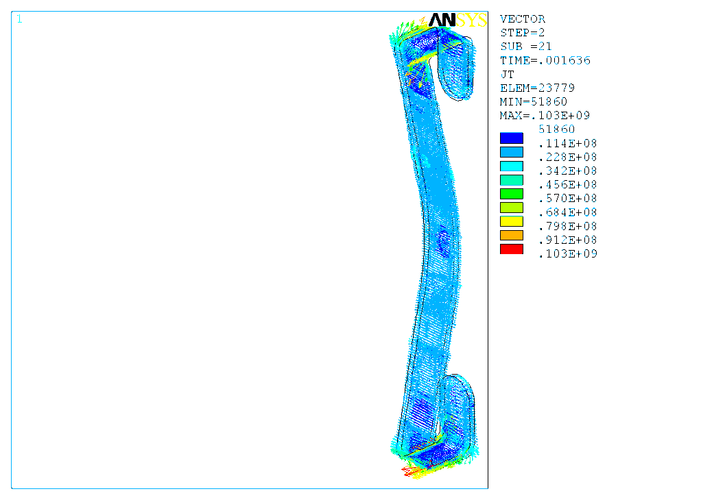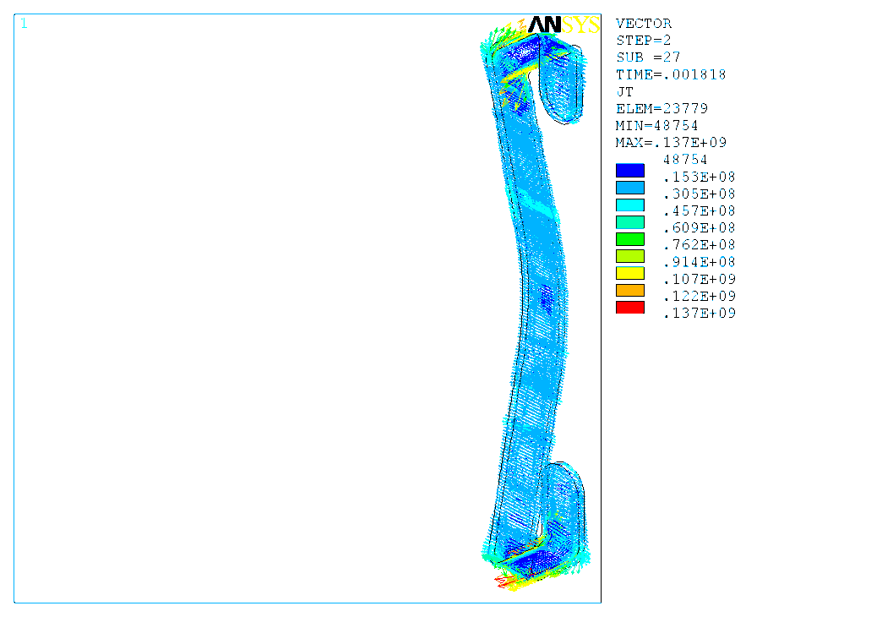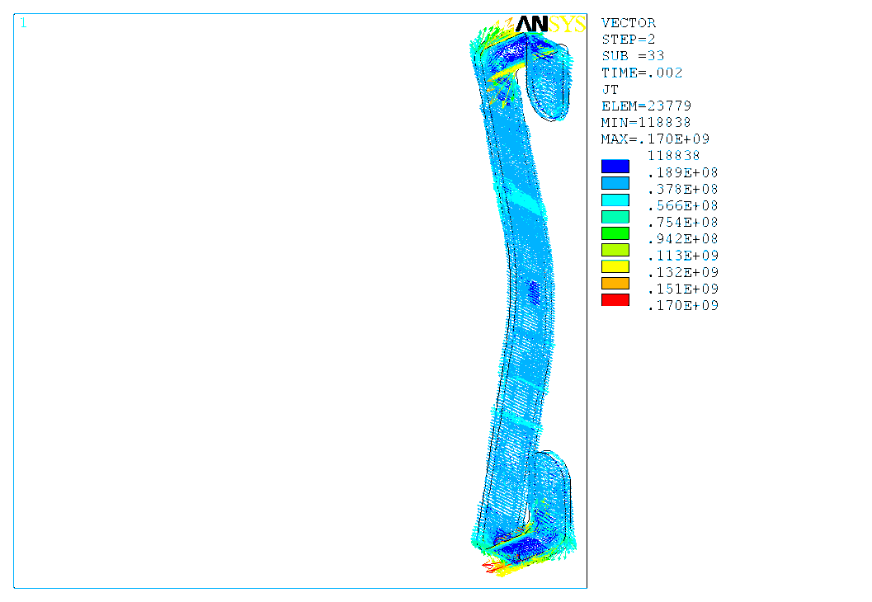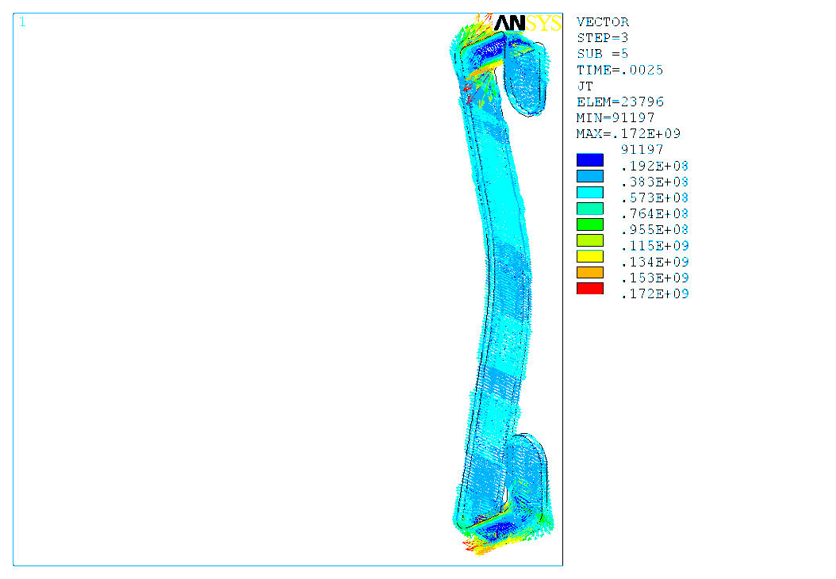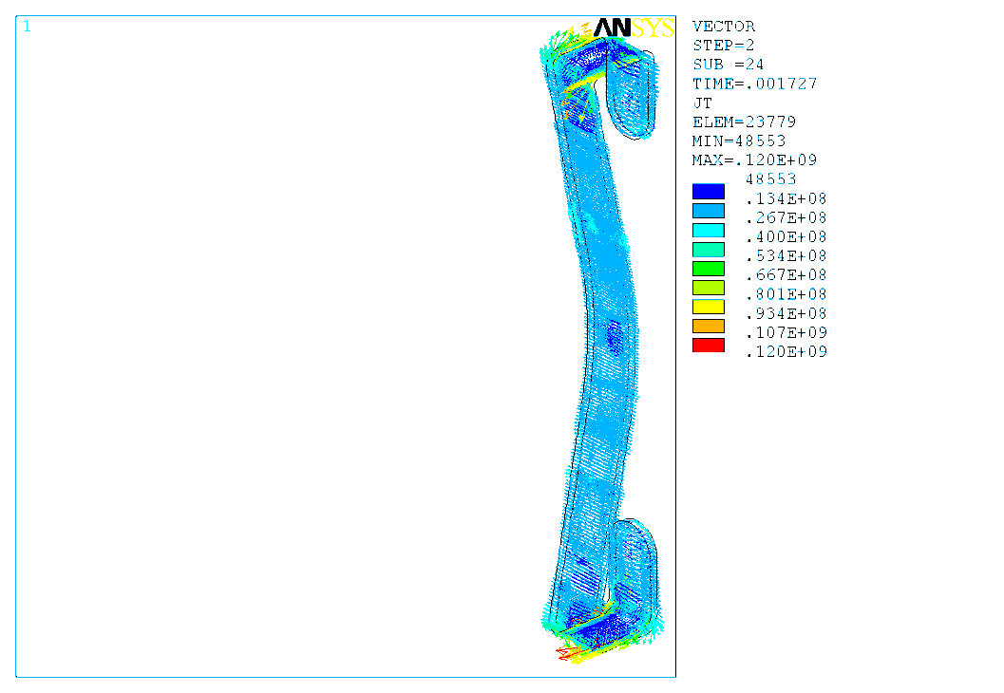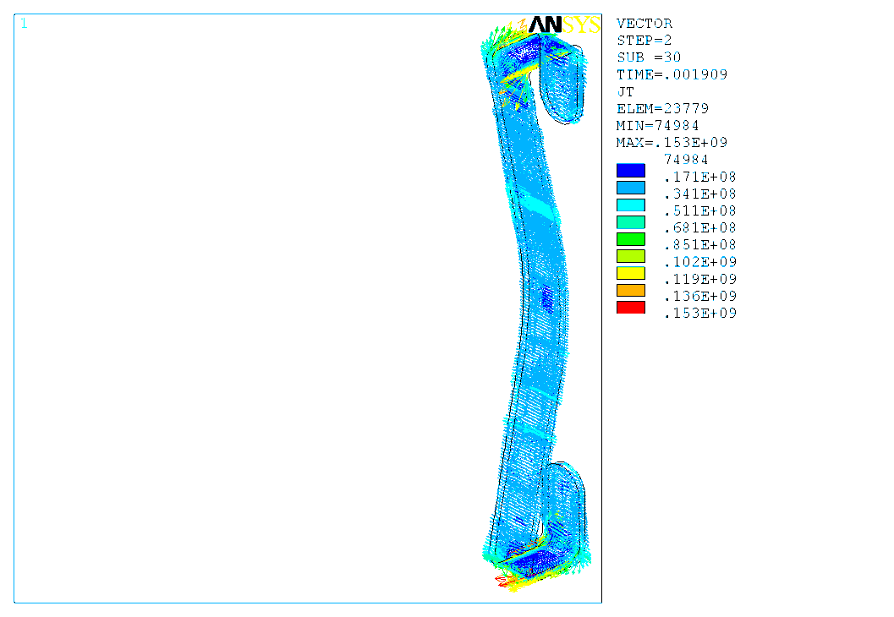

**Figure 13: Eddy current pattern in antenna (A/m2).**

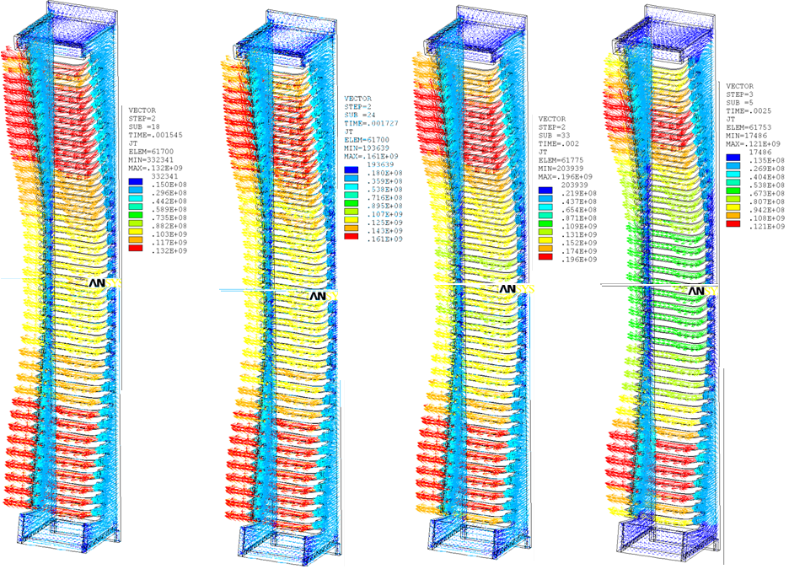

**Figure 14: Eddy current pattern in Faraday cage (A/m2).**

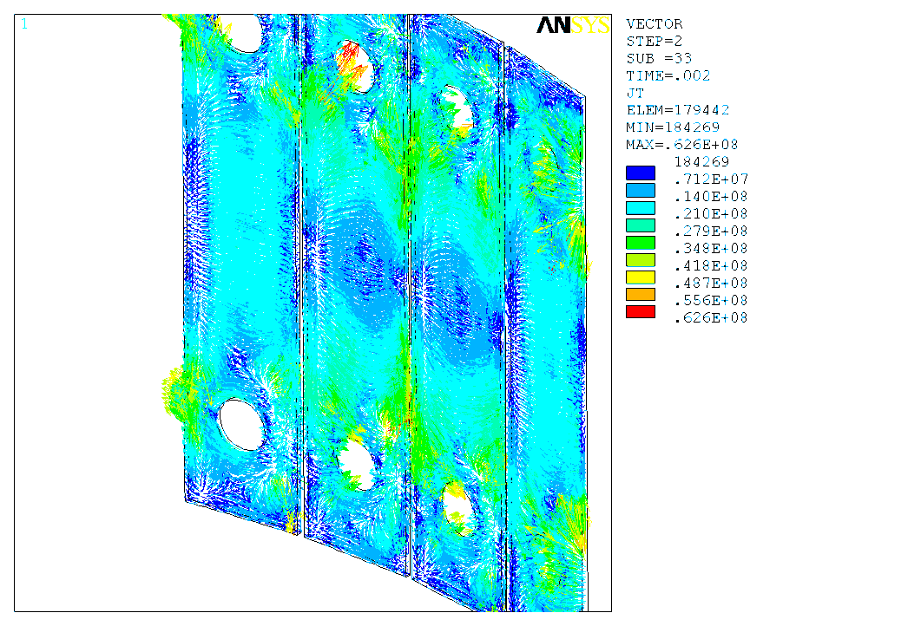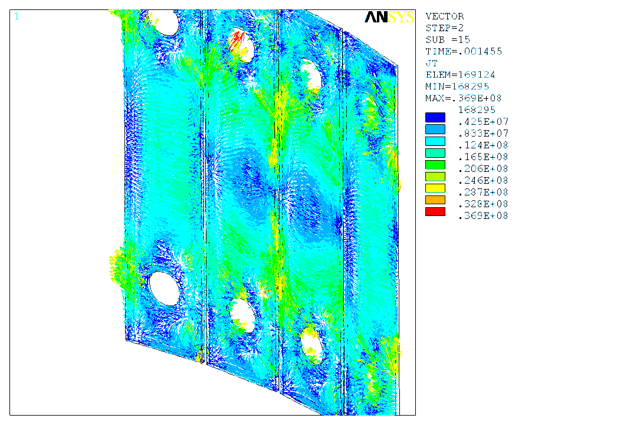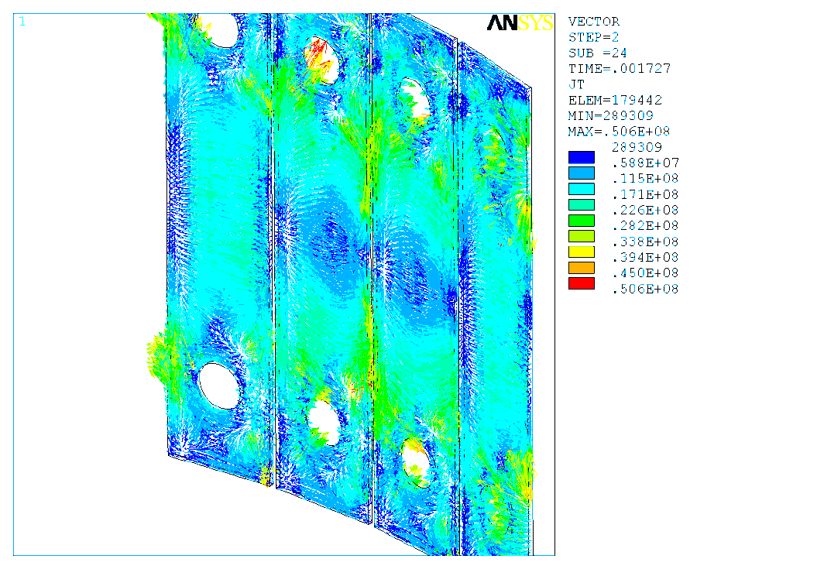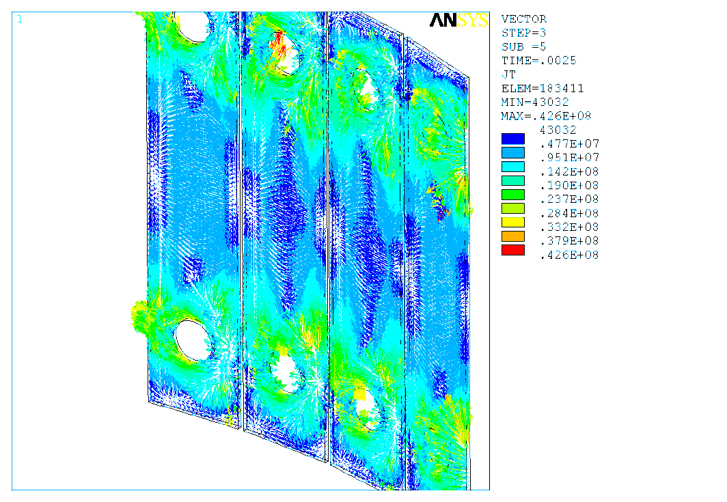

**Figure 15: Eddy current pattern in the back plate of Faraday cage (A/m2).**

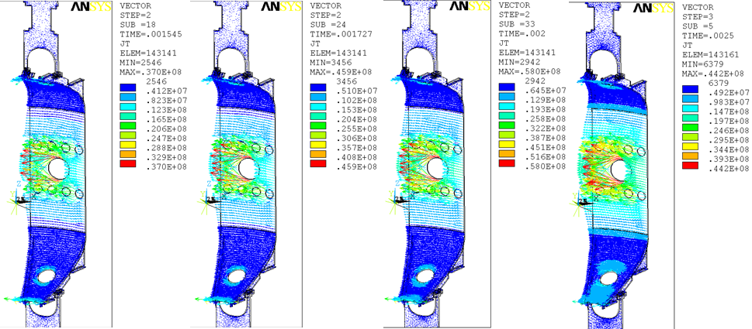

**Figure 16: Eddy current pattern in the vessel (A/m2).**

With NSTX upgrade, at the position of antenna there is a background field of Bvertical=0.65 T and Btoroidal=0.56 T. They won’t induce eddy current but they produce Lorentz force to the components with currents. Because the eddy currents reach maximum at 1ms (the end of disruption), background field is added at this time point to calculate Lorentz force and then transfer the force data to the structural model for static run. The structural model is mainly same as EM model but air is removed and some structural connections are added. As described previously, the antenna, Faraday cage and vessel have some structural connections that are hard to be included in this model. These components include ceramic plug assembly, stainless steel flanges, conductors, bellows and ceramic insulations (). But the loads on them need to be extracted from the model and then transfer to the detailed models or calculations for qualification. So in the structural model, some simple beams are added to simulate these fixtures and the loads are extracted.

See , at 1ms (end of disruption), displacement of antenna is within 0.6 mm and maximal Von Mises stress is in the strips of Faraday cage, 155 MPa (22.5ksi). Searching from literatures, the tensile strength of Molybdenum is from 560 ~ 1150 MPa. So this stress is within allowable.

**Figure 17: Structural connections are simplified in the model.**

**Figure 18: Displacement and Von Mises stress in antenna.**

To simulate the fixtures, a beam element is used to connect the nodes at different components, e.g. a node at the antenna connected to a node at the back plate of Faraday cage. Thus the beam orientation will depend on the two nodes’ positions, which will be a little different from real fixture, and loads direction cannot be consistent with regular coordinate system, i.e. Cartesian or cylindrical. To clearly show the axial and normal components of the loads, Local coordinate system was built and the loads are lists in the local coordinate. Local system x axis is the axial direction of the beam, y axis parallel to horizontal plane and z perpendicular to x and y.

~21 show the beam loads and local coordinate systems.

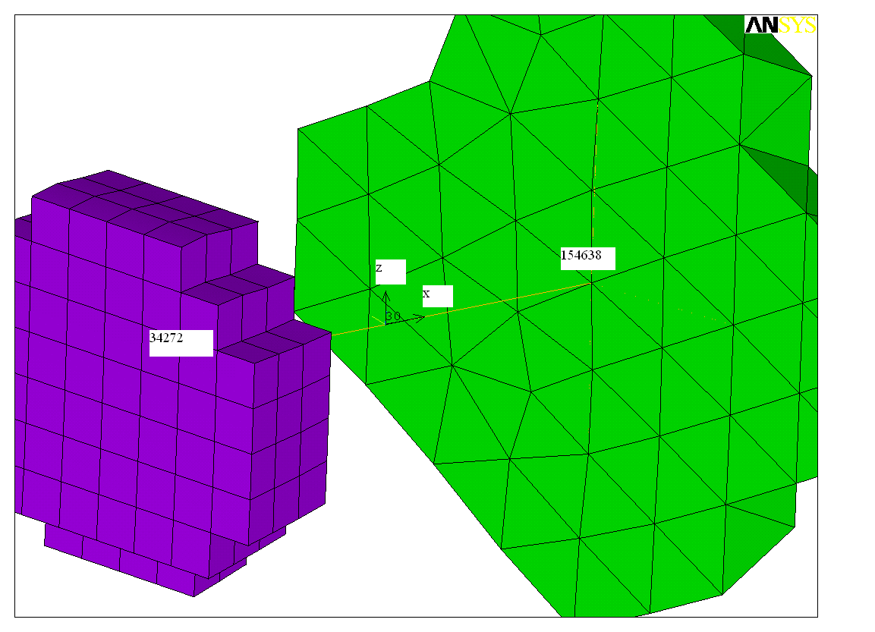

**Figure 19: Beam connection between the middle of antenna and back plate of Faraday cage.**

NODE FX (N) FY (N) FZ (N) MX (N-m) MY (N-m) MZ (N-m)

34272 -22.380 -3.4283 180.95 17.379 5.2062 2.2805

154638 22.476 3.4586 -180.70 -17.379 -14.640 -2.4569

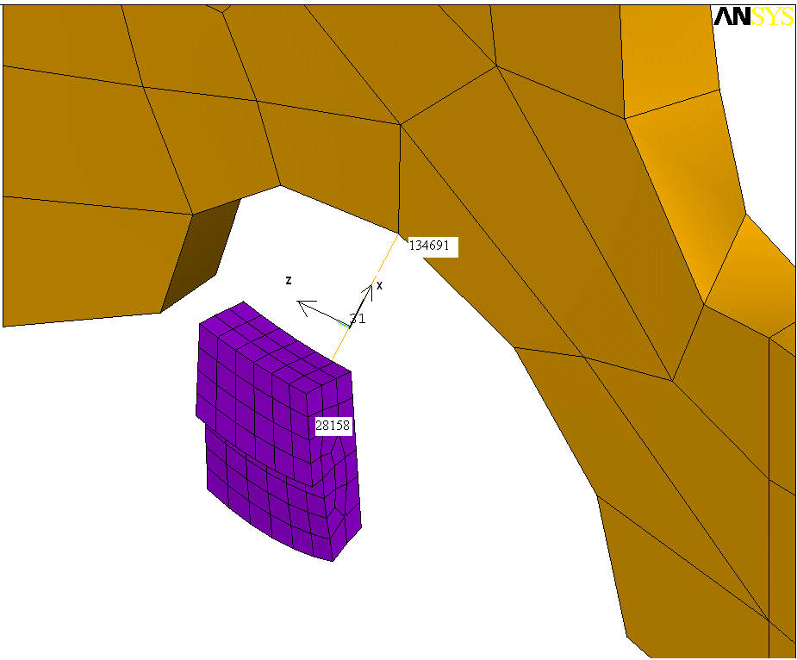

**Figure 20: Beam connection between the end of antenna and vessel.**

NODE FX (N) FY (N) FZ (N) MX (N-m) MY (N-m) MZ (N-m)

28158 -456.59 -100.76 144.26 43.229 -22.416 2.5311

134691 446.01 103.85 -143.27 -43.229 16.145 -6.9066

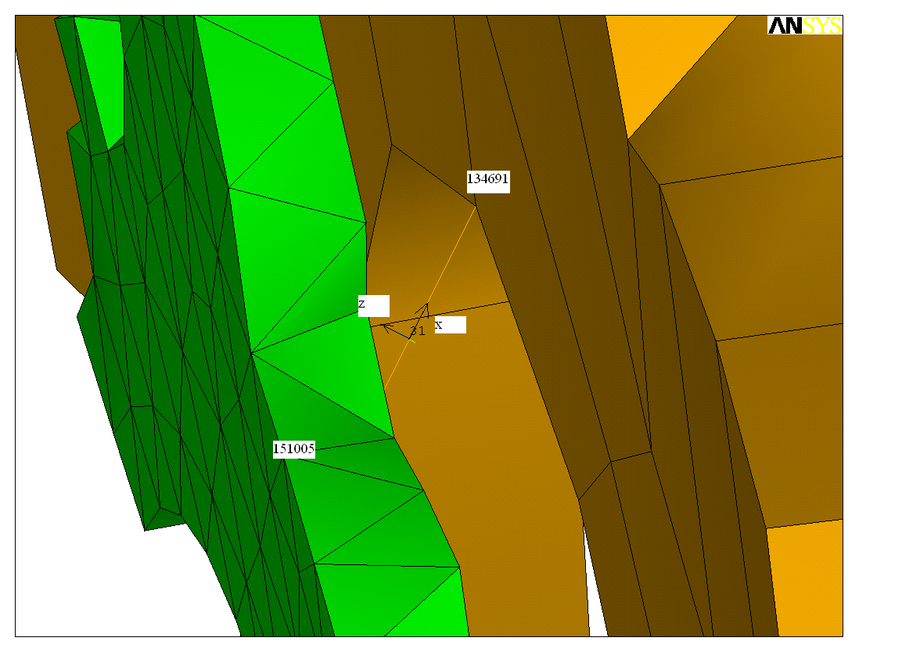

**Figure 21: Beam connection between back plate of Faraday cage and vessel.**

NODE FX (N) FY (N) FZ (N) MX (N-m) MY (N-m) MZ (N-m)

134691 6322.0 76.240 2460.1 -4.9614 -27.779 10.602

151005 -6334.7 -73.981 -2454.1 4.9614 79.724 -12.168